**ESCUELA NORMAL DE EDUCACIÓN PREESCOLAR**

**ENGLISH B1.1.2 BECOMMING INDEPENDENT COMMUNICATORS**

**ONLINE ACTIVITIES - MONDAY, APRIL 20th**

**UNIT 11 – PASSIVE VOICE**

**ACTIVITY 1**

Review the information of your last activity in Escuela en Red, check the video and the Power Point presentation to review grammar.

Change the following sentences into the passive voice.

1. The Greeks built the Parthenon in the fifth century BCE.

    The Parthenon was built by the Greeks in the fifth century BCE.

2. Russia sold Alaska to the United States in the 1860s.

    In the 1860’s Alaska was sold to the united states by russia

3. Over one million workers constructed the Suez Canal in the 1860s.

    The suez canal was constructed over one million workers In the 1860’s

4. The U.S. government named Yellowstone a national park in 1872.

    The national park was named yellowstone by the U.S. government in 1972

5. The French architect Gustave Eiffel designed the Eiffel Tower.

The eiffel tower was designed by the french architect gustave

**ACTIVITY 2**

Go to the following link and listen to the audio: <https://www.cambridge.org/files/4414/9745/2967/IC5_TSS_L2U11.mp3>

Complete the following activities.

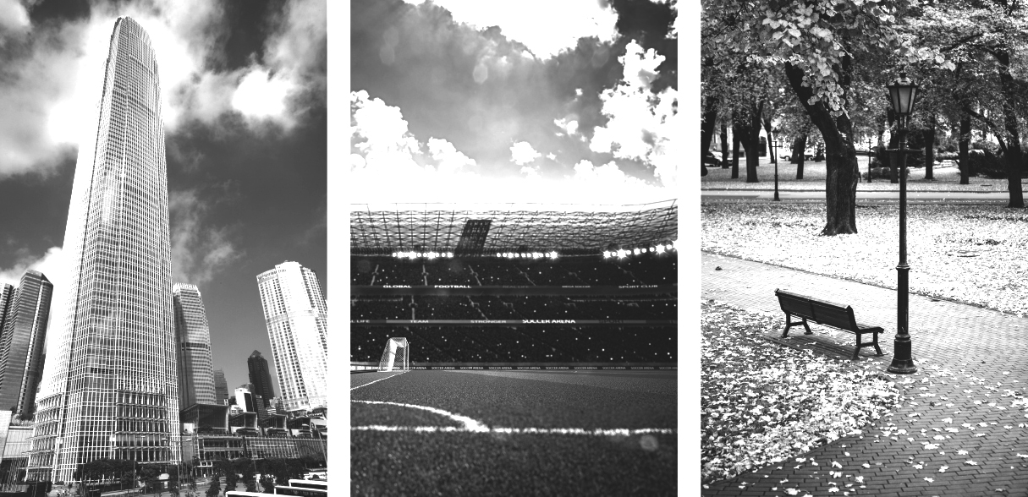

**2 skyscraper 3 stadium 1 park**

A  Listen to a tour guide talk about the places. Number the pictures   
from 1 to 3.

B  Listen again. Complete the sentences.

1. The place was opened ________________ years ago. It’s a good place to relaxing, listen the birds, and smell the flowers.

2. This place was finished _2 years ago. It’s over _fifty_ stories high.

There’s a tweny floors at the top. On a clear day, you can see

for eighty kilometers or more.

3. This place was opened Ten years ago. It was built for Baseball and

fut bol teams. It can hold over three thousand people.

C Choose four special or interesting places in your city or town.   
Write three features of each place.

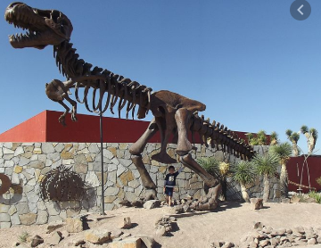

1. **THE DESERT MUSEUM**

- The desert museum was built by the architect Fco.Lopez Guerrera

- On November 1999 Was inaugurated

- In the 90's the project was promoted

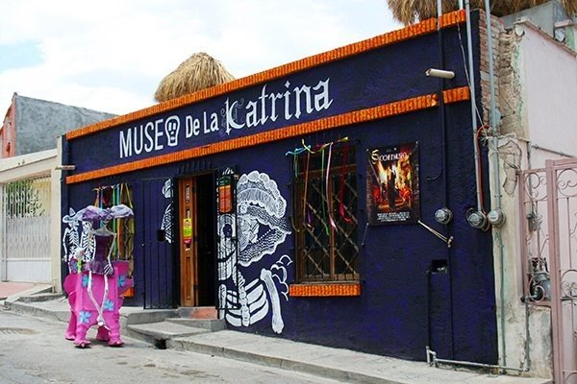2. **Catrina museum**

- In 2009 this museum was created.

- In San Antonio de las Alazanas the mummy that receives visitors was found

- You can see La Calavera Garbancera, she was Posada's most important engraving

3. **Urban forest**

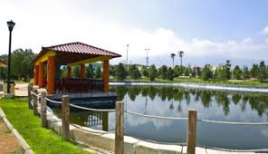 - The first tree was planted in 2003

- This place was opened 17 years ago

- It’s a good place to pass time with family and friends

**ACTIVITY 3**

Listen to the audio uploaded in Escuela en Red and answer the questions for each monument.

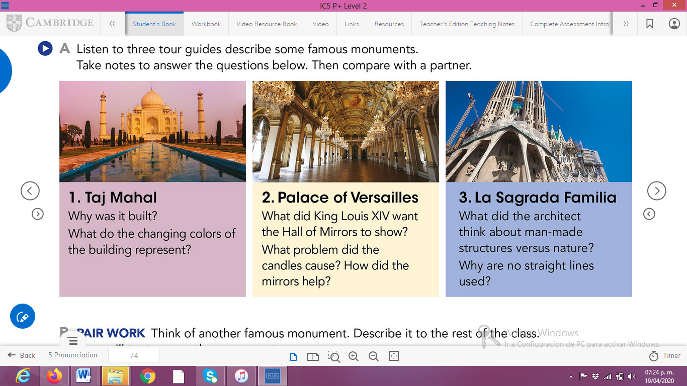

ANSWERS TO THE QUESTIONS:

1. **Taj Mahal**
2. **Palace of Versailles**
3. **La Sagrada Familia**

**ACTIVITY 4**

Write a description of another famous monument using the passive voice. **(50 words minimum)**

**“** **Pyramid of the Sun”**

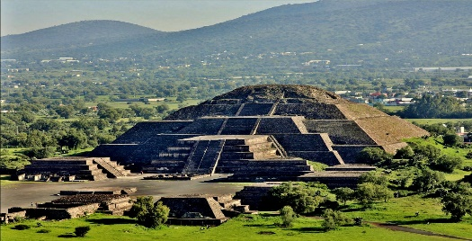**One of the largest building in Mesoamerica was pyramid of the sun. It located on the Causeway of the Dead, between the Pyramid of the Moon and the ancient city of Teotihuacán.**

**In the tzacualli stage, construction began was when Teotihuacán began to develop at he main city of Mesoamerica the**