**ESCUELA NORMAL DE EDUCACIÓN PREESCOLAR**

**ENGLISH B1.1.2 BECOMMING INDEPENDENT COMMUNICATORS**

**ONLINE ACTIVITIES - MONDAY, APRIL 20th**

**UNIT 11 – PASSIVE VOICE**

**ACTIVITY 1**

Review the information of your last activity in Escuela en Red, check the video and the Power Point presentation to review grammar.

Change the following sentences into the passive voice.

1. The Greeks built the Parthenon in the fifth century BCE.

    The Parthenon was built by the Greeks in the fifth century BCE.

2. Russia sold Alaska to the United States in the 1860s.

    In 1860s Russia was sold Alaska to the United States.

3. Over one million workers constructed the Suez Canal in the 1860s.

    The Suez Canal was constructed over one million workers in 1860s.

4. The U.S. government named Yellowstone a national park in 1872.

    The Yellowstone was named national park in 1872.

5. The French architect Gustave Eiffel designed the Eiffel Tower.

    The Eiffel Tower was designed by the French architect Gustave Eiffel.

**ACTIVITY 2**

Go to the following link and listen to the audio: <https://www.cambridge.org/files/4414/9745/2967/IC5_TSS_L2U11.mp3>

Complete the following activities.

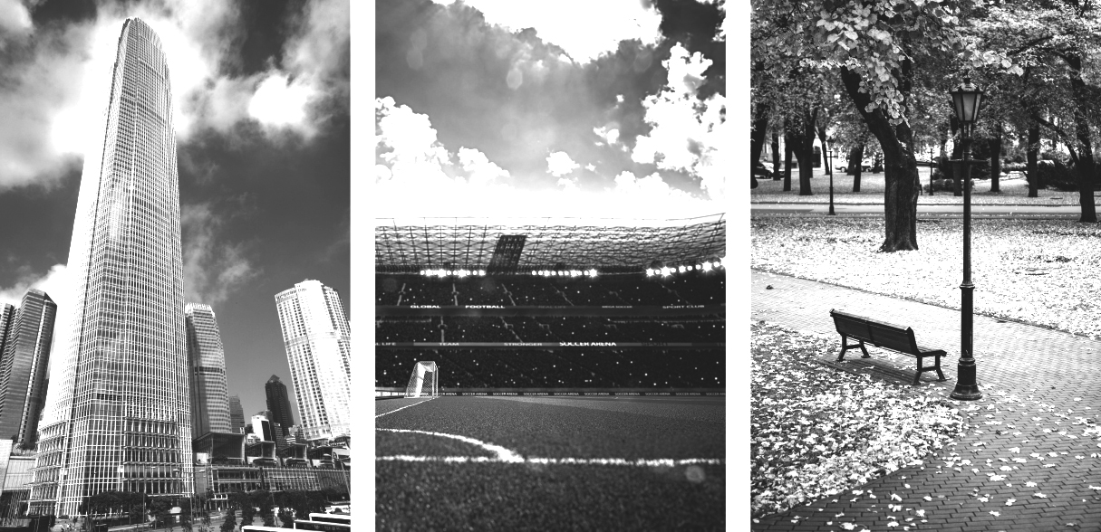

**Skyscraper (2) stadium (3) park (1)**

A  Listen to a tour guide talk about the places. Number the pictures   
from 1 to 3.

B  Listen again. Complete the sentences.

1. The place was opened a couple the years ago. It’s a good place to listen the birds and smell the flowers.

2. This place was finished 2 years ago. It’s over fifty stories high.

There’s twenty floors at the top. On a clear day, you can see for 80 kilometers or more.

3. This place was opened 10 years ago. It was built for baseball and football teams. It can hold over 30, 000 people.

C Choose four special or interesting places in your city or town.   
Write three features of each place.

Desert museum

It is very interesting.

Dinosaurs teach us.

There are animals like bears, deer, llaneros dogs.

Mall

There are many trees.

It's relaxing.

There is a small lake where you can paddle.

Torre Latino

Now it is remodeled.

It has a great view from very high.

There are many things where they tell us about the city.

City center

There you find anything.

There are several museums.

You can have a good time with your family.

**ACTIVITY 3**

Listen to the audio uploaded in Escuela en Red and answer the questions for each monument.

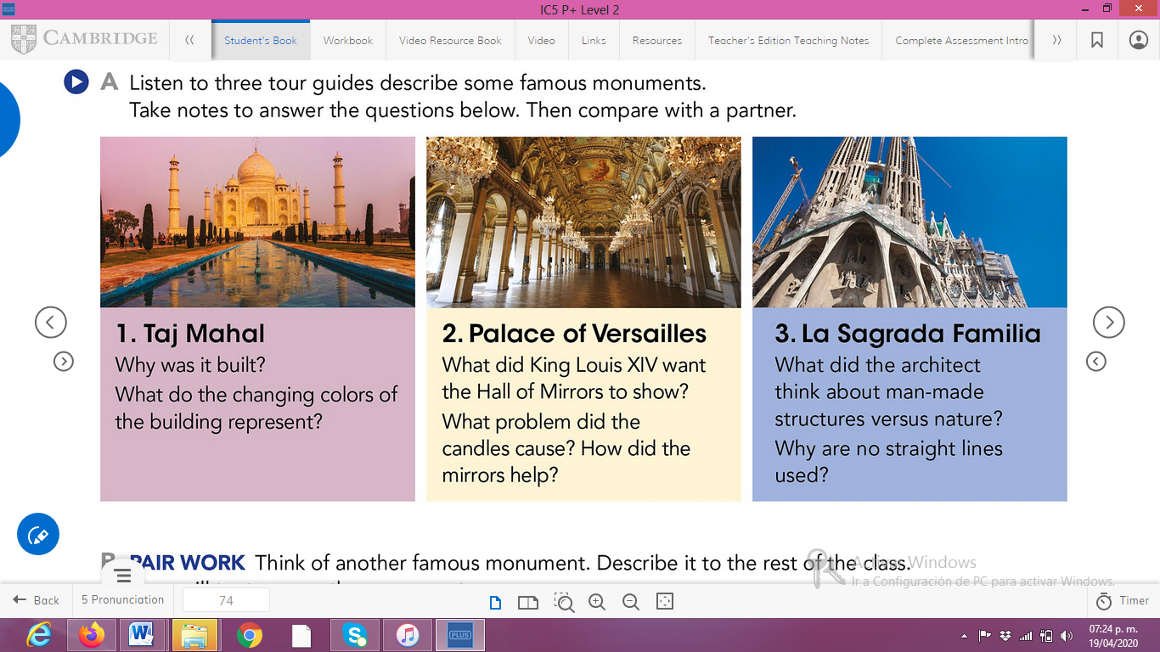

ANSWERS TO THE QUESTIONS:

1. **Taj Mahal:   
   I was built so that the emperor would remember his wife who died.**

**Colors change with the time of day and represent women's moods**

1. **Palace of Versailles:**

**He wanted to show the wealth and power of france, the paintings and the details of the garden.**

**The candles smoke and can damage the paintings, thanks to the mirrors only few candles were used due to the reflection.**

1. **La Sagrada Familia:**

**He believed that no structure should be taller than its natural environment.**

**He said that if straight lines do not exist in nature, then there should be no architecture.**

**ACTIVITY 4**

Write a description of another famous monument using the passive voice. **(50 words minimum)**

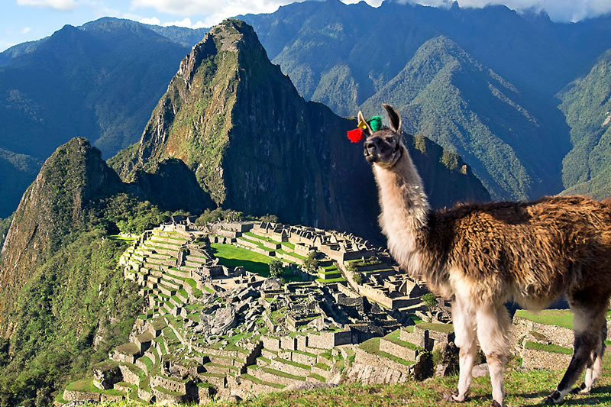

**Machu Picchu**

Machu Picchu “old mountain”, is situed in Peru. It was constructed in the 15th century.

The ruins are formed by stone blocks. The place was inhibited by the incas. They worked and harvested the land. It was used as a temple to worship tehir gods.

It was built with a group fifty thousand men. It was directed and built by the first Inca emperor, Pachacutec.

The incas had a cosmological visión of their existence. The city was built as a sanctuary.Llamas are perhaps the most beloved mammals in the Andes; llamas live in the mountainous regions of Chile, Argentina, Bolivia and Peru, where they greatly contribute to the development of the vast Empire of the Incas.

