**ESCUELA NORMAL DE EDUCACIÓN PREESCOLAR**

**ENGLISH B1.1.2 BECOMMING INDEPENDENT COMMUNICATORS**

**ONLINE ACTIVITIES - MONDAY, APRIL 20th**

**UNIT 11 – PASSIVE VOICE**

**ACTIVITY 1**

Review the information of your last activity in Escuela en Red, check the video and the Power Point presentation to review grammar.

Change the following sentences into the passive voice.

1. The Greeks built the Parthenon in the fifth century BCE.

 The Parthenon was built by the Greeks in the fifth century BCE.

2. Russia sold Alaska to the United States in the 1860s.

   Alaska was sold by Russia to the United States in the 1860s.

3. Over one million workers constructed the Suez Canal in the 1860s.

The Suez Canal was constructed by over one million workers in the 1860s.

4. The U.S. government named Yellowstone a national park in 1872.

  Yellowstone was named by the U.S. government a national park in 1872.

5. The French architect Gustave Eiffel designed the Eiffel Tower.

The Eiffel Tower was designed by the French architect Gustave Eiffel.

**ACTIVITY 2**

Go to the following link and listen to the audio: <https://www.cambridge.org/files/4414/9745/2967/IC5_TSS_L2U11.mp3>

Complete the following activities.

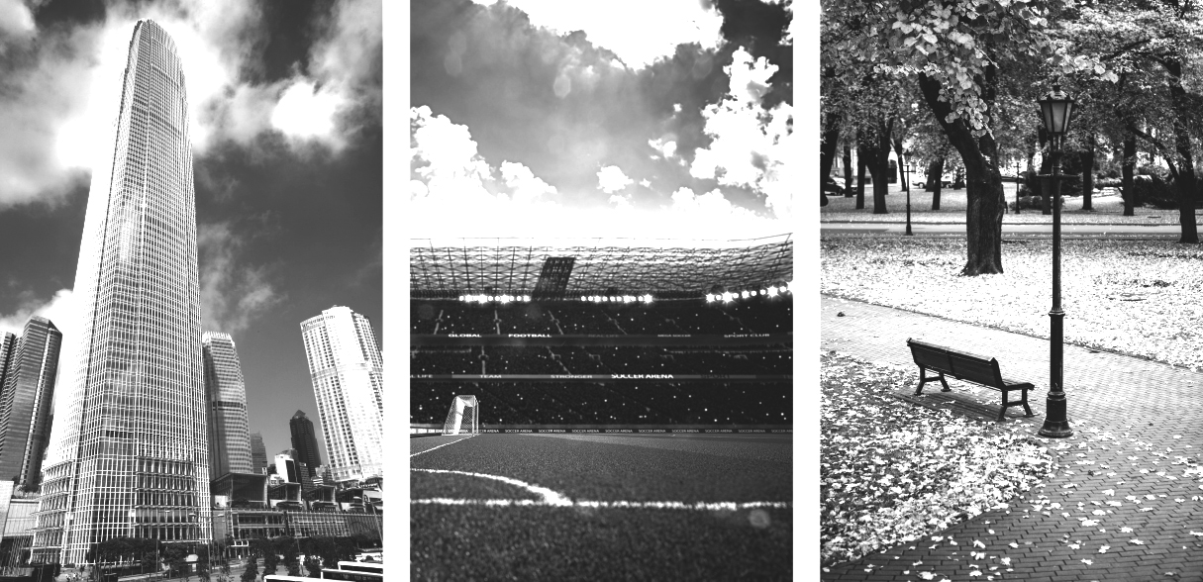

**Skyscraper 2 stadium 3 park 1**

A  Listen to a tour guide talk about the places. Number the pictures   
from 1 to 3.

B  Listen again. Complete the sentences.

1. The place was opened **five** years ago. It’s a good place to **relaxing**, **come here to the weekend,** **listen to the birds**, and **smell the flowers.**

2. This place was finished **two** years ago. It’s over **fifty** stories high.

There’s a **twenty floors are a hotel** at the top. On a clear day, you can see for **eighty** kilometers or more.

3. This place was opened **teen** years ago. It was built for **baseball** and **footbal**l teams. It can hold over **thirty thousand** people.

C Choose four special or interesting places in your city or town.   
Write three features of each place.

**ACTIVITY 3**

Listen to the audio uploaded in Escuela en Red and answer the questions for each monument.

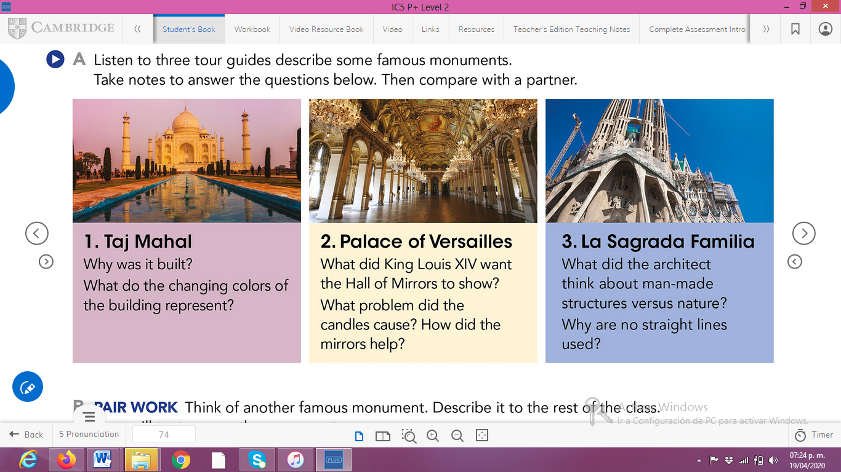

ANSWERS TO THE QUESTIONS:

1. **Taj Mahal**

For love, was designed by his wife when she died

Represent of the different moods of woman

1. **Palace of Versailles**

Paintings, beautiful details and garden outside

Candles make smoke

The mirrors reflected the candles so didn´t have to use is many

1. **La Sagrada Familia**

Believe that no man make structure show be taller than the natural arrounding and no there’s the curves of the church this is another example.

He said if stand lines don’t exist nature the shouldn’t exist architect either.

**ACTIVITY 4**

Write a description of another famous monument using the passive voice. **(50 words minimum)**

Christ redeemer

The Christ the Redeemer or Cristo del Corcovado is a huge statue of Jesus of Nazareth with open arms showing the city of Rio de Janeiro, Brazil. The statue was made by the French sculptor Paul Landowski in Rio de Janeiro. This monument was inaugurated on October 12, 1931, after approximately five years of construction.