**ESCUELA NORMAL DE EDUCACIÓN PREESCOLAR**

**ENGLISH B1.1.2 BECOMMING INDEPENDENT COMMUNICATORS**

**ONLINE ACTIVITIES - MONDAY, APRIL 20th**

**UNIT 11 – PASSIVE VOICE**

**ACTIVITY 1**

Review the information of your last activity in Escuela en Red, check the video and the Power Point presentation to review grammar.

Change the following sentences into the passive voice.

1. The Greeks built the Parthenon in the fifth century BCE.

    The Parthenon was built by the Greeks in the fifth century BCE.

2. Russia sold Alaska to the United States in the 1860s.

    Alaska was sold by United States for Russia in the 1860

3. Over one million workers constructed the Suez Canal in the 1860s.

  the Suez Canal was constructed by Over one million workers in the 1860

4. The U.S. government named Yellowstone a national park in 1872.

    the Yellowstone was named a national park by the U.S. government in 1872.

5. The French architect Gustave Eiffel designed the Eiffel Tower.

the Eiffel Tower was designed by The French architect Gustave Eiffel

**ACTIVITY 2**

Go to the following link and listen to the audio: <https://www.cambridge.org/files/4414/9745/2967/IC5_TSS_L2U11.mp3>

Complete the following activities.

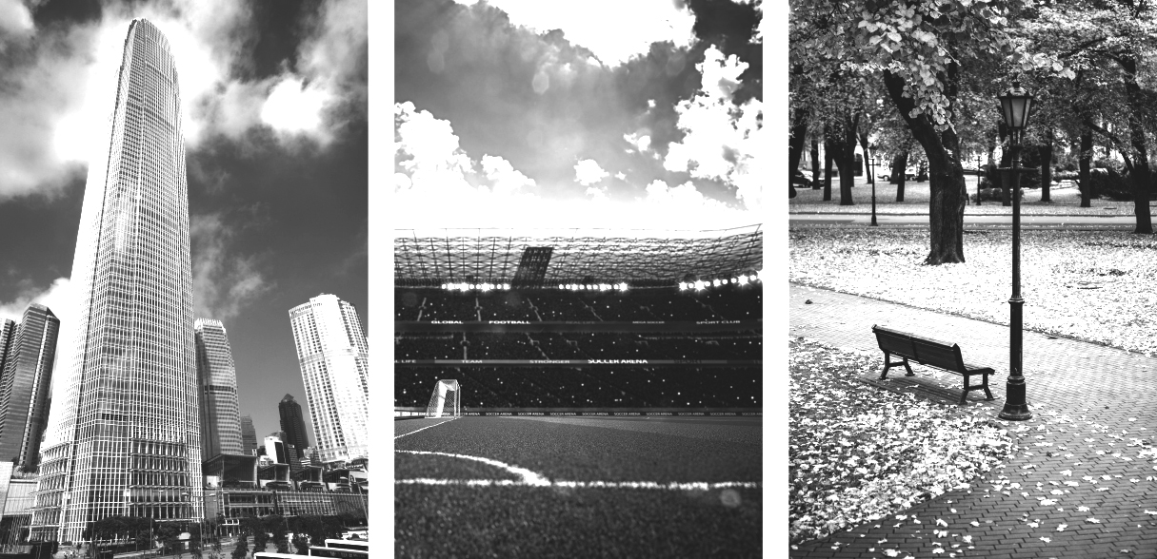

**2. skyscraper 3.stadium 1. park**

A  Listen to a tour guide talk about the places. Number the pictures   
from 1 to 3.

B  Listen again. Complete the sentences.

a couple of years ago

1. The place was opened ____,____________ years ago. It’s a good place to

Relaxing, to listen to the birds and smell the flowers

2. This place was finished ________________ years ago. It’s over ________________ stories high.

two

fifteen

There’s a ________________ at the top. On a clear day, you can see

twenty

for ________________ kilometers or more.

Eighteen

ten

3. This place was opened ________________ years ago. It was built for ________________ and

________________ teams. It can hold over ________________ people.

thirty thousand

C Choose four special or interesting places in your city or town.   
Write three features of each place.

**Catedral de Santiago**

It is located in the historic center of the city

It is one of the tallest in the country

The tower was built in 1883

**Cañón de San Lorenzo**

Located in the Sierra de Zapalinamé

It is a tourist attraction

you can do extreme sports

Composed of geological formations

**Alameda Zaragoza**

It is recognized as one of the most beautiful in the country.

you can take quiet walks

It is located in the historic center of the city

it has many trees

**stadium Francisco I. Madero**

the largest park in the city

was built in 1963

people go to watch baseball games

**ACTIVITY 3**

Listen to the audio uploaded in Escuela en Red and answer the questions for each monument.

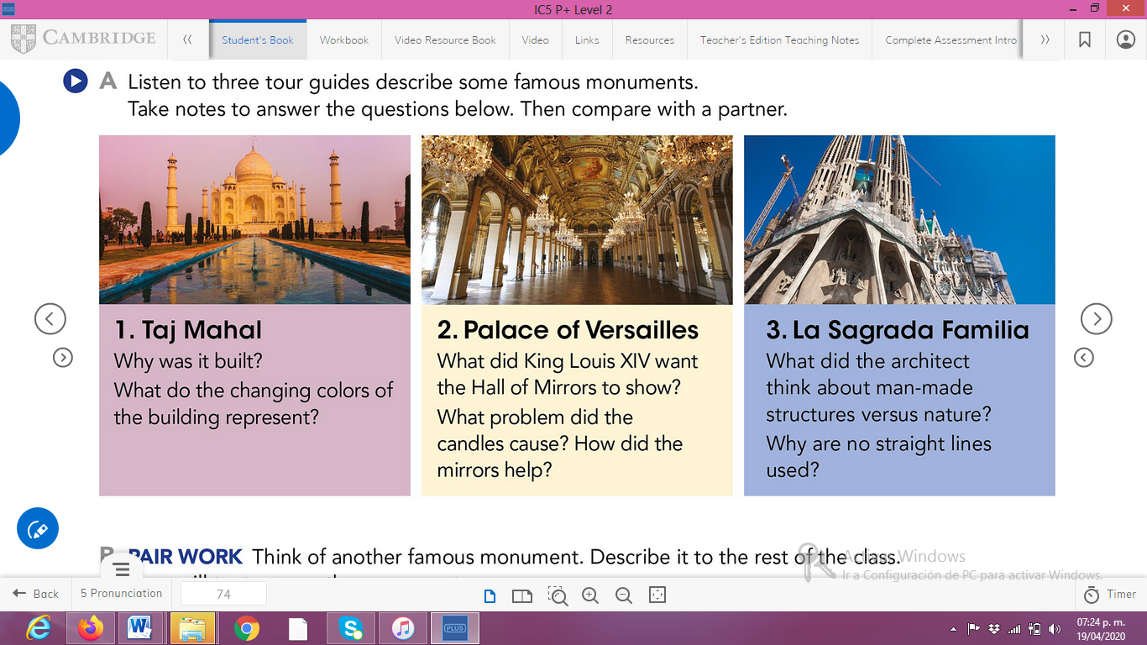

ANSWERS TO THE QUESTIONS:

1. **Taj Mahal**

**1. for remember his wife**

**2.** **The colors of the building change with the time of day and they say that the different colors represent the different moods**

1. **Palace of Versailles**

**2.the candles makes smoke**

**Mirrors reflect candlelight**

**ACTIVITY 4**

Write a description of another famous monument using the passive voice. **(50 words minimum)**

*Liberty Enlightening the World*

it is one of the most famous monuments in New York and around the world.

It was built by the French government for the American government to commemorate the centennial of the United States Declaration of Independence and as a sign of friendship between the two nations in 1886.

It was opened by US President Grover Cleveland on October 28, 1886