**ESCUELA NORMAL DE EDUCACIÓN PREESCOLAR**

**ENGLISH B1.1.2 BECOMMING INDEPENDENT COMMUNICATORS**

**ONLINE ACTIVITIES - MONDAY, APRIL 20th**

**UNIT 11 – PASSIVE VOICE**

**ACTIVITY 1**

Review the information of your last activity in Escuela en Red, check the video and the Power Point presentation to review grammar.

Change the following sentences into the passive voice.

1. The Greeks built the Parthenon in the fifth century BCE.

    The Parthenon was built by the Greeks in the fifth century BCE.

2. Russia sold Alaska to the United States in the 1860s.

    Alaska was sold by Russia to the United States in the 1860s.

3. Over one million workers constructed the Suez Canal in the 1860s.

  The Suez Canal was constructed by over one million workers in the 1860s.

4. The U.S. government named Yellowstone a national park in 1872.

    Yellowstone a national park was named by the U.S. government in 1872.

5. The French architect Gustave Eiffel designed the Eiffel Tower.

    The Eiffel Tower was designed by the French architect Gustave Eiffel.

**ACTIVITY 2**

Go to the following link and listen to the audio: <https://www.cambridge.org/files/4414/9745/2967/IC5_TSS_L2U11.mp3>

Complete the following activities.

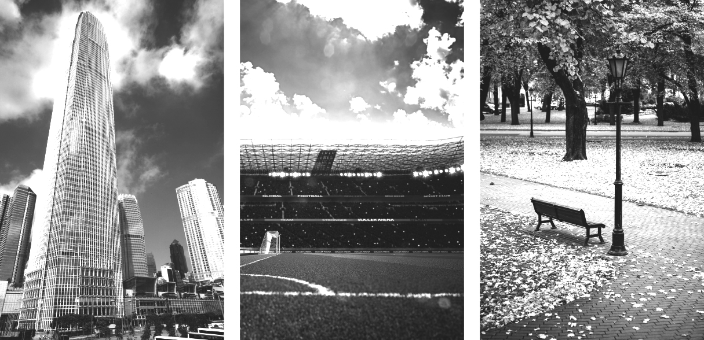

**2) skyscraper 3) stadium 1) park**

A  Listen to a tour guide talk about the places. Number the pictures   
from 1 to 3.

B  Listen again. Complete the sentences.

1. The place was opened a couple of years ago. It’s a good place to relax, go to a walk, listen to the birds and smell the flowers.

2. This place was finished 2 years ago. It’s over 15 stories high.

There’s a hotel and a restaurant at the top. On a clear day, you can see for 18 kilometers or more.

3. This place was opened 10 years ago. It was built for ower local baseball and football teams. It can hold over thirteen thousand people.

C Choose four special or interesting places in your city or town.   
Write three features of each place.

If you visit the capital of Coahuila you need to see its beautiful cathedral of Santiago that´s located in the center of the city. It was built in 1745 and it has a baroque style. After you could go for a dinner in the restaurant named Villas de Santiago that's beside the cathedral they serve mexican food and traditional dishes.

Another famous place in Saltillo is The musuem of desert there are four pavilions: desert, human, the life and evolution. You can also interact with the exhibitions, watch videos and other wonderful stuffs.

Saltillo is known by its museums. One of the most important museums worldwide,is the museum of the birds. It has an environmental education theme, dedicated exclusively to birds. They have more than 2,500 species of birds that live in Mexico and this represent the 73% of the birds in the country.

The museum of Sarape was opened in 2008, there you´ll know the process to do the sarape that's part of saltillo´s costum.

If you go to Saltillo you must walk around the alameda it's a romantic and beautiful parc.

**ACTIVITY 3**

Listen to the audio uploaded in Escuela en Red and answer the questions for each monument.

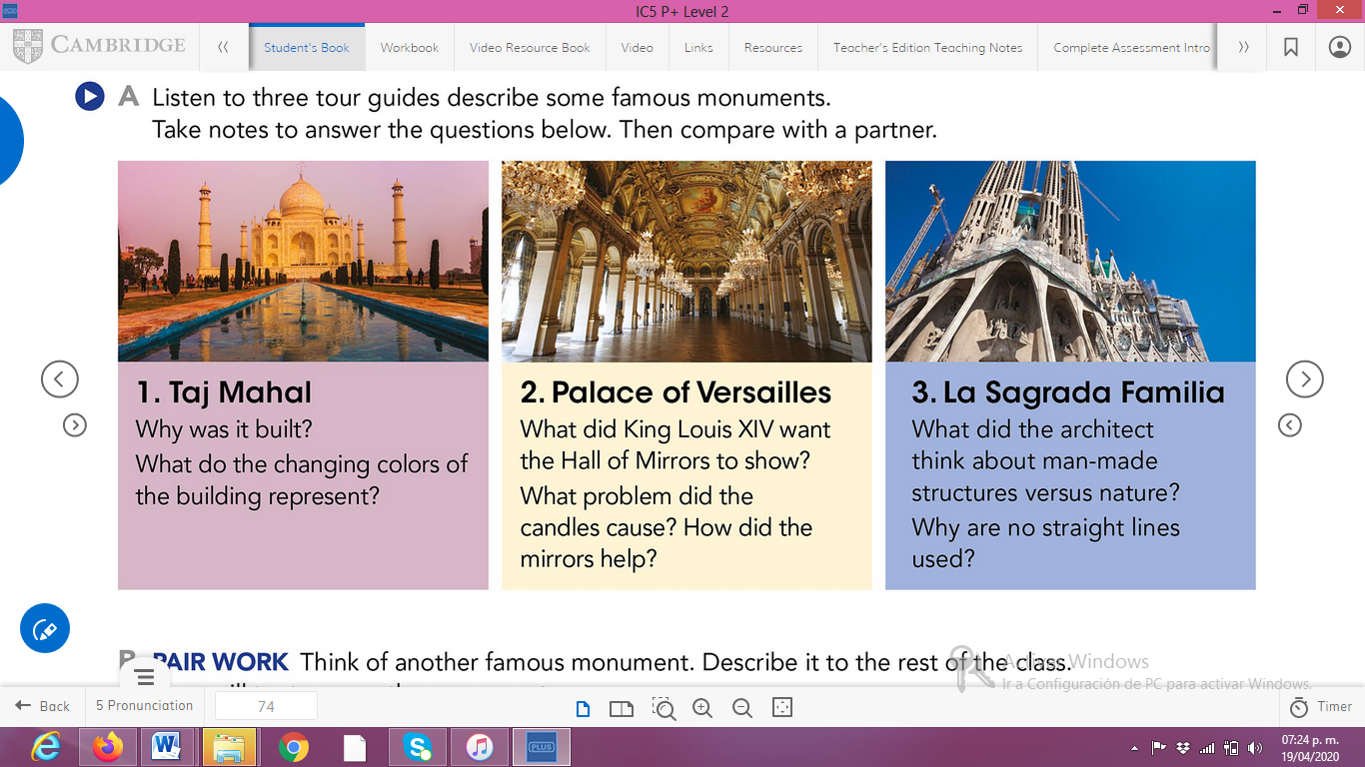

ANSWERS TO THE QUESTIONS:

1. **Taj Mahal**

Because the wife of the emperor die and she was one of his favorite wife.

Represent the different moods of the women’s.

1. **Palace of Versailles**

**Show the riches and friends.**

The problem of the candles is that they make smoke and it damage paintings. But the mirrors help because they reflect the candles and they didn´t need to put many.

1. **La Sagrada Familia**

The architect should reflect nature.

They are no straight lines used because the said straight lines don’t exist in nature so they don´t exist in architect.

**ACTIVITY 4**

Write a description of another famous monument using the passive voice. **(50 words minimum)**

The Statue of Liberty is one of the most famous monuments in New York, in the United States and around the world. It is located on Liberty Island south of Manhattan Island, next to the mouth of the Hudson River and near Ellis Island.

The Statue of Liberty was given by the French government.

The Statue of Liberty was done by the French architect Frédéric Auguste Bartholdi.

He is compared to the ancient Greek goddess Hecate and the figure of the statue, as a very accurate inspiration, based on the symbols used, which are, among others, the ray crown and the torch.