**ESCUELA NORMAL DE EDUCACIÓN PREESCOLAR**

**ENGLISH B1.1.2 BECOMMING INDEPENDENT COMMUNICATORS**

**ONLINE ACTIVITIES - MONDAY, APRIL 20th**

**UNIT 11 – PASSIVE VOICE**

**ACTIVITY 1**

Review the information of your last activity in Escuela en Red, check the video and the Power Point presentation to review grammar.

Change the following sentences into the passive voice.

1. The Greeks built the Parthenon in the fifth century BCE.

    The Parthenon was built by the Greeks in the fifth century BCE.

2. Russia sold Alaska to the United States in the 1860s.

    Alaska was sold to United States by Russia in the 1860’s

3. Over one million workers constructed the Suez Canal in the 1860s.

    The Suez Canal was constructed by over one million workers in the 1860’s.

4. The U.S. government named Yellowstone a national park in 1872.

    National Park Yellowstone was named by the U.S. government in 1872.

5. The French architect Gustave Eiffel designed the Eiffel Tower.

    The Eiffel Tower was designed by the French architect Gustave Eiffel.

**ACTIVITY 2**

Go to the following link and listen to the audio: <https://www.cambridge.org/files/4414/9745/2967/IC5_TSS_L2U11.mp3>

Complete the following activities.

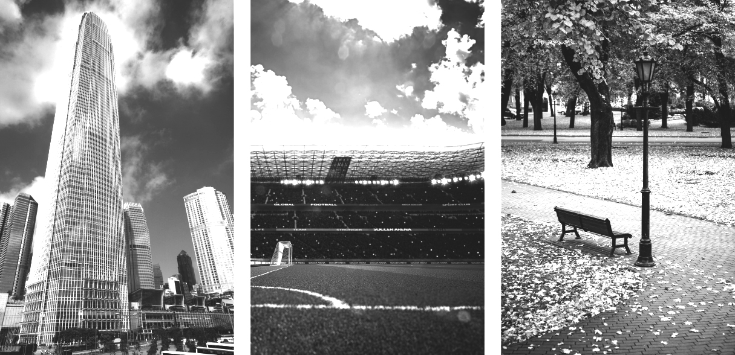

**skyscraper stadium park**

A  Listen to a tour guide talk about the places. Number the pictures   
from 1 to 3. **1. Park** **2. Skyscraper. 3. Stadium**

B  Listen again. Complete the sentences.

1. The place was opened ______only on couples of days in year____ years ago. It’s a good place to ___hwalk_____________,

_lil=smell the flowers_______, and ____listen the birds____________.

2. This place was finished __2 years ago______________ years ago. It’s over ______50__________ stories high.

There’s a _________restaurant_______ at the top. On a clear day, you can see

for _________80_______ kilometers or more.

3. This place was opened ______10__________ years ago. It was built for __local ffootball___ and

local_baseball____ teams. It can hold over _____30000___________ people.

C Choose four special or interesting places in your city or town.   
Write three features of each place.

1. The Macro Plaza

* Is a very large park that is divided in 2 in one of them you can go for a run or walk, and the other one has several football, basketball and volleyball courts. Games for kids.

1. La Gran Plaza

* This square has a variety of things, in it is located the museum of chapulin which is very interactive and fun for children, also has a bridge that you can cross walking, this leads you to some ramps where you can run and walk, to one side is the Rio bravo, so it has very nice view.

1. The Club Campestre

* This club is only for members, but it has 2 pools very big and 1 roof for cold time, plus it has 60 grills to spend with your family every day you want , and also has 3 parties rooms.

**ACTIVITY 3**

Listen to the audio uploaded in Escuela en Red and answer the questions for each monument.

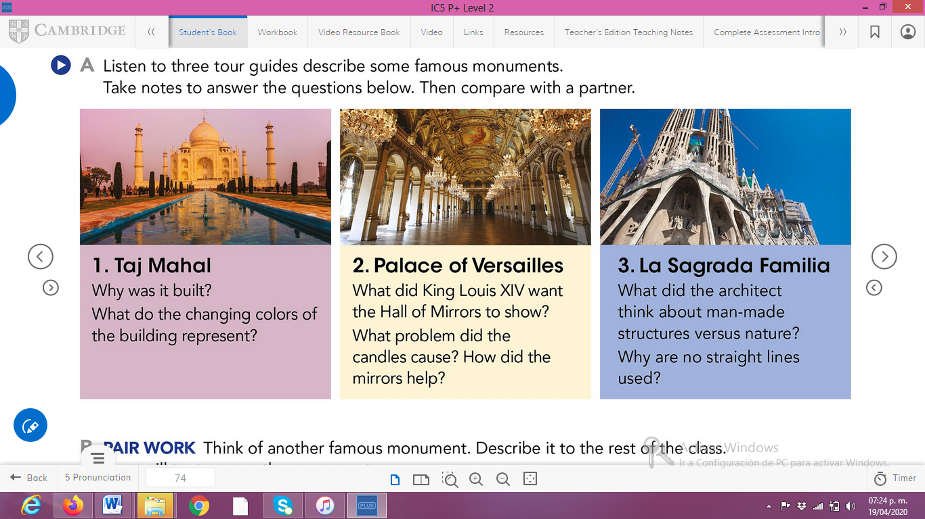

ANSWERS TO THE QUESTIONS:

1. **Taj Mahal**

* **Why was it built?**

Shah Jahan built the Taj Mahal to expressed his love to his dead wife.

* **What do the changing colors of the building represent?**

Represent the different moods of women

1. **Palace of Versailles**

* **What did King Louis XIV want the Hall of mirrors to show?**

To show all the richest and powerful friends, the paintings on the wall, the beautiful details on the room, the gardens outside, they were all more visible with the mirrors.

* **What problem did the candles cause? How did the mirrors help?**

Candles make smoke and the smoke damage the paintings. The mirrors reflect the light of the candles so they didn’t use too many.

1. **La Sagrada Familia**

* **What did the architect think about man-made structures versus nature?**

La sagrada Familia is exactly 1m shorter because Gaudi believe that no man-made structure should be taller than its natural surroundings.

* **Why are no straight lines used?**

Gaudi said that if Straight Lines don’t exist in nature, they shouldn’t exist in architecture either.

**ACTIVITY 4**

Write a description of another famous monument using the passive voice. **(50 words minimum)**

“The Pyramid of The Sun”

It is the largest building in Teotihuacan: it measures 225 m per side and reaches 65 m of height. The Pyramid of the Sun was built by the Mexicas in a single stage, during the Tzacualli phase (1-150 AD). The Mexicas called it tonatiuh itzacual, "encierro del Sol", it is commonly thought that it was dedicated to the cult of that star.