**ESCUELA NORMAL DE EDUCACIÓN PREESCOLAR**

**ENGLISH B1.1.2 BECOMMING INDEPENDENT COMMUNICATORS**

**ONLINE ACTIVITIES - MONDAY, APRIL 20th**

**UNIT 11 – PASSIVE VOICE**

**ACTIVITY 1**

Review the information of your last activity in Escuela en Red, check the video and the Power Point presentation to review grammar.

Change the following sentences into the passive voice.

1. The Greeks built the Parthenon in the fifth century BCE.

    The Parthenon was built by the Greeks in the fifth century BCE.

2. Russia sold Alaska to the United States in the 1860s.

3. Over one million workers constructed the Suez Canal in the 1860s.

    The Suez Canal was constructed by over one million workers in the 1860s.

4. The U.S. government named Yellowstone a national park in 1872.

    A national park Yellowstone was named by the U.S. government in 1872.

5. The French architect Gustave Eiffel designed the Eiffel Tower.

    The Eiffel Tower was designed by the French architect Gustavo Eiffel.

**ACTIVITY 2**

Go to the following link and listen to the audio: <https://www.cambridge.org/files/4414/9745/2967/IC5_TSS_L2U11.mp3>

Complete the following activities.

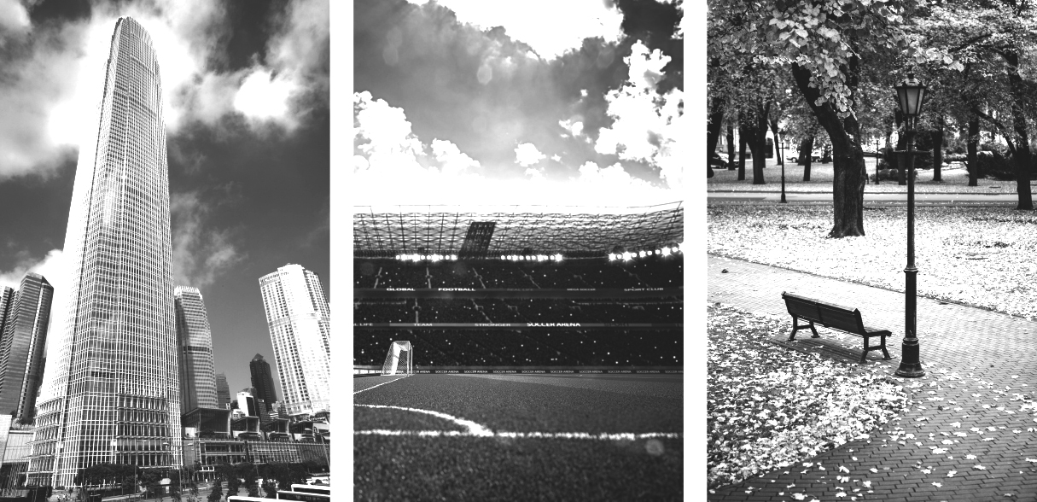

**skyscraper stadium park**

A  Listen to a tour guide talk about the places. Number the pictures   
from 1 to 3.

B  Listen again. Complete the sentences.

1. The place was opened a couple of years ago. It’s a good place to listen to the birds and smell flowers.

2. This place was finished **2** years ago. It’s over **5** stories high.

There’s a **21 floors** at the top. On a clear day, you can see for **80** kilometers or more.

3. This place was opened **10** years ago. It was built for **baseball** and **football** teams. It can hold over **30,000** people.

C Choose four special or interesting places in your city or town.   
Write three features of each place.

1. The Desert Museum was designed by the architect Francisco López Guerra, it was opened 20 years ago, it has a wide collection of fossils, plants and even native animals from the Mexican desert.
2. The Catedral de Saltillo was building in 1745 in front of the parade ground, it is the tallest cathedral in northern Mexico, and one of the tallest in the country.
3. The Bird Museum was inaugurated on November 15, 1993, It has more than 2,500 birds and is considered one of the most important museums worldwide.
4. The Francisco I. Madero Stadium is a baseball stadium that is part of the Francisco I. Madero Sports City in Saltillo, Coahuila, was built in 1963.

**ACTIVITY 3**

Listen to the audio uploaded in Escuela en Red and answer the questions for each monument.

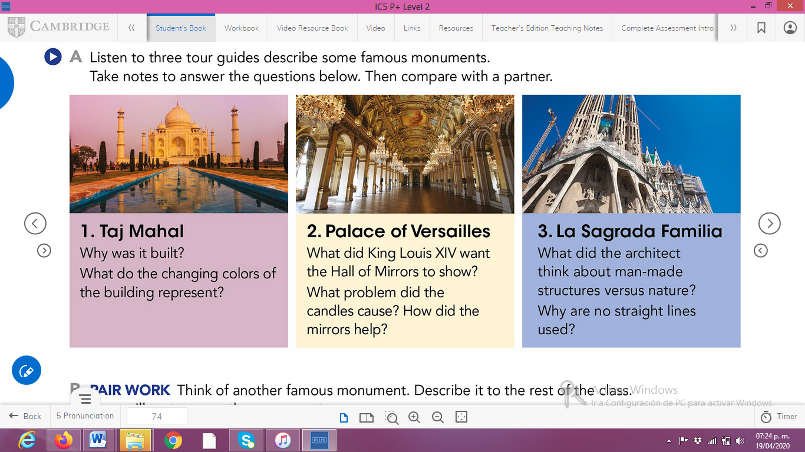

ANSWERS TO THE QUESTIONS:

1. **Taj Mahal**

**· It was designed for his wife when she died.**

**· They’re colors change whit the time of day, the different colors represent moods of women.**

1. **Palace of Versailles**

**· King Louis XlV wanted the Hall of Mirrors to show all the riches and power of France.**

**· The candles cause make smoke.**

**· The mirrors reflected the lighting of the candles.**

1. **La Sagrada Familia**

**· The architect Anthony Gowdy felt very strongly that architecture should reflect nature.**

**ACTIVITY 4**

Write a description of another famous monument using the passive voice. **(50 words minimum)**

**To celebrate the 4th year of Saltillo's function, they were installed the sculptures of a Tlaxcalteca Indian, in the beginning of the boulevard Fundadores, while in the end that of a Spanish was installed. Both sculptures they were made by César Ledesma, a sculptor from Saltillo.**

[Escriba una cita del documento o el resumen de un punto interesante. Puede situar el cuadro de texto en cualquier lugar del documento. Use la ficha Herramientas de dibujo para cambiar el formato del cuadro de texto de la cita.]