**ESCUELA NORMAL DE EDUCACIÓN PREESCOLAR**

**ENGLISH A1.2 DEVELOPING ELEMENTARY CONVERSATIONS**

**ONLINE ACTIVITIES - APRIL 20th**

**KARLA ANDREA MUÑIZ IBARRA**

**REVIEW UNITS 7 AND 8 – SELF ASSESSMENT**

**ACTIVITY 1**

Imagine you are moving to this apartment. What things are in the rooms?

1. Paste pictures inside each room.
2. Write **15 affirmative and negative sentences** describing what things are in the rooms of your apartment. Use *there is, there are, there is no, and there are no*.

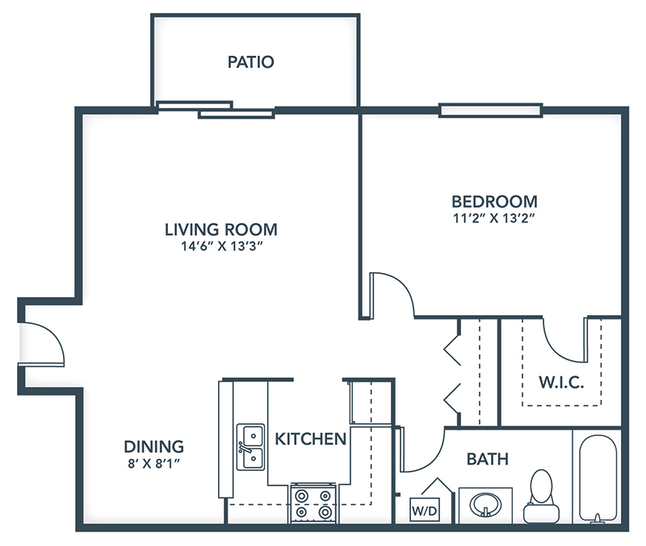

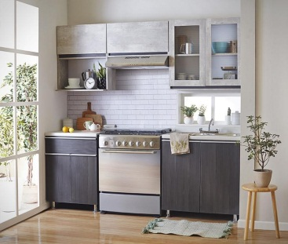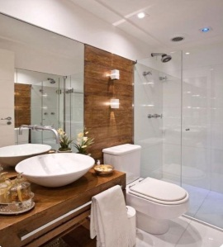

1. There is no TV in the living room.

2. There is a bed in the bedroom.

3. There is no refrigeration in the kitchen.

4. There are some chairs in the patio.

5. There are no curtains on the windows in the bedroom.

6. There is a rug in the bedroom.

7. There is no coffee maker in the kitchen.

8. There is a desk in the bedroom.

9. There are some tables in the living room.

10. There is a sofa in the patio.

11. There are some plants in the living room.

12. There is a laptop in the bedroom.

13. There are some windows in the bedroom.

14. There are no pictures in the living room.

15. There is a stove in the kitchen.

**ACTIVITY 2**

Write questions for the following answers.

***Note:*** *Remember that the structure to build questions is the following.*

**Wh- word** (where/what/how) + **do/does** + **subject** + **verb** + complement?

Example:

1. A: ***Where*** *does your father work?*

B: My father? He works in a store.

1. A:**What** does he do?

B: He is a salesperson.

1. A: **How** does he like it?

B: He likes his job a lot.

1. A:**What** do you do?

B: I’m an accountant.

1. A: **Where** do you work?

B: I work in an office.

1. A: **How** do you like it?

B: It’s OK. I guess I like it.

**ACTIVITY 3**

Upload a **video or a voice recording** where you talk about the jobs in the pictures. Tell what they do, what they do exactly, where they work and give your opinion about each job using adjectives.

Example:

She is a teacher.

She **prepares** material for the class.

She **works** in a school.

**I think** she has a **difficult** job.



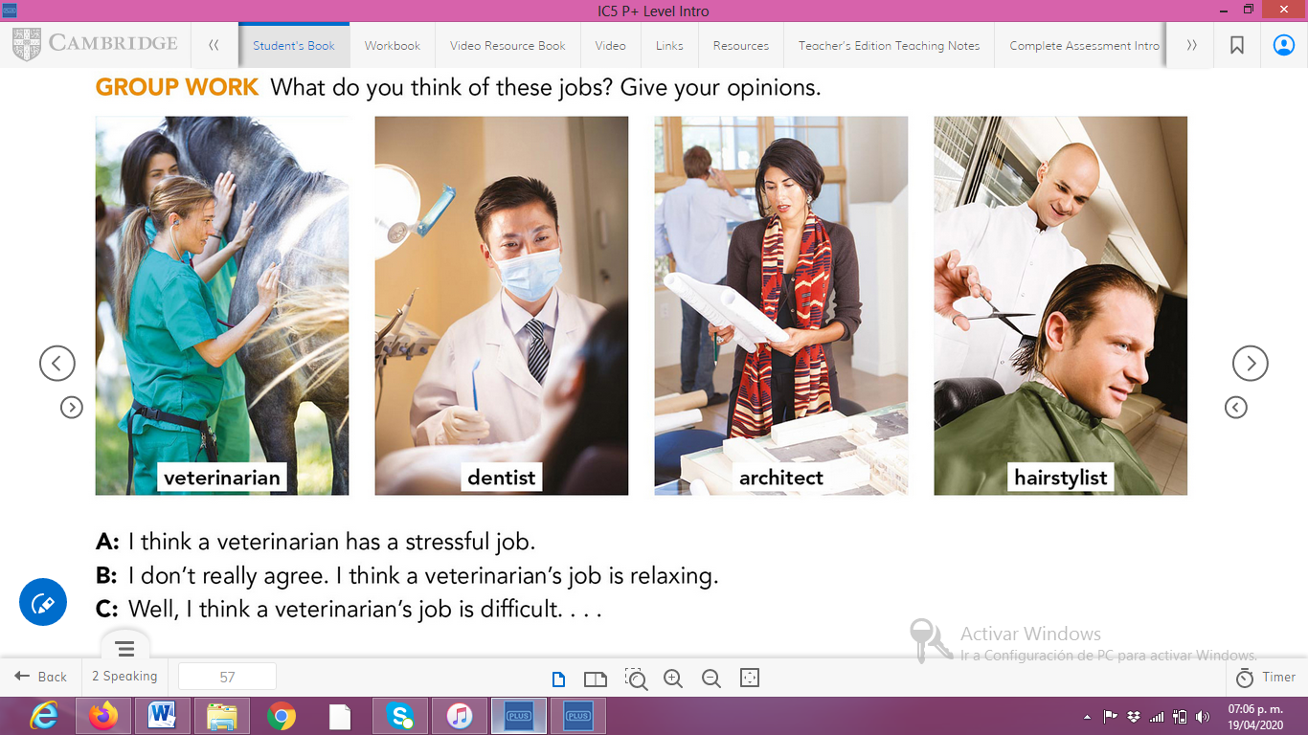

**ACTIVITY 4**

Complete your self-assessment.

