**ESCUELA NORMAL DE EDUCACIÓN PREESCOLAR**

**ENGLISH A1.2 DEVELOPING ELEMENTARY CONVERSATIONS**

**ONLINE ACTIVITIES - APRIL 20th**

**REVIEW UNITS 7 AND 8 – SELF ASSESSMENT**

**ACTIVITY 1**

Imagine you are moving to this apartment. What things are in the rooms?

1. Paste pictures inside each room.
2. Write **15 affirmative and negative sentences** describing what things are in the rooms of your apartment. Use *there is, there are, there is no, and there are no*.

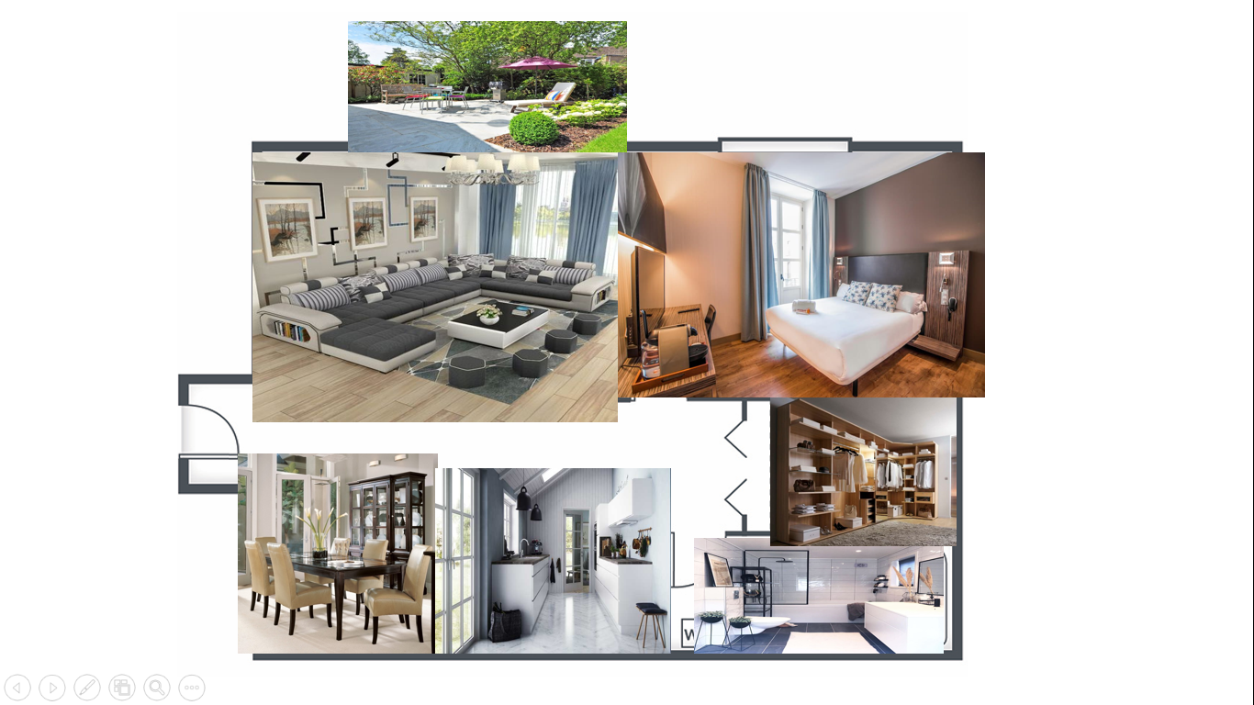

1. There´s a bed in the bedroom

2. There´s a t.v in the bedroom

3. There´s a window in the bedroom

4. There´s a pictures in the living room

5. There are no lamps in the living room

6. There´s a coffee table in the living room

7. There are not curtains in the bathroom

8. There´s a mirror in the bathroom

9. There are some chairs in the dining room

10. There´s a table in the dining room

11. There are some lamps in the kitchen

12. There´s a stove in the kitchen

13. There are some cupboards in the kitchen

14. There’s no rug in the patio

15. There are some pictures in the picture

**ACTIVITY 2**

Write questions for the following answers.

***Note:*** *Remember that the structure to build questions is the following.*

**Wh- word** (where/what/how) + **do/does** + **subject** + **verb** + complement?

Example:

1. A: ***Where*** *does your father work?*

B: My father? He works in a store.

1. **A: _What does he do?____________**

B: He is a salesperson.

1. **A: How does he like?____________**

B: He likes his job a lot.

1. **A: _What do you do?____________**

B: I’m an accountant.

1. **A: Where do you work?______**

B: I work in an office.

1. **A: How do you like it?__________**

B: It’s OK. I guess I like it.

**ACTIVITY 3**

Upload a **video or a voice recording** where you talk about the jobs in the pictures. Tell what they do, what they do exactly, where they work and give your opinion about each job using adjectives.

Example:

She is a teacher.

She **prepares** material for the class.

She **works** in a school.

**I think** she has a **difficult** job.



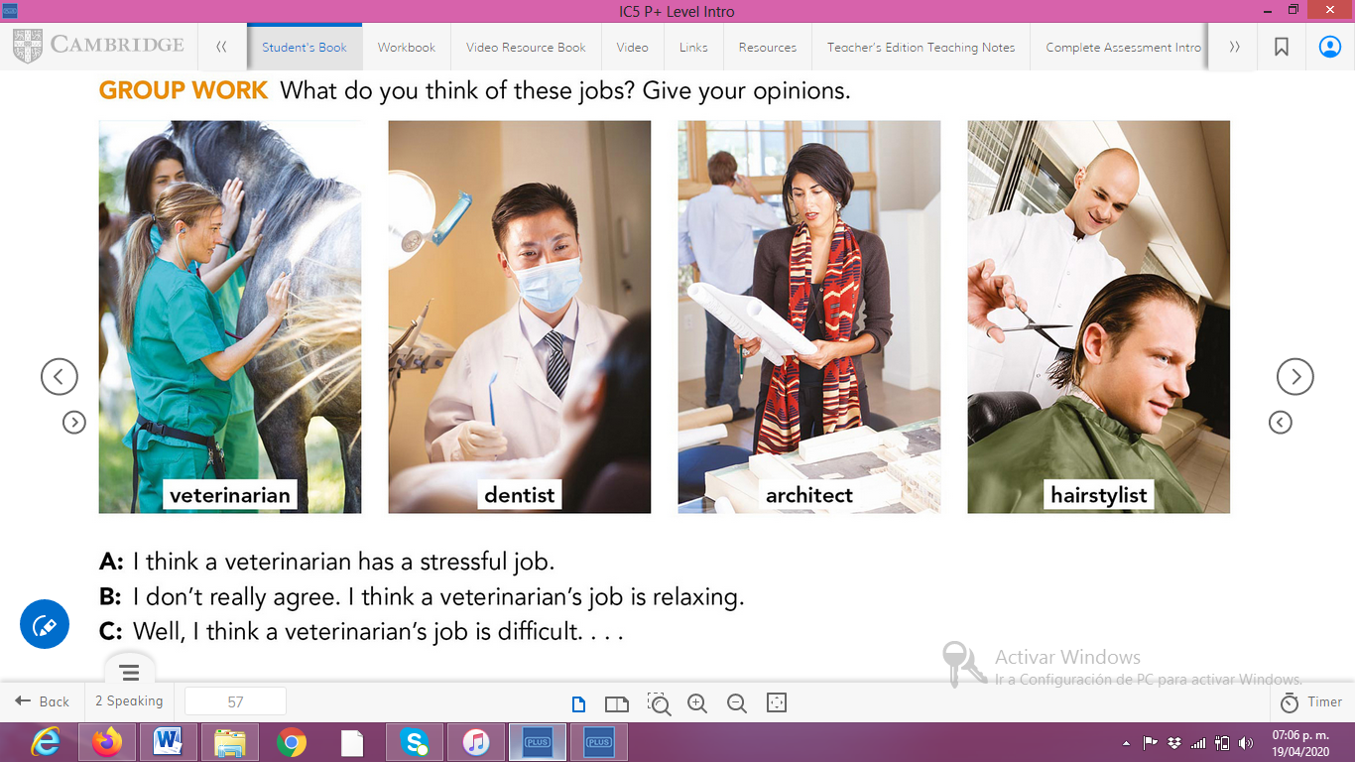

**ACTIVITY 4**

Complete your self-assessment. 