**ESCUELA NORMAL DE EDUCACIÓN PREESCOLAR**

**ENGLISH A1.2 DEVELOPING ELEMENTARY CONVERSATIONS**

**ONLINE ACTIVITIES - APRIL 20th**

**REVIEW UNITS 7 AND 8 – SELF ASSESSMENT**

**ACTIVITY 1**

Imagine you are moving to this apartment. What things are in the rooms?

1. Paste pictures inside each room.
2. Write **15 affirmative and negative sentences** describing what things are in the rooms of your apartment. Use *there is, there are, there is no, and there are no*.

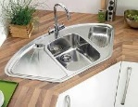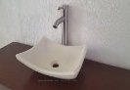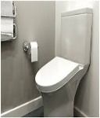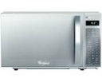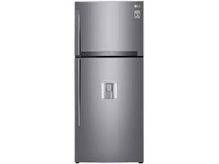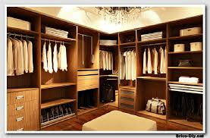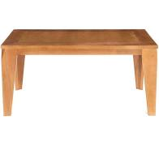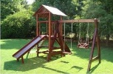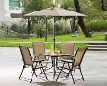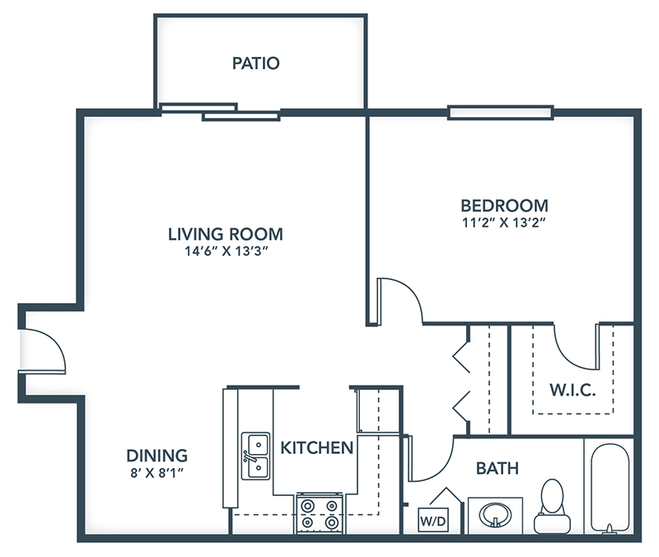

1. there are sofas in the living room

2. there are a rug in the bedroom, dining room and hall

3. there is not pool in the yard

4. there is window in the kitchen, bedroom and dining room

5. there are black mirror in the bedroom and bathroom

6. there is no black mirror in the W.I.C

7. there are curtains in the dining room

8. there are a lamps in the living room and bedroom

9. there is patio table

10. there is dresser in the bedroom

11. there are not two bedrooms

12.there are stairs in the living room

13. there are not curtains in the bedroom

14. there is one bathroom

15. there is not yard big

**ACTIVITY 2**

Write questions for the following answers.

***Note:*** *Remember that the structure to build questions is the following.*

**Wh- word** (where/what/how) + **do/does** + **subject** + **verb** + complement?

Example:

1. A: ***Where*** *does your father work?*

B: My father? He works in a store.

1. A: What does he work __________________________

B: He is a salesperson.

1. A: What does he like work?__________________________

B: He likes his job a lot.

1. A: What do you work? __________________________

B: I’m an accountant.

1. A: Where do you work?__________________________

B: I work in an office.

1. A: What do you like work?__________________________

B: It’s OK. I guess I like it.

**ACTIVITY 3**

Upload a **video or a voice recording** where you talk about the jobs in the pictures. Tell what they do, what they do exactly, where they work and give your opinion about each job using adjectives.

Example:

She is a teacher.

She **prepares** material for the class.

She **works** in a school.

**I think** she has a **difficult** job.



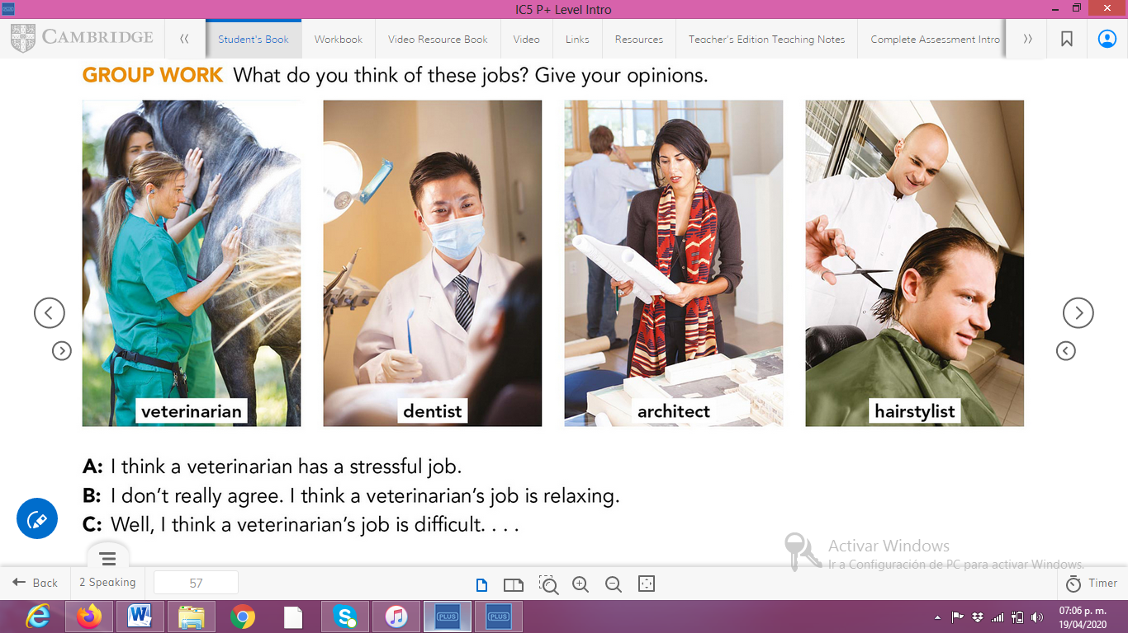

**ACTIVITY 4**

Complete your self-assessment.

