**ESCUELA NORMAL DE EDUCACIÓN PREESCOLAR**

**ENGLISH A1.2 DEVELOPING ELEMENTARY CONVERSATIONS**

**ONLINE ACTIVITIES - APRIL 20th**

**REVIEW UNITS 7 AND 8 – SELF ASSESSMENT**

**ACTIVITY 1**

Imagine you are moving to this apartment. What things are in the rooms?

1. Paste pictures inside each room.
2. Write **15 affirmative and negative sentences** describing what things are in the rooms of your apartment. Use *there is, there are, there is no, and there are no*.

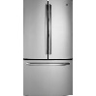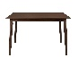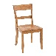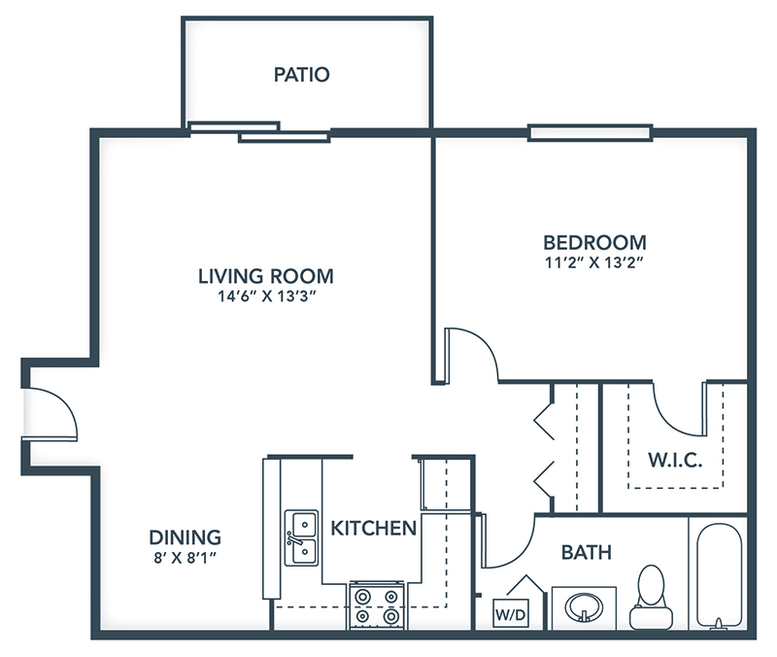

1. There are games in the patio

2. There is no sofa in the patio

3. There are chairs in the dining

4. There is table in the dining

5. There are no microwaves in the dining

6. There is big bed in the bedroom

7. There are lamps in the bedroom

8. There are not televisions in the bedroom

9. There is closer in the bedroom

10. There is sofa in the living room

11. There is TV in the living room

12. There are no refrigerator in the living room

13. There are refrigerator in the kitchen

14. There is mirror in the bathroom

15. There are curtains in the house

**ACTIVITY 2**

Write questions for the following answers.

***Note:*** *Remember that the structure to build questions is the following.*

**Wh- word** (where/what/how) + **do/does** + **subject** + **verb** + complement?

Example:

1. A: ***Where*** *does your father work?*

B: My father? He works in a store.

1. A: __What does he do? ______

B: He is a salesperson.

1. A: ___How does he like it? ______

B: He likes his job a lot.

1. A: __What do you do? _________

B: I’m an accountant.

1. A: _ where do you work? ______

B: I work in an office.

1. A: __How do you like it? __

B: It’s OK. I guess I like it.

**ACTIVITY 3**

Upload a **video or a voice recording** where you talk about the jobs in the pictures. Tell what they do, what they do exactly, where they work and give your opinion about each job using adjectives.

Example:

She is a teacher.

She **prepares** material for the class.

She **works** in a school.

**I think** she has a **difficult** job.



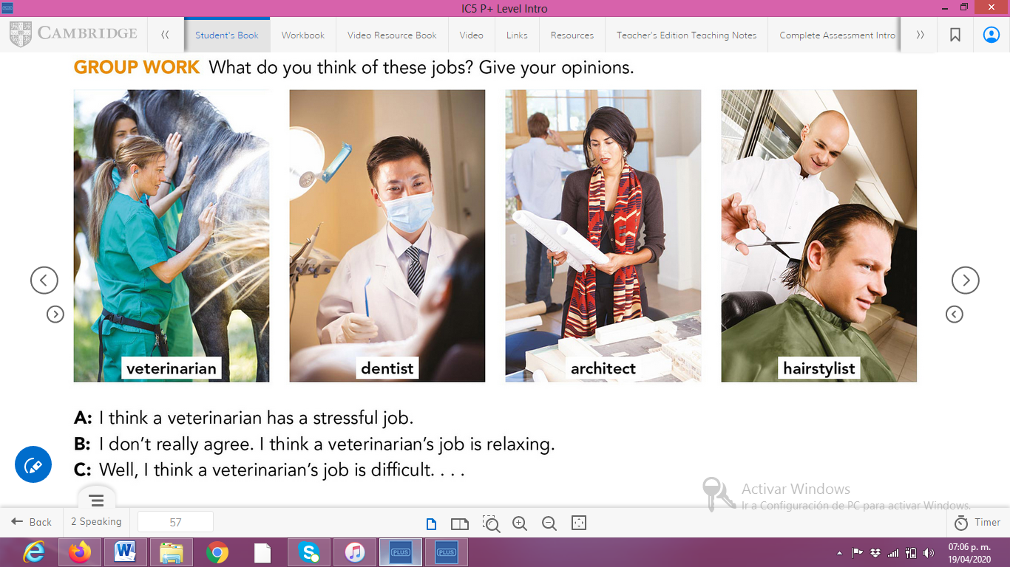

**ACTIVITY 4**

Complete your self-assessment.

