**ESCUELA NORMAL DE EDUCACIÓN PREESCOLAR**

**ENGLISH A1.2 DEVELOPING ELEMENTARY CONVERSATIONS**

**ONLINE ACTIVITIES - APRIL 20th**

**REVIEW UNITS 7 AND 8 – SELF ASSESSMENT**

**ACTIVITY 1**

Imagine you are moving to this apartment. What things are in the rooms?

1. Paste pictures inside each room.
2. Write **15 affirmative and negative sentences** describing what things are in the rooms of your apartment. Use *there is, there are, there is no, and there are no*.

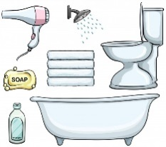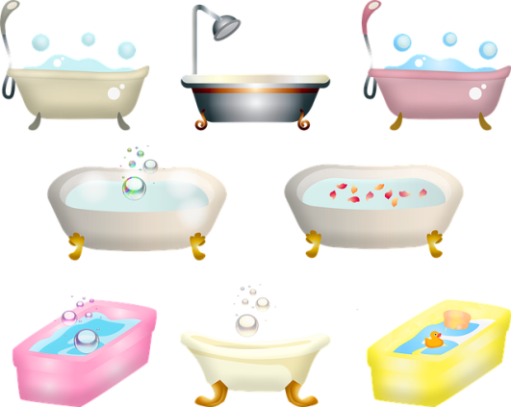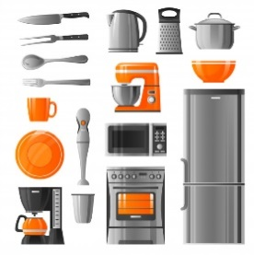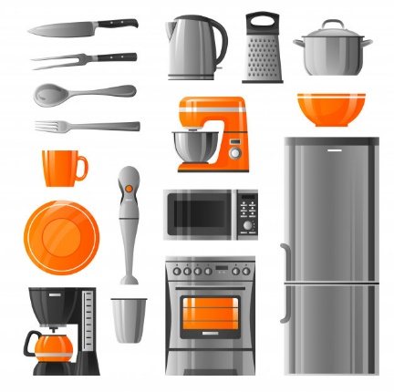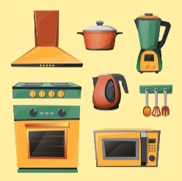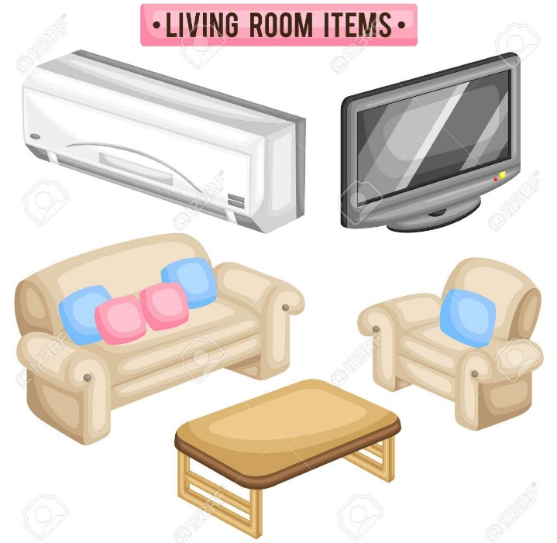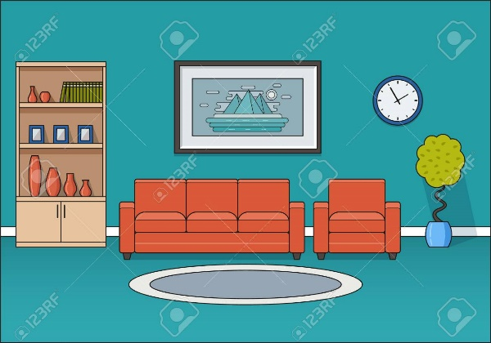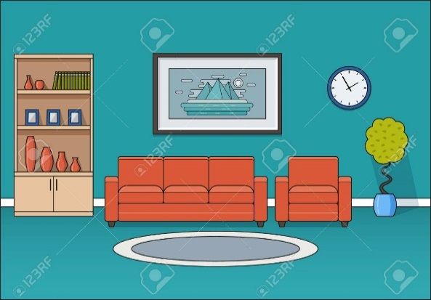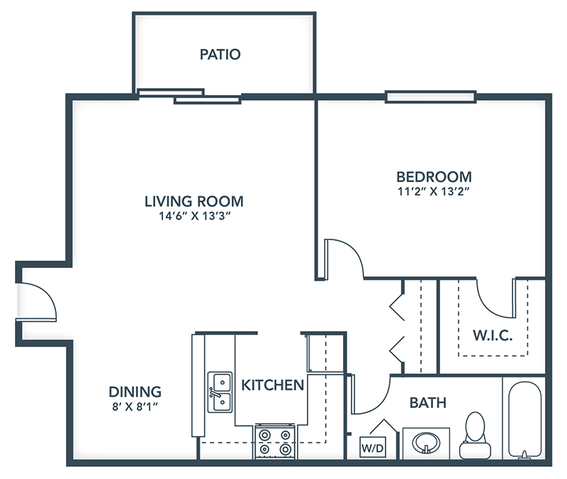

1. There´s no a rug in the floor.

2. There are some chairs in the dining room.

3. There´s a bed in the bedroom.

4. There´s a stove in the kitchen.

5. There´s no a cupboards in the kitchen.

6. There´s a mirror in the bedroom.

7. There´s a car in the garage.

8. There´s a dresser in the bedroom.

9. There´s an armchair in the living room.

10. There´s no a pictures in the living room.

11. There are no vase in the dining room.

12. There are some books in the bookcase.

13. There´s a coffee maker in the kitchen.

14. There´s a bathtub in the bathroom.

15. There´s a coffee table in the living room.

**ACTIVITY 2**

Write questions for the following answers.

***Note:*** *Remember that the structure to build questions is the following.*

**Wh- word** (where/what/how) + **do/does** + **subject** + **verb** + complement?

Example:

1. A: ***Where*** *does your father work?*

B: My father? He works in a store.

1. A: What does he work?

B: He is a salesperson.

1. A: How does he like it?

B: He likes his job a lot.

1. A: What do you do?

B: I’m an accountant.

1. A: Where do you work?

B: I work in an office.

1. A: How do you like it?

B: It’s OK. I guess I like it.

**ACTIVITY 3**

Upload a **video or a voice recording** where you talk about the jobs in the pictures. Tell what they do, what they do exactly, where they work and give your opinion about each job using adjectives.

Example:

She is a teacher.

She **prepares** material for the class.

She **works** in a school.

**I think** she has a **difficult** job.



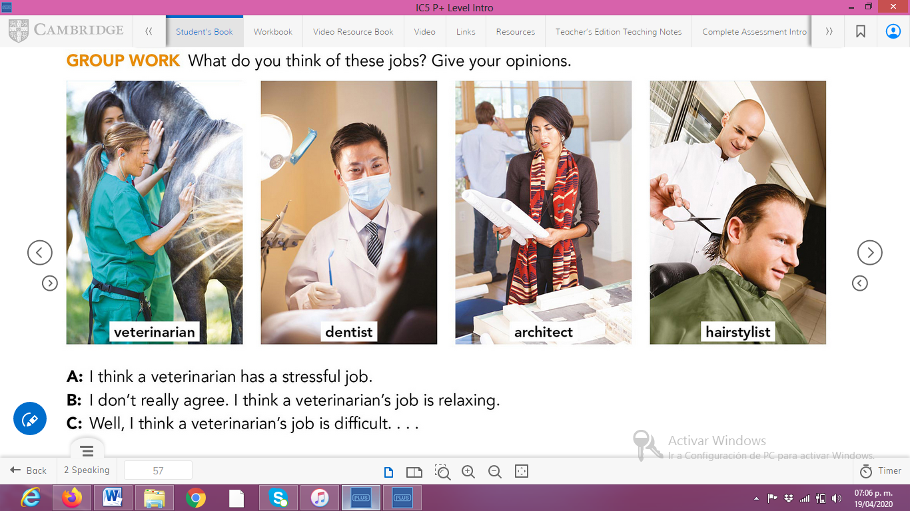

**ACTIVITY 4**

Complete your self-assessment.

