**ESCUELA NORMAL DE EDUCACIÓN PREESCOLAR**

**ENGLISH A1.2 DEVELOPING ELEMENTARY CONVERSATIONS**

**ONLINE ACTIVITIES - APRIL 21st**

**UNIT 9 – “I always have breakfast”**

**VOCABULARY**

**Hello dear students! During this unit we will learn and practice vocabulary and expressions related to the food. This unit is not included in your book, therefore all the activities will be done in your notebook and in documents uploaded to Escuela en Red.**

**ACTIVITY 1**

* Go to <https://www.youtube.com/watch?v=0KbA8pFW3tg> and watch the video “The Food Pyramid”.

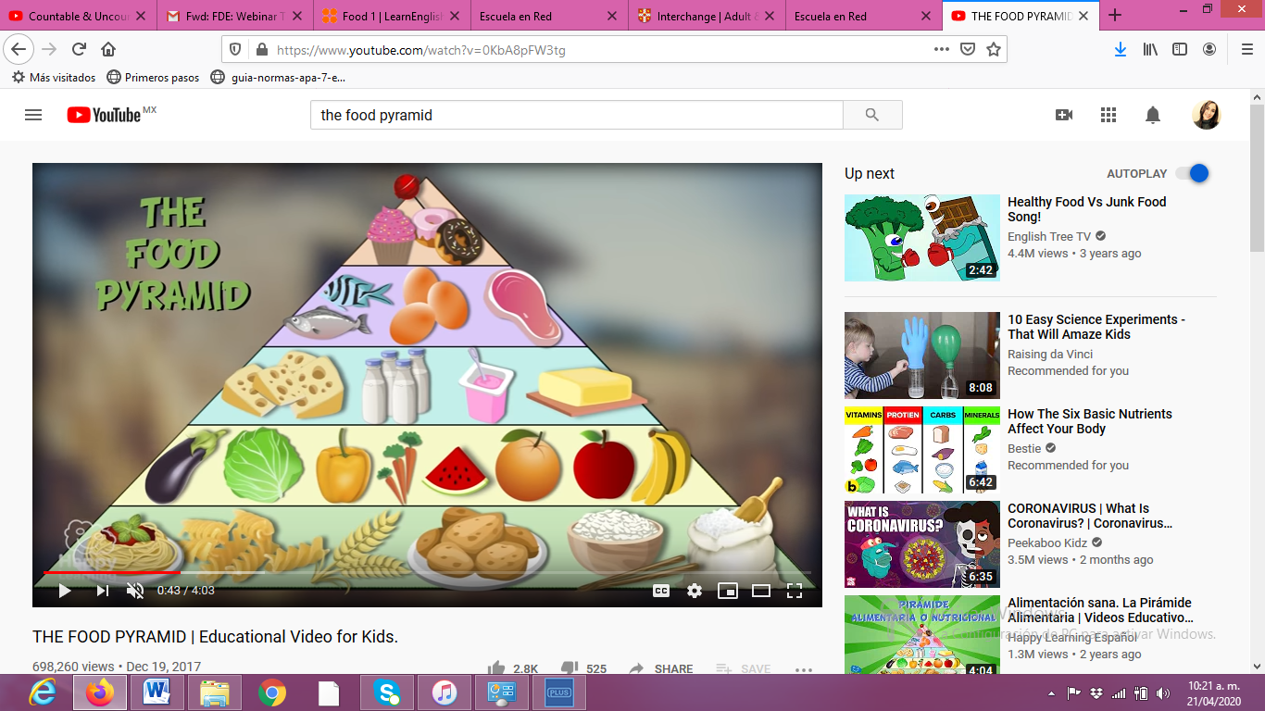

* **Match the food groups** with their description.

|  |  |  |  |
| --- | --- | --- | --- |
| **1** | Fruits and vegetables | 3 | These are the favorite of the children. They are delicious but they have a lot of calories. They are bad for our health. |
| **2** | Proteins | 5 | This group includes milk, yogurt and cheese. |
| **3** | Sweets and fats | 1 | They have a lot of vitamins and minerals. We must eat them 5 times a day. |
| **4** | Carbohydrates | 2 | This group is formed by meat, egg and fish. |
| **5** | Dairy | 4 | This group includes bread, cereals, pasta and potatoes. You must eat them daily. |

**ACTIVITY 2**

* Look at the picture and read the words.

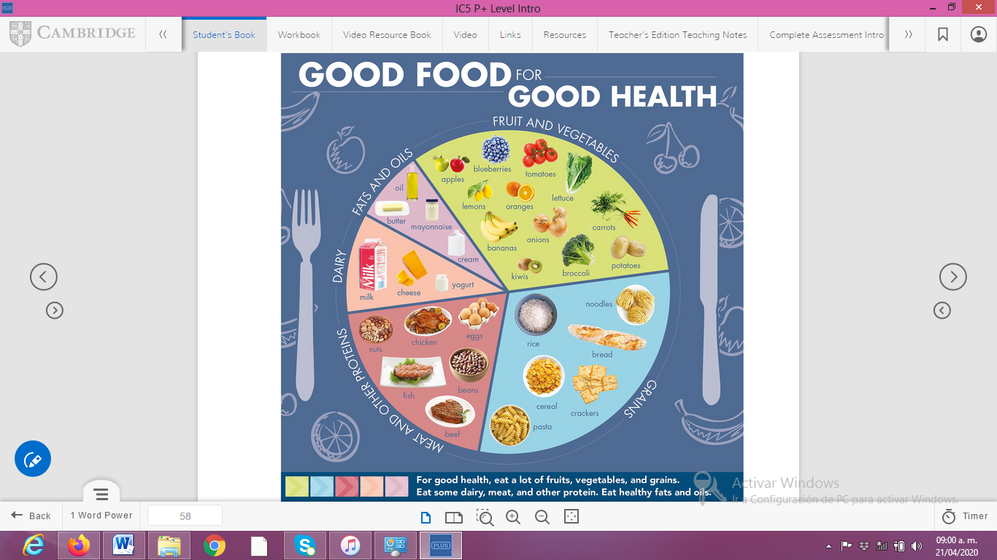

* **Practice the pronunciation** of words and study them (pueden encontrar el archivo de audio para la escuchar la pronunciación de las palabras en Escuela en Red).
* Copy the vocabulary in your notebook and **paste a picture here**.

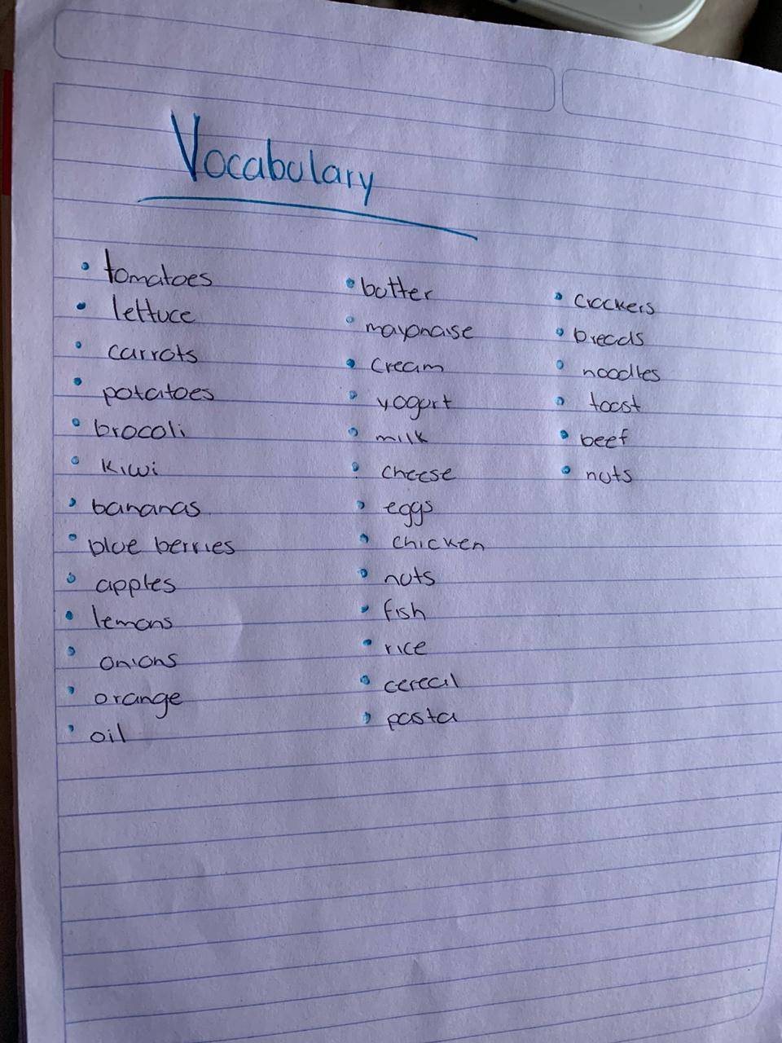

**ACTIVITY 3**

* Go to the following links and play the games. Listen and practice the pronunciation of each word.
  + <https://learnenglishkids.britishcouncil.org/word-games/food-1>
  + <https://learnenglishkids.britishcouncil.org/word-games/food-2>
* 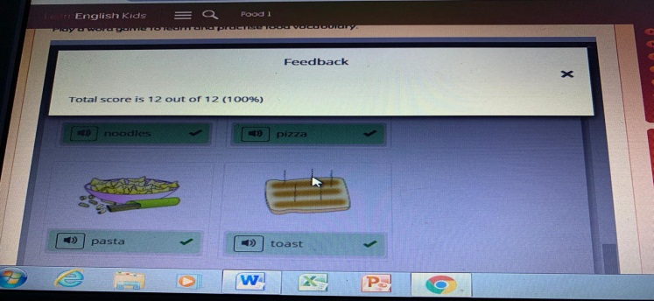**Include a screenshot** of your work in this part.

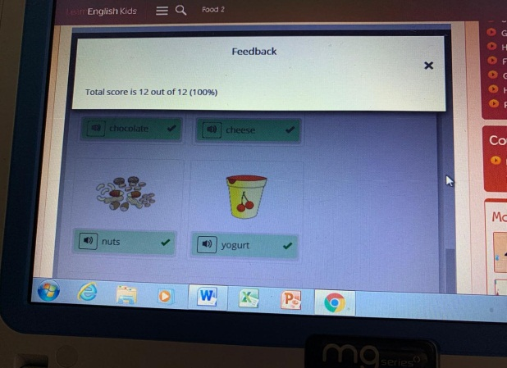

**ACTIVITY 4**

Go to your refrigerator and to your food cupboard and **write ten food items** you can see there. If the word is not in the vocabulary you can use a dictionary.

Link for Spanish-English dictionary: <https://dictionary.cambridge.org/us/dictionary/english-spanish/>

|  |  |
| --- | --- |
| **FOOD IN MY KITCHEN** | |
| 1.carrots | 6.watermelon |
| 2.potatos | 7.milk |
| 3.tomatoes | 8.pasta |
| 4.onion | 9.sandwich |
| 5.pineapple | 10.banana |

**ACTIVITY 5**

Make a list of the food you like and the food you don’t like. If you don’t know the word in English you can always use a Spanish-English dictionary.

|  |  |
| --- | --- |
| Like Emoji - Smiley Face Thumbs Up Transparent PNG - 800x765 ... **I like…** | Library of don like image freeuse png files ▻▻▻ Clipart Art 2019 **I don’t like…** |
| watermelon | tomatoes |
| carrots | onion |
| cucumber | cheese |
| lettuce | sweets |
| Pine apple | yogurt |