**ESCUELA NORMAL DE EDUCACIÓN PREESCOLAR**

**ENGLISH A1.2 DEVELOPING ELEMENTARY CONVERSATIONS**

**ONLINE ACTIVITIES - APRIL 20th**

**REVIEW UNITS 7 AND 8 – SELF ASSESSMENT**

**ACTIVITY 1**

Imagine you are moving to this apartment. What things are in the rooms?

1. Paste pictures inside each room.
2. 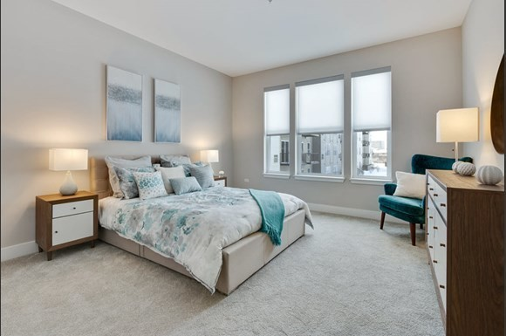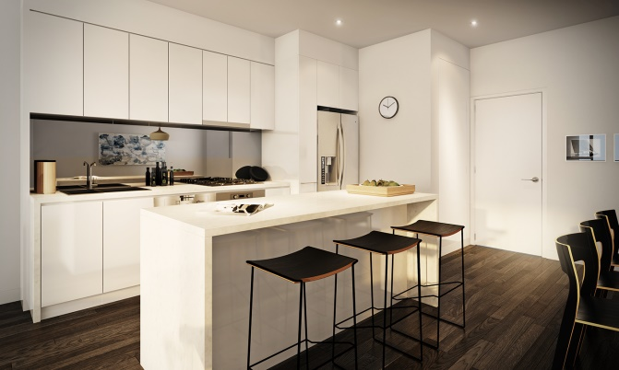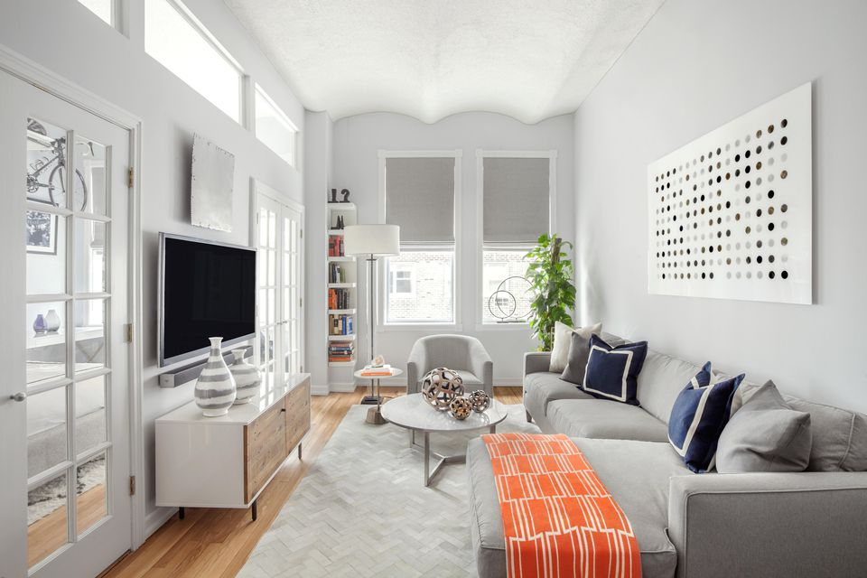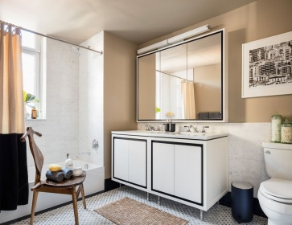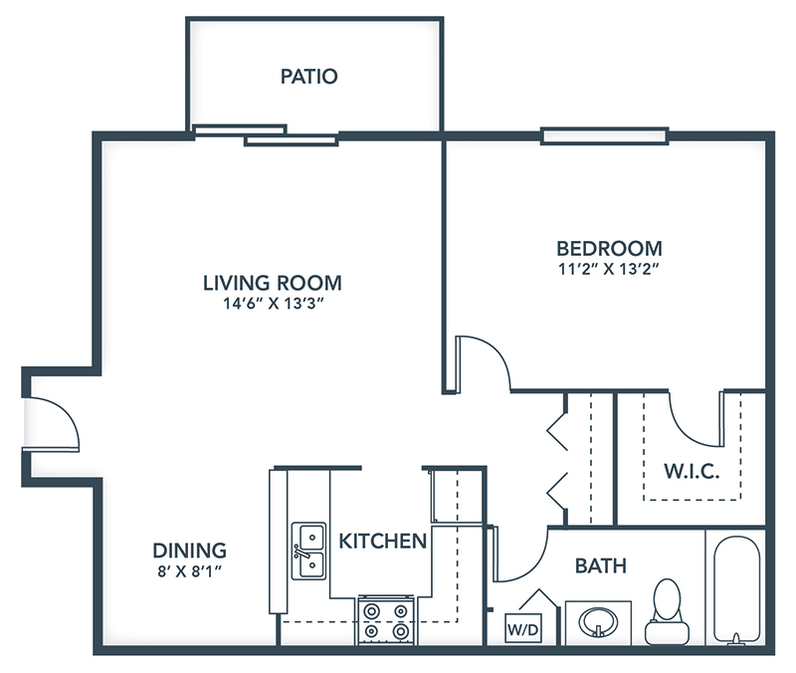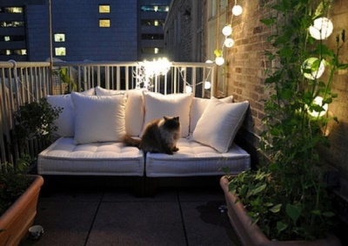Write **15 affirmative and negative sentences** describing what things are in the rooms of your apartment. Use *there is, there are, there is no, and there are no*.

1. There are some banks in the dining

2. There´s a armchair in the bedroom

3. There are two plants in the patio

4. There´s no a microwave in the kitchen

5. There´s a picture in the bathroom

6. There are some lamps in the bedroom

7. There are no courtains in the bedroom

8. There are books in the bookcase

9. There´s a tv in the living room

10. There´s sofa in the patio

11. There´s a rug in the living room

12. There´s no a coffee maker

13. There are two windows in the living room

14. There´s no a desk in the bedroom

15. There are some pictures in the living room

**ACTIVITY 2**

Write questions for the following answers.

***Note:*** *Remember that the structure to build questions is the following.*

**Wh- word** (where/what/how) + **do/does** + **subject** + **verb** + complement?

Example:

1. A: ***Where*** *does your father work?*

B: My father? He works in a store.

1. A: What does your father do? ___

B: He is a salesperson.

1. A: What´s his job like’___

B: He likes his job a lot.

1. A: _What do you do? _________

B: I’m an accountant.

1. A: __Where do you work?___

B: I work in an office.

1. A: What´s your job like? ___

B: It’s OK. I guess I like it.

**ACTIVITY 3**

Upload a **video or a voice recording** where you talk about the jobs in the pictures. Tell what they do, what they do exactly, where they work and give your opinion about each job using adjectives.

Example:

She is a teacher.

She **prepares** material for the class.

She **works** in a school.

**I think** she has a **difficult** job.



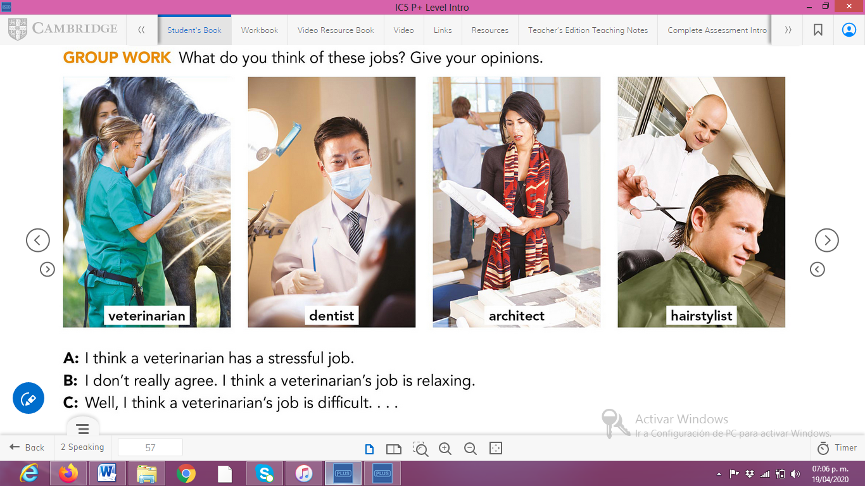

**ACTIVITY 4**

Complete your self-assessment.

