**ESCUELA NORMAL DE EDUCACIÓN PREESCOLAR**

**ENGLISH A1.2 DEVELOPING ELEMENTARY CONVERSATIONS**

**ONLINE ACTIVITIES - APRIL 20th**

***Norma Janette Zarate Agundis***

**REVIEW UNITS 7 AND 8 – SELF ASSESSMENT**

**ACTIVITY 1**

Imagine you are moving to this apartment. What things are in the rooms?

1. Paste pictures inside each room.
2. Write **15 affirmative and negative sentences** describing what things are in the rooms of your apartment. Use *there is, there are, there is no, and there are no*.

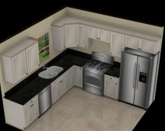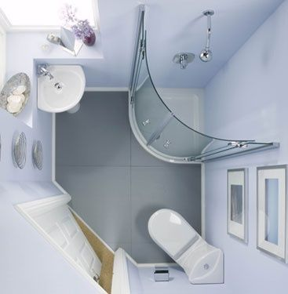 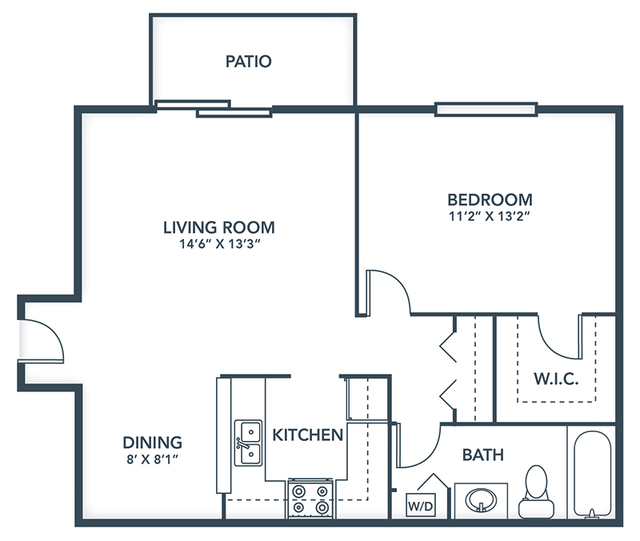

1. There are four chairs in the dining room

2. There is a refrigerator in the kitchen

3. There is a piano in the living room

4. There is no bookcase in the living room

5. There is a mirror in the bathroom

6. There is no a TV in the bedroom

7. There are some plants in the yard

8. There are no chairs in the kitchen

9. There is a computer in the living room

10. There are two sofas in the living room

11. There are cupboards in the kitchen

12. There is a toilet in the bathroom

13. There are two lamps in the bedroom

14. There is no dresser in the bedroom

15. There is no microwave in the kitchen

**ACTIVITY 2**

Write questions for the following answers.

***Note:*** *Remember that the structure to build questions is the following.*

**Wh- word** (where/what/how) + **do/does** + **subject** + **verb** + complement?

Example:

1. A: ***Where*** *does your father work?*

B: My father? He works in a store.

1. A: ***What does he do?***

B: He is a salesperson.

1. A: ***How does he like it?***

B: He likes his job a lot.

1. A: ***What do you do?***

B: I’m an accountant.

1. A: ***Where do you work?***

B: I work in an office.

1. A: ***How do you like it?***

B: It’s OK. I guess I like it.

**ACTIVITY 3**

Upload a **video or a voice recording** where you talk about the jobs in the pictures. Tell what they do, what they do exactly, where they work and give your opinion about each job using adjectives.

Example:

She is a teacher.

She **prepares** material for the class.

She **works** in a school.

**I think** she has a **difficult** job.



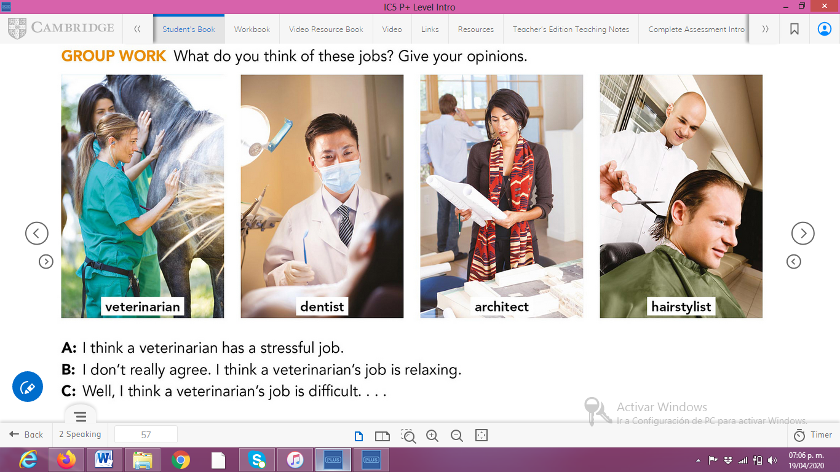

**ACTIVITY 4**

Complete your self-assessment.

