**ESCUELA NORMAL DE EDUCACIÓN PREESCOLAR**

**ENGLISH A1.2 DEVELOPING ELEMENTARY CONVERSATIONS**

**ONLINE ACTIVITIES - APRIL 20th**

**REVIEW UNITS 7 AND 8 – SELF ASSESSMENT**

**ACTIVITY 1**

Imagine you are moving to this apartment. What things are in the rooms?

1. Paste pictures inside each room.
2. Write **15 affirmative and negative sentences** describing what things are in the rooms of your apartment. Use *there is, there are, there is no, and there are no*.

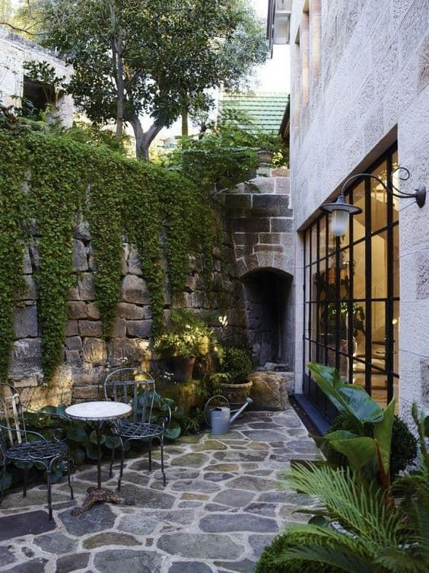 Patio 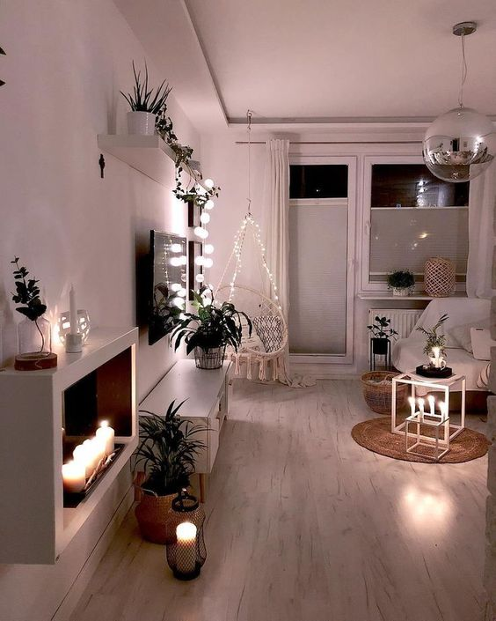Living room

Bedroom  Diningroom 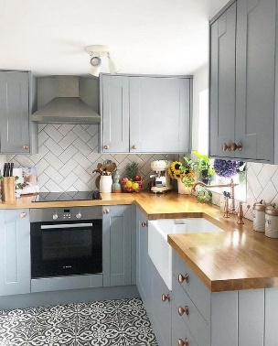Kitchen

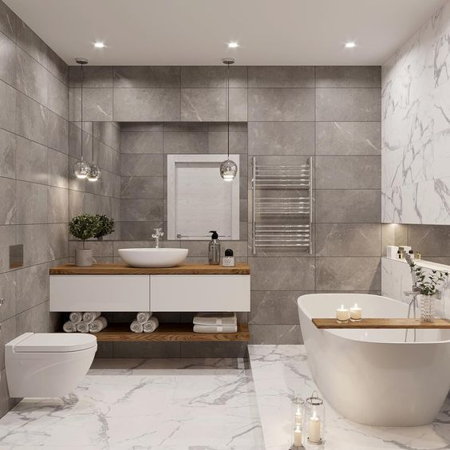 Bath 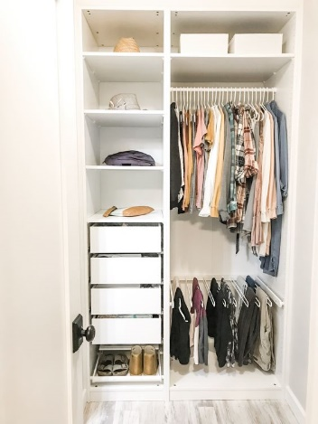 WIC

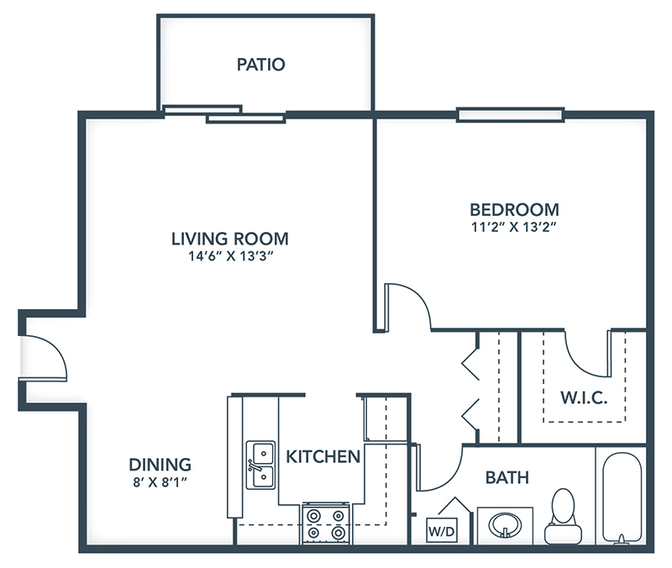

1.There is a lamp in my bedroom

2.There are some windows in the apartment

3.There are not second flour in the apartment

4.There is only one room in the apartment

5.There is not much space in the dining room

6.There is a big plant in the garden

7.There are 5 chair, 3 table and 2 mirrors inside the apartment

8.There are not laundry room in the house

9.There is a stove in the kitchen

10.There are many books in the bookcase

11.There not chairs in the bath

12.There is not a good view of the neighbrhood

13.There is not enough rooms

14. There are not space for children

15.There is a large space for the armchairs

**ACTIVITY 2**

Write questions for the following answers.

***Note:*** *Remember that the structure to build questions is the following.*

**Wh- word** (where/what/how) + **do/does** + **subject** + **verb** + complement?

Example:

1. A: ***Where*** *does your father work?*

B: My father? He works in a store.

1. A: Where does he work?

B: He is a salesperson.

1. A: How does he like his job?

B: He likes his job a lot.

1. A: What do you do?

B: I’m an accountant.

1. A: Where do you work?

B: I work in an office.

1. A: How do you like his job?

B: It’s OK. I guess I like it.

**ACTIVITY 3**

Upload a **video or a voice recording** where you talk about the jobs in the pictures. Tell what they do, what they do exactly, where they work and give your opinion about each job using adjectives.

Example:

She is a teacher.

She **prepares** material for the class.

She **works** in a school.

**I think** she has a **difficult** job.



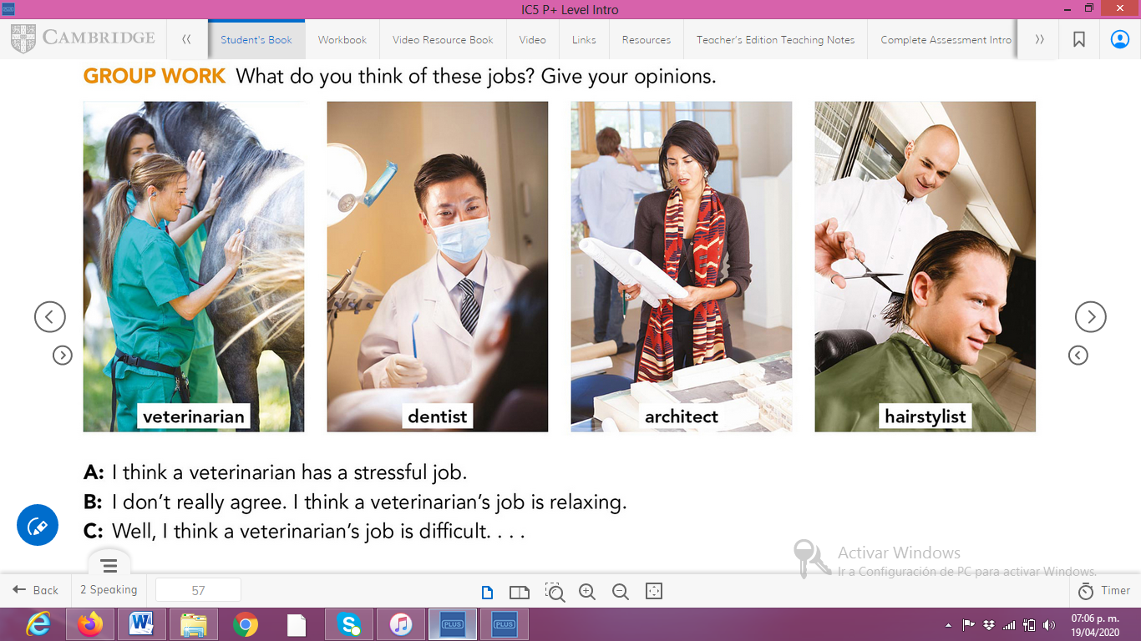

**ACTIVITY 4**

Complete your self-assessment.

