**ESCUELA NORMAL DE EDUCACIÓN PREESCOLAR**

**ENGLISH A1.2 DEVELOPING ELEMENTARY CONVERSATIONS**

**ONLINE ACTIVITIES - APRIL 20th**

**REVIEW UNITS 7 AND 8 – SELF ASSESSMENT**

**ACTIVITY 1**

Imagine you are moving to this apartment. What things are in the rooms?

1. Paste pictures inside each room.
2. Write **15 affirmative and negative sentences** describing what things are in the rooms of your apartment. Use *there is, there are, there is no, and there are no*.

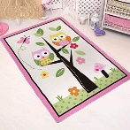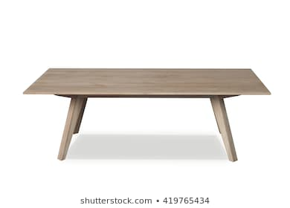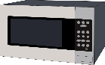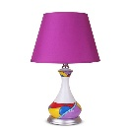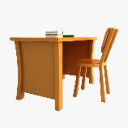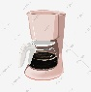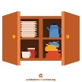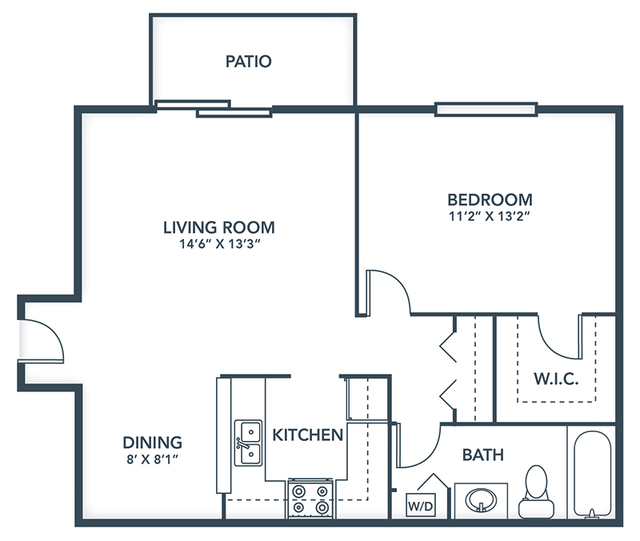

1. There is a bed in the bedroom

2. There are pictures in the living room.

3. There are no chairs in the kitchen.

4. There is no a mirror in the patio.

5. There is a refrigerator in the kitchen.

6. There are not curtains in the bathroom.

7. There is cupboards in the kitchen.

8. There is a sofa in the living room.

9.There is a lamps in the bedroom.

10. There is not a rug in the bedroom.

11. There is a table in the dining room.

12. There is a coffee maker in the kitchen.

13. There is no a desk in the kitchen.

14. There is no a microware in the dining room.

15. There is a coffee table in the living room.

**ACTIVITY 2**

Write questions for the following answers.

***Note:*** *Remember that the structure to build questions is the following.*

**Wh- word** (where/what/how) + **do/does** + **subject** + **verb** + complement?

Example:

1. A: ***Where*** *does your father work?*

B: My father? He works in a store.

1. A: What does he do?

B: He is a salesperson.

1. A: What is his like?

B: He likes his job a lot.

1. A: What do you do?

B: I’m an accountant.

1. A: Where do you work?

B: I work in an office.

1. A: What is your job like?

B: It’s OK. I guess I like it.

**ACTIVITY 3**

Upload a **video or a voice recording** where you talk about the jobs in the pictures. Tell what they do, what they do exactly, where they work and give your opinion about each job using adjectives.

Example:

She is a teacher.

She **prepares** material for the class.

She **works** in a school.

**I think** she has a **difficult** job.



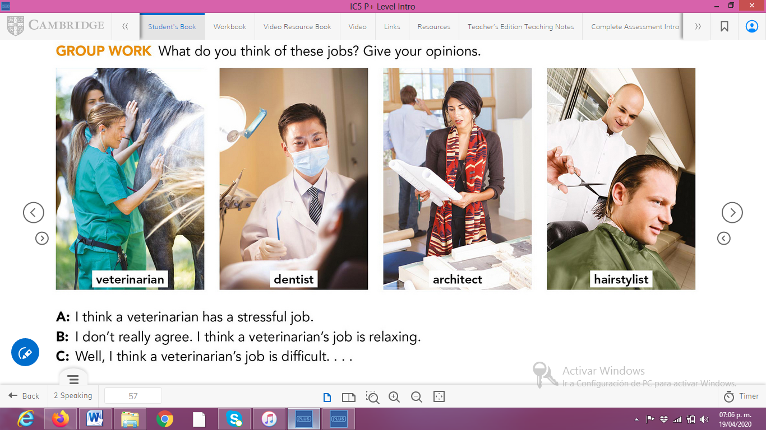

**ACTIVITY 4**

Complete your self-assessment.

