**ESCUELA NORMAL DE EDUCACIÓN PREESCOLAR**

**ENGLISH A1.2 DEVELOPING ELEMENTARY CONVERSATIONS**

**ONLINE ACTIVITIES - APRIL 20th**

**REVIEW UNITS 7 AND 8 – SELF ASSESSMENT**

**SOFIA ABISAI GARCIA MURILLO**

**ACTIVITY 1**

1. Write **15 affirmative and negative sentences** describing what things are in the rooms of your apartment. Use *there is, there are, there is no, and there are no*.

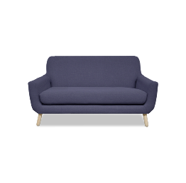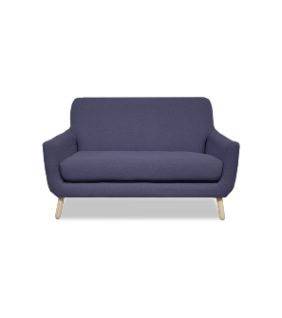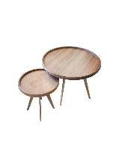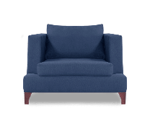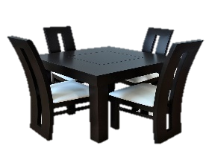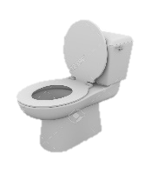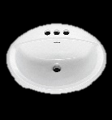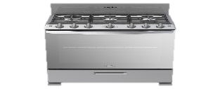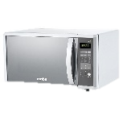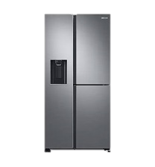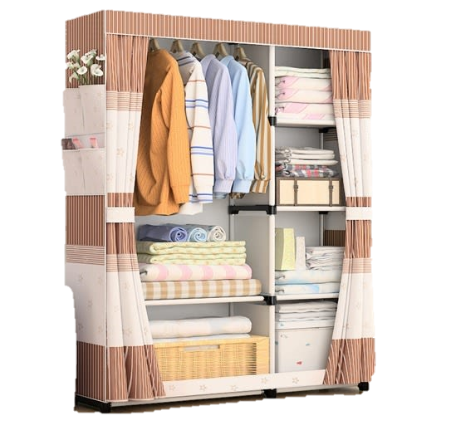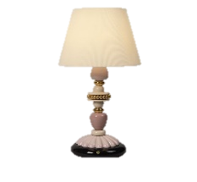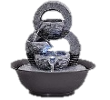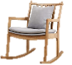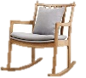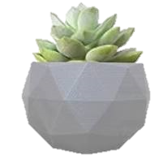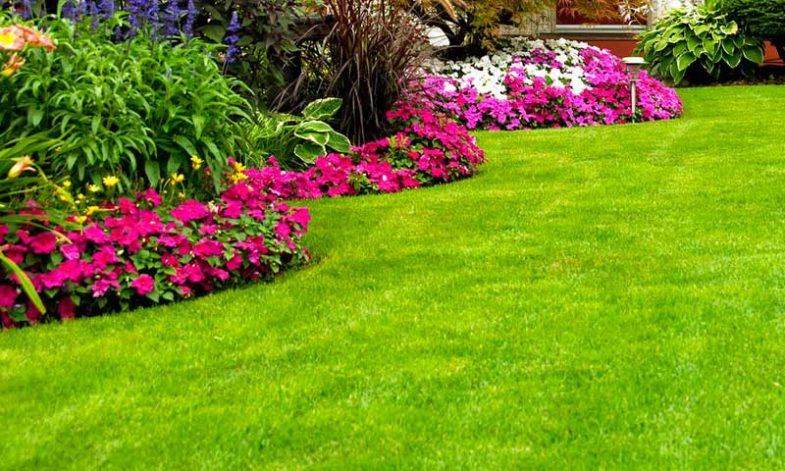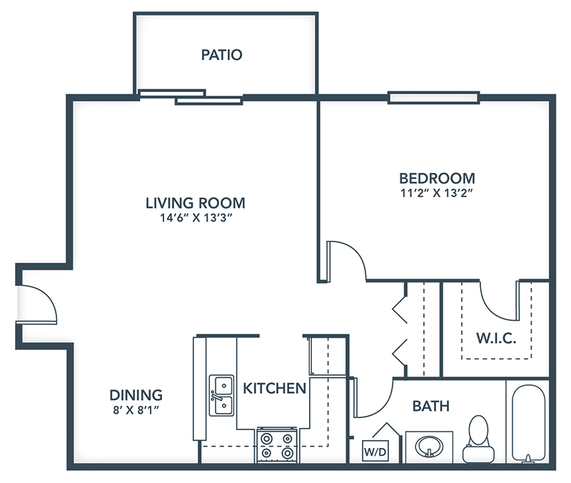

1. There is a lamp in the bedroom

2. There is no lamp in the bathroom

3. There are a chairs in the garden

4. There is a refrigerator in the kitchen

5. There isn´t a clock in the living room

6. There are two sofa in the living room

7. There are a chairs in the dining room

8. There is an armchair in the living room

9. There aren´t a chairs in the kitchen

10. There is a microwave in the kitchen

11. There is a stove in the kitchen

12. There is a rug in the dining room

13. There is a rug in the bedroom

14. There is a mirror in the bathroom

15. There is a bed in the bedroom

**ACTIVITY 2**

Write questions for the following answers.

***Note:*** *Remember that the structure to build questions is the following.*

**Wh- word** (where/what/how) + **do/does** + **subject** + **verb** + complement?

Example:

1. A: ***Where*** *does your father work?*

B: My father? He works in a store.

1. A: **What** does he do?

B: He is a salesperson.

1. A: **How** does he like work?

B: He likes his job a lot.

1. A: **What** do you do?

B: I’m an accountant.

1. A: **Where** do you work?

B: I work in an office.

1. A: **How** do you like it?

B: It’s OK. I guess I like it.

**ACTIVITY 4**

Complete your self-assessment.

