**ESCUELA NORMAL DE EDUCACIÓN PREESCOLAR**

**ENGLISH A1.2 DEVELOPING ELEMENTARY CONVERSATIONS**

**ONLINE ACTIVITIES - APRIL 20th**

**REVIEW UNITS 7 AND 8 – SELF ASSESSMENT**

**Student: Sandra Gpe Flores Alvizo**

**ACTIVITY 1**

Imagine you are moving to this apartment. What things are in the rooms?

1. Paste pictures inside each room.
2. Write **15 affirmative and negative sentences** describing what things are in the rooms of your apartment. Use *there is, there are, there is no, and there are no*.

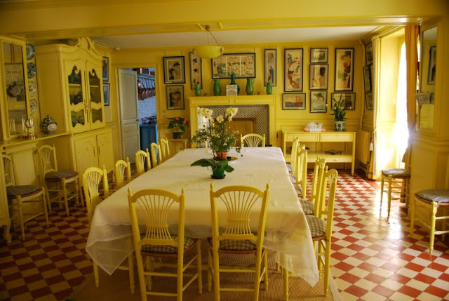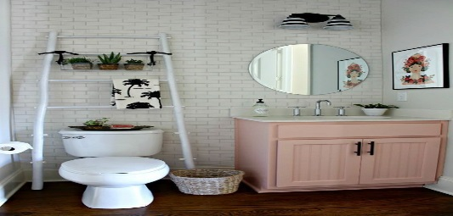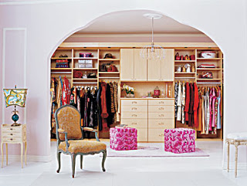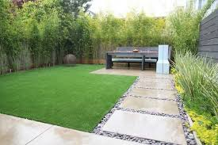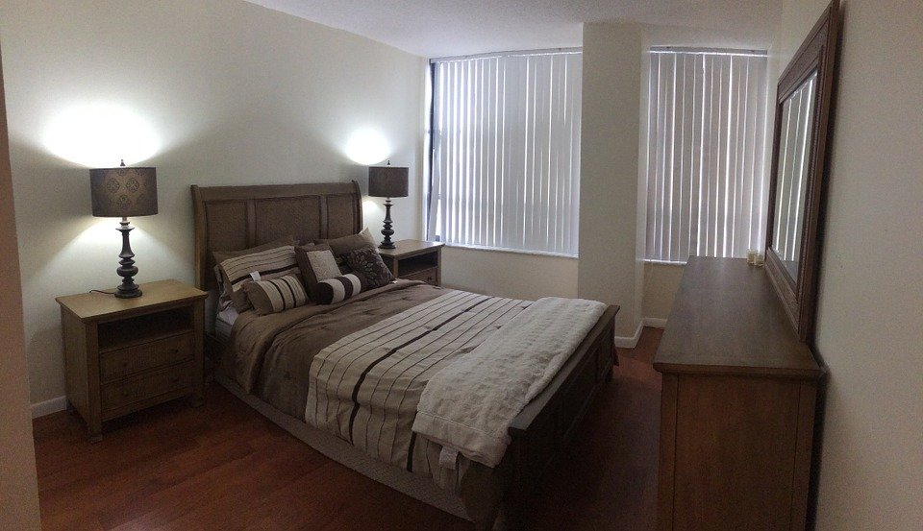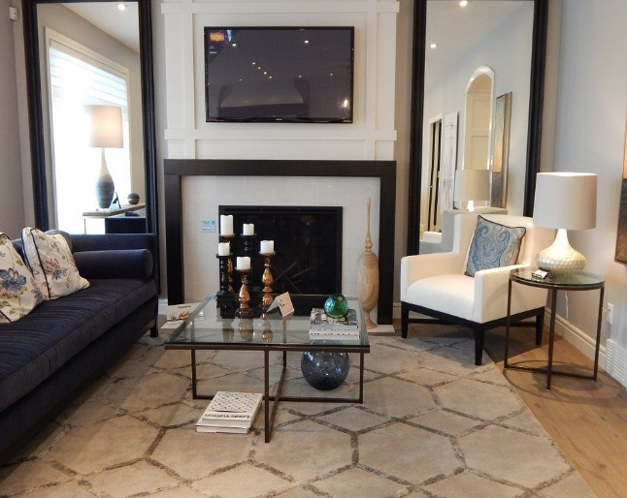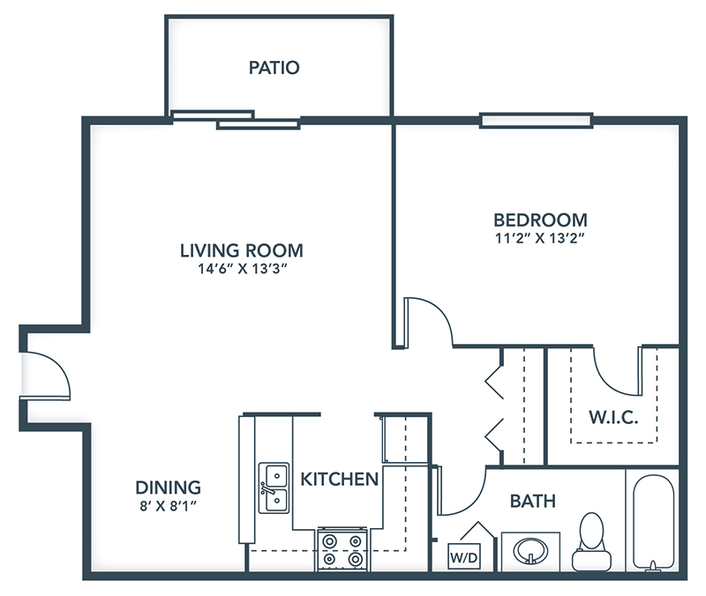

1. THERE IS A TELEVISION IN THE ROOM

2. THERE IS NO CARPET IN LIVING ROOM

3. THERE IS A SOFA

4. THERE IS NO SOURCE IN THE YARD

5. THERE IS A TABLE WITH 6 CHAIRS WITH A NICE VASE IN THE KITCHEN

6. IN THE ROOM THERE IS A TABLE AND AN ARMCHAIR

7. IN THE ROOM THERE IS A FIREPLACE UNDER WHERE THE T.V

8. THERE IS A NICE GARDEN WITH MANY PLANTS

9. IN THE DINING ROOM THERE IS A SHOWCASE

10. THERE ARE TWO LAMPS IN THE ROOM

11. IN THE BATHROOM THERE IS A SHELF FOR DECORATIONS

12. THERE IS A WHOLE GREEN KITCHEN

13. IN THE BEDROOM THERE ARE TWO BUROS AND TWO LAMPS

14. IN THE BATHROOM THERE IS A TOILET

15. THERE IS A PINK CLOSET WITH TWO BENCHES

**ACTIVITY 2**

Write questions for the following answers.

***Note:*** *Remember that the structure to build questions is the following.*

**Wh- word** (where/what/how) + **do/does** + **subject** + **verb** + complement?

Example:

1. A: ***Where*** *does your father work?*

B: My father? He works in a store.

1. A: *What does your father do?*

B: He is a salesperson.

1. A: *How does he like***?**

B: He likes his job a lot.

1. A: What do you do?

B: I’m an accountant.

1. A: *Where do you work?*

B: I work in an office.

1. A: *How do you like?*

B: It’s OK. I guess I like it.

**ACTIVITY 3**

Upload a **video or a voice recording** where you talk about the jobs in the pictures. Tell what they do, what they do exactly, where they work and give your opinion about each job using adjectives.

Example:

She is a teacher.

She **prepares** material for the class.

She **works** in a school.

**I think** she has a **difficult** job.



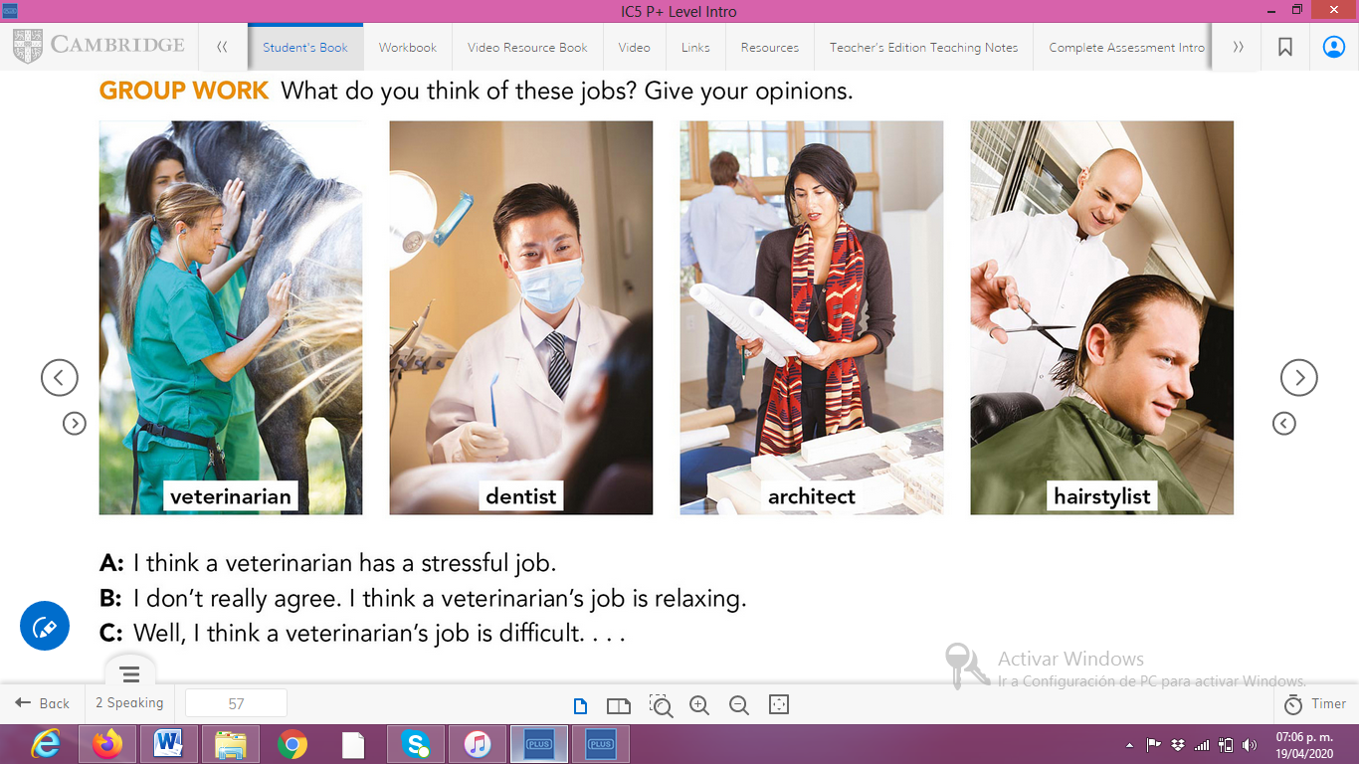

**ACTIVITY 4**

Complete your self-assessment.

