THESE ARE THE PAGES YOU NEED TO COMPLETE.

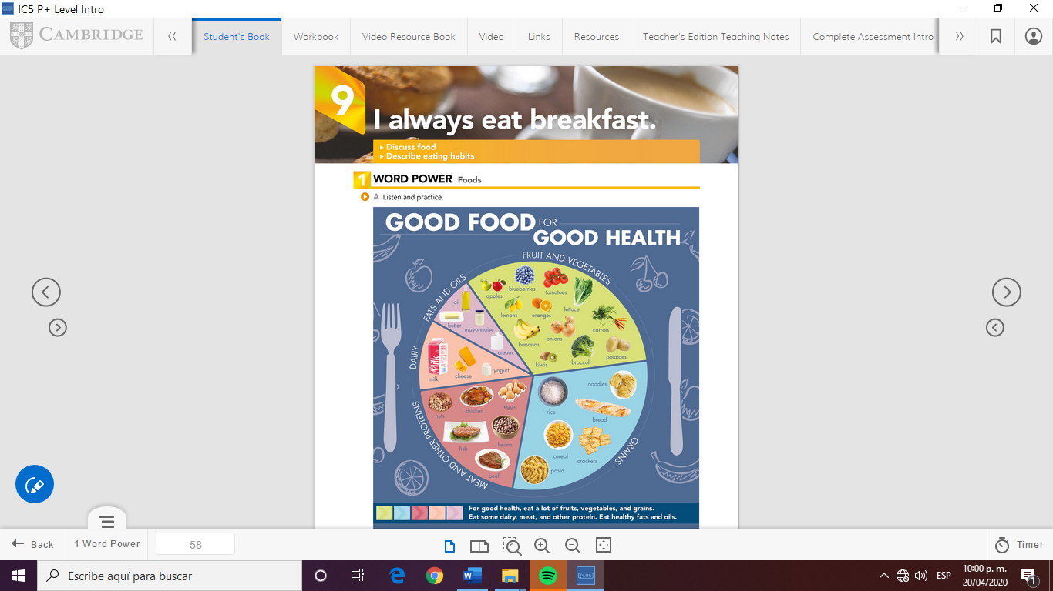

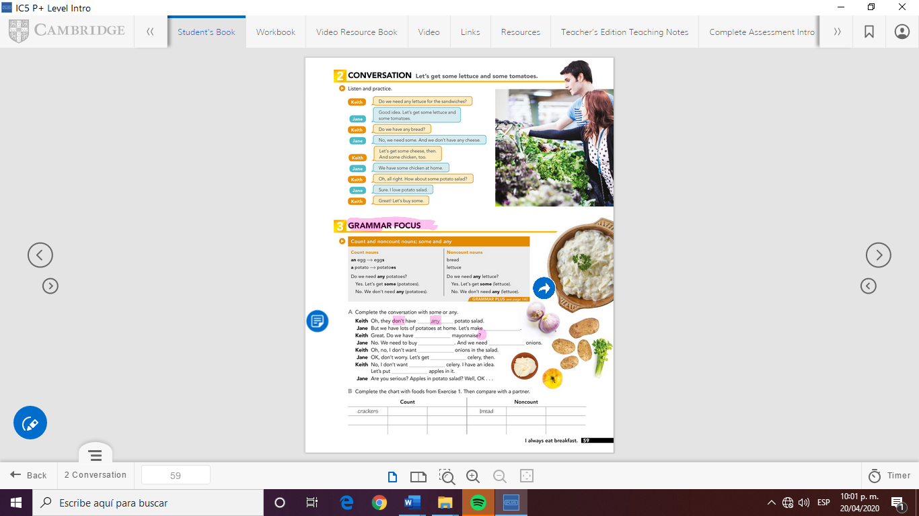

**Walnuts**

**Strawberrys**

**pumkins**

**brownies**

**Salads**

**Cherrys**

**Chips**

**Soup**

**flour**

**Sugar**

**Rice**

**Bisquet**

**Salt**

**Milk**

**Cake**

**cookies**

**Any**

**Any**

**Any**

**Some**

**Any**

**any**

**Some**

**Some**

GRAMMAR FOCUS

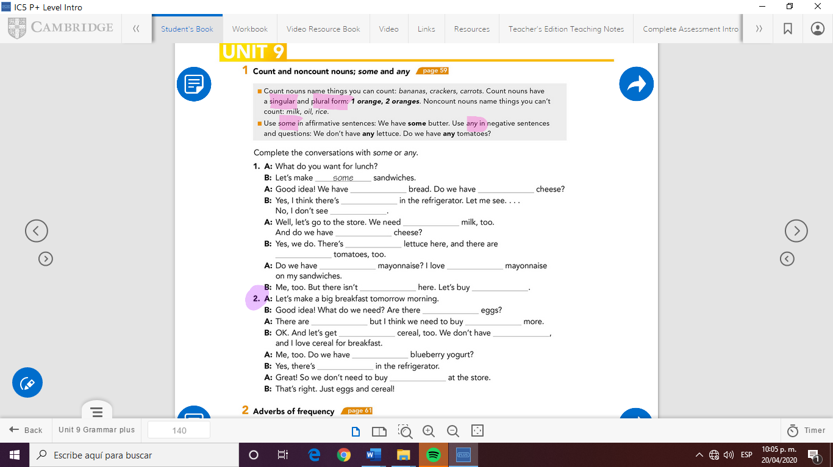

some

any

any

some

any

some

any

some

any

some

some

any

some

some

any

some

any

some

any

some



Check your answers here:

<https://drive.google.com/open?id=1tAdUNvs29Gw88jv3MEnq2BzbMMsPabRa>