MY ANSWERS ARE BELOW

DANNA SOPHIA RANGEL IBARRA

THESE ARE THE PAGES YOU NEED TO COMPLETE.

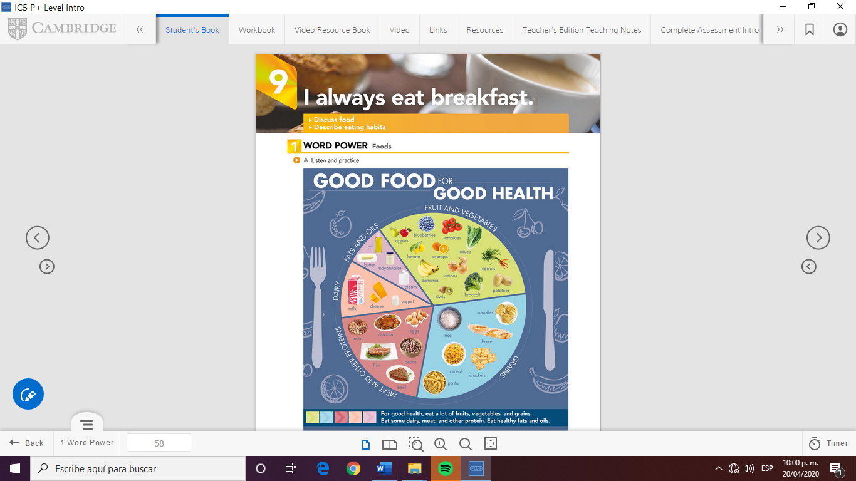

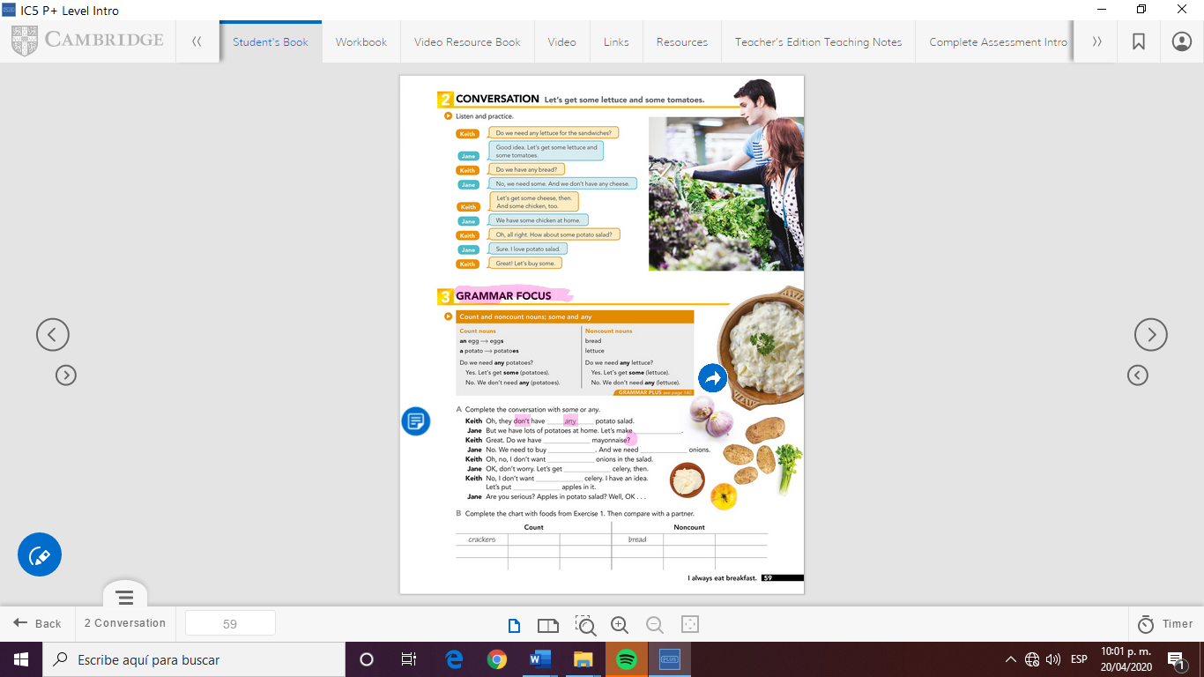

GRAMMAR FOCUS

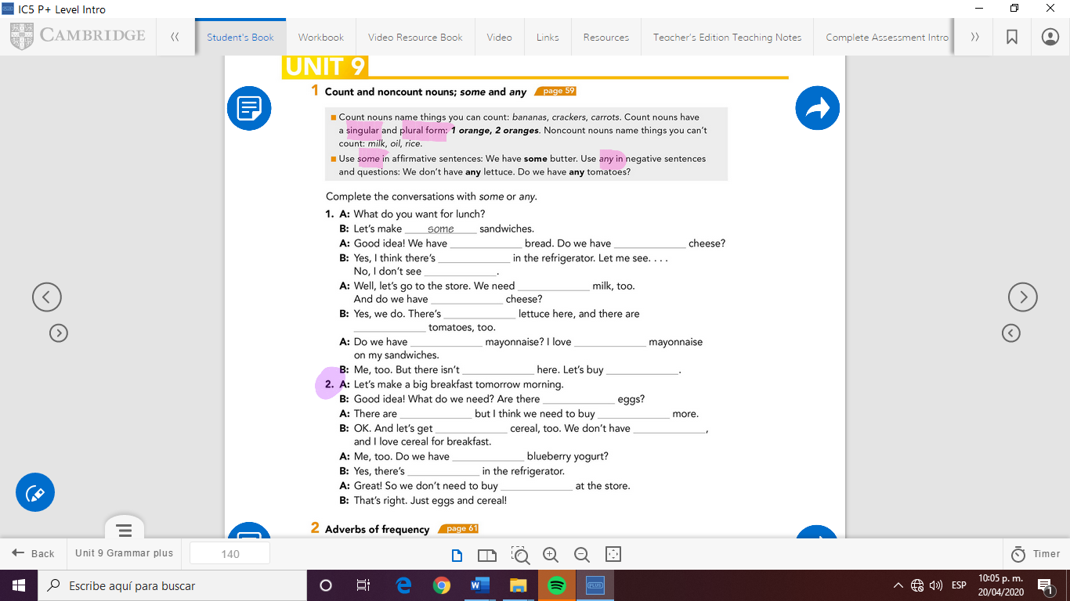

MY ANSWERS:

A)

1. Some
2. Any
3. Any any
4. Some
5. Some
6. Some
7. Any

B)

Count: Tomatoes, blueberries, lemons, bananas, Kiwis, apples, beans, onions.

Noncount: rice, cheese, yogurt, chicken, oil, cream, fish, cheese.

C)

1. Some, any, some, any, any, any, some, some, any, some, any, some.

2. Any, some, any, some, any, any, some, any.

SENTENCES

We have in my fridge:

I have some eggs in my fridge. But I don’t have any sandwich bread. Oh we need to buy some, mmm tomatoes for a soup, and y have some water for mix. Do we have any lemons for dessert? Yes I have lemons in my fridge. We need to buy some cookies and we need to buy some potatoes. I have apples in my fridge.



Check your answers here:

<https://drive.google.com/open?id=1tAdUNvs29Gw88jv3MEnq2BzbMMsPabRa>