THESE ARE THE PAGES YOU NEED TO COMPLETE. **BRENDA SAIDALY DE LA ROSA RIVERA**

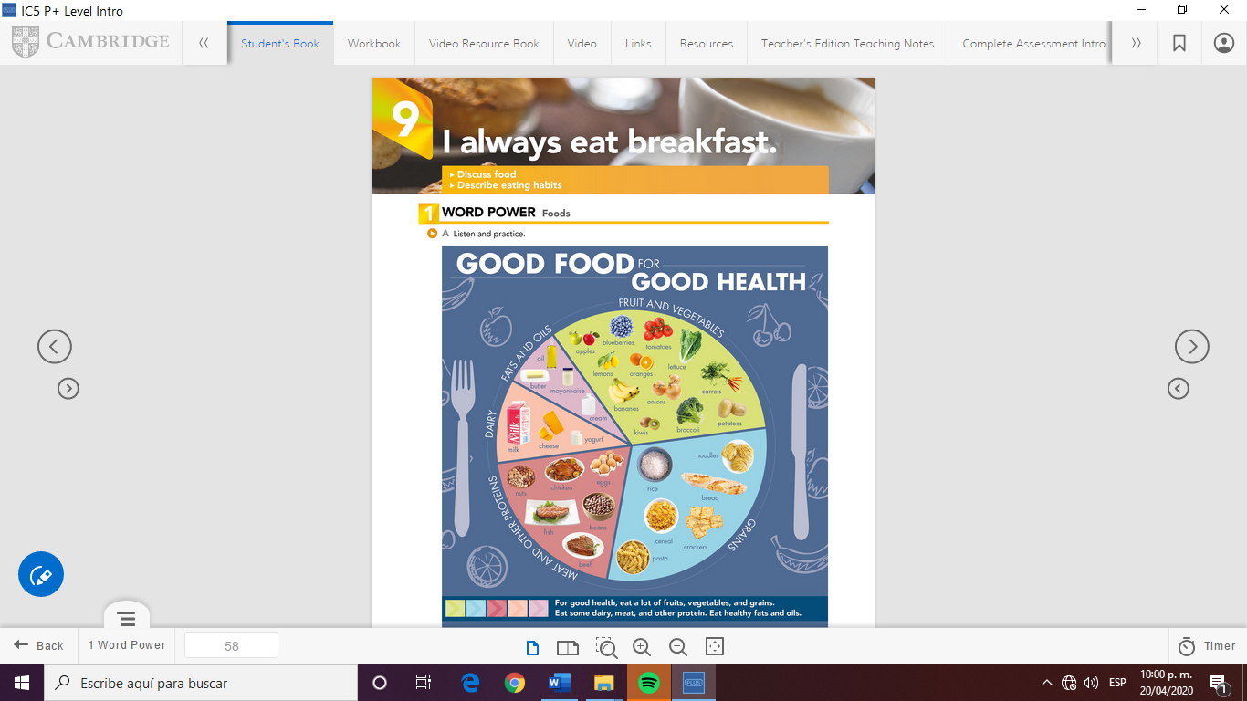

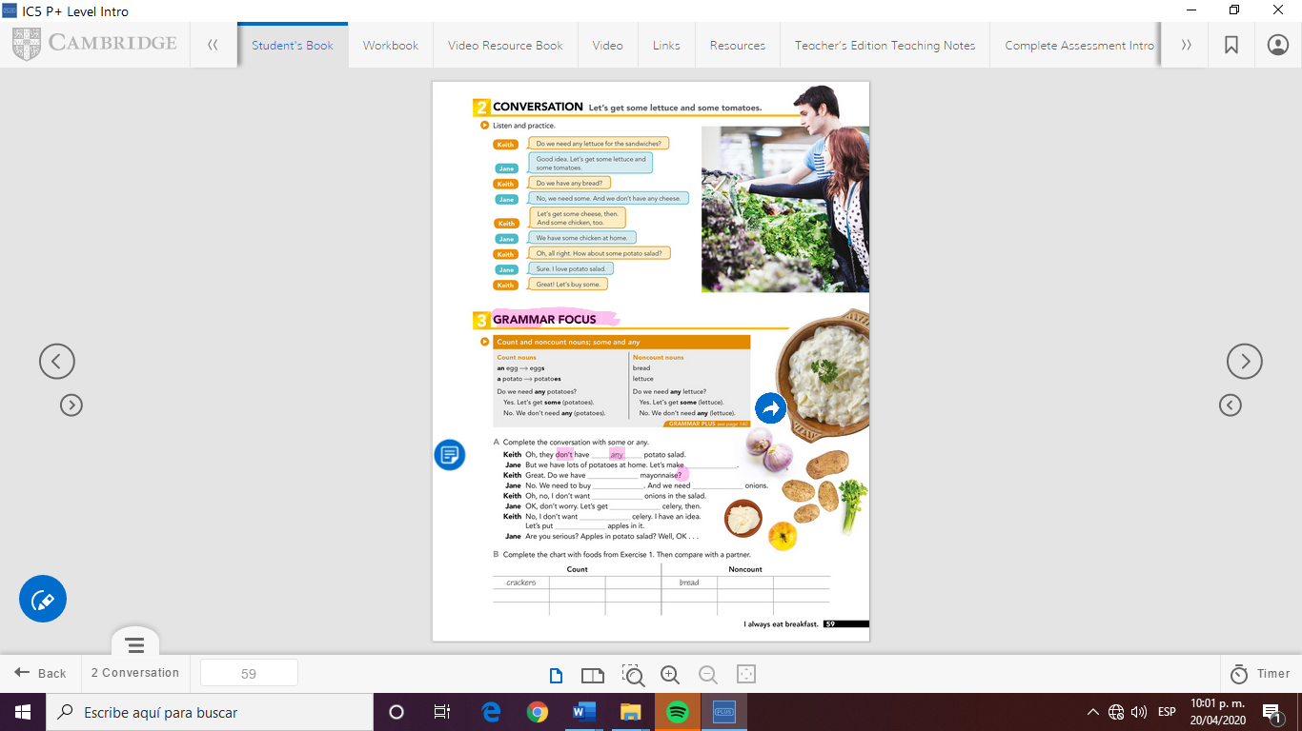

GRAMMAR FOCUS

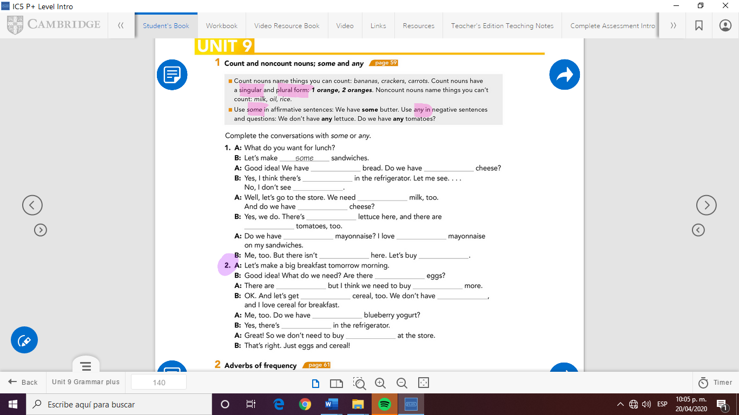

**MY ANSWERS:**

*Page 59*

**Jane:** some

**Keith:** any

**Jane:** some, some

**Keith:** any

**Jane:** some

**Keith:** any, some

*Grammar focus:*

**1**

1. Some, any
2. Some, any
3. Some, any
4. Some, some
5. Any, some
6. Any, some

**2**

**B:** any

**A:** some, some

**B:** some, any

**A:** any

**B:** some

**A:** any



Check your answers here:

<https://drive.google.com/open?id=1tAdUNvs29Gw88jv3MEnq2BzbMMsPabRa>