THESE ARE THE PAGES YOU NEED TO COMPLETE.

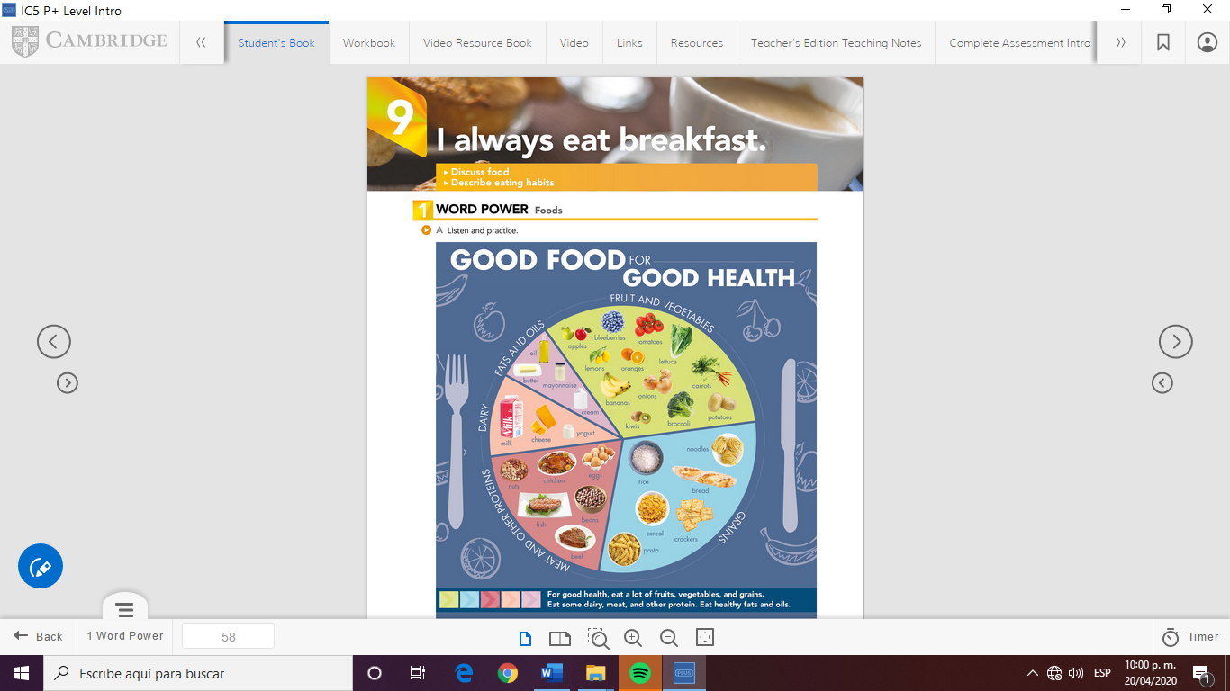

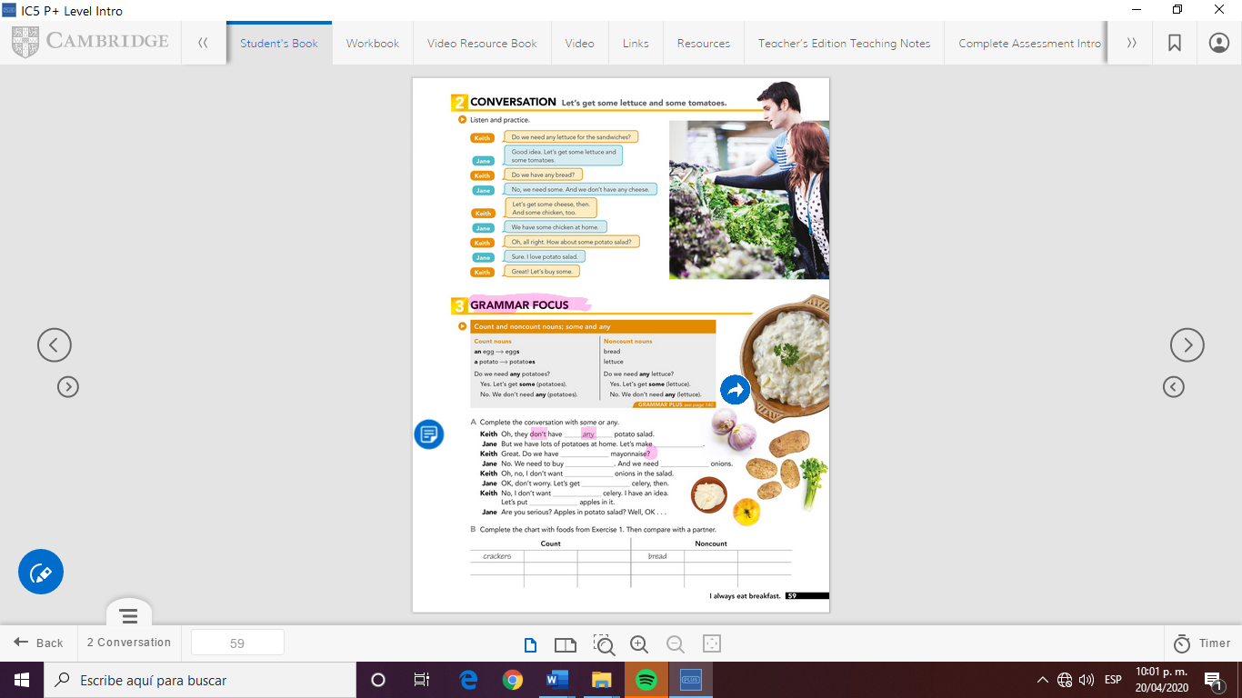

GRAMMAR FOCUS

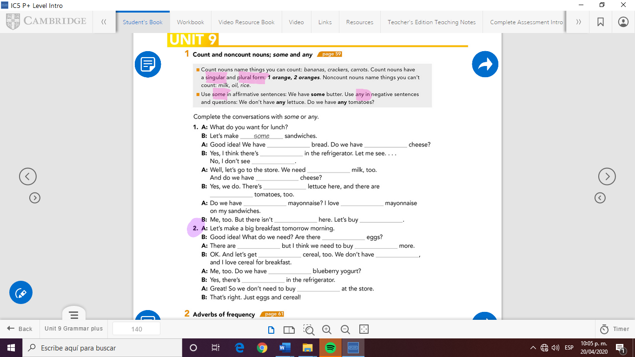



Check your answers here:

<https://drive.google.com/open?id=1tAdUNvs29Gw88jv3MEnq2BzbMMsPabRa>

Respuestas

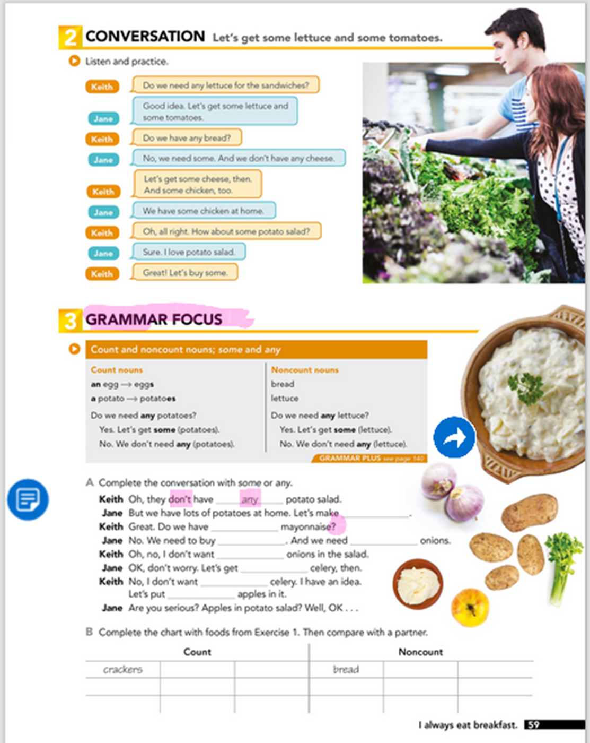

Jene: some

Keith: any

Jane: some- some

Keith: any

Jane: some

Keith: any - some

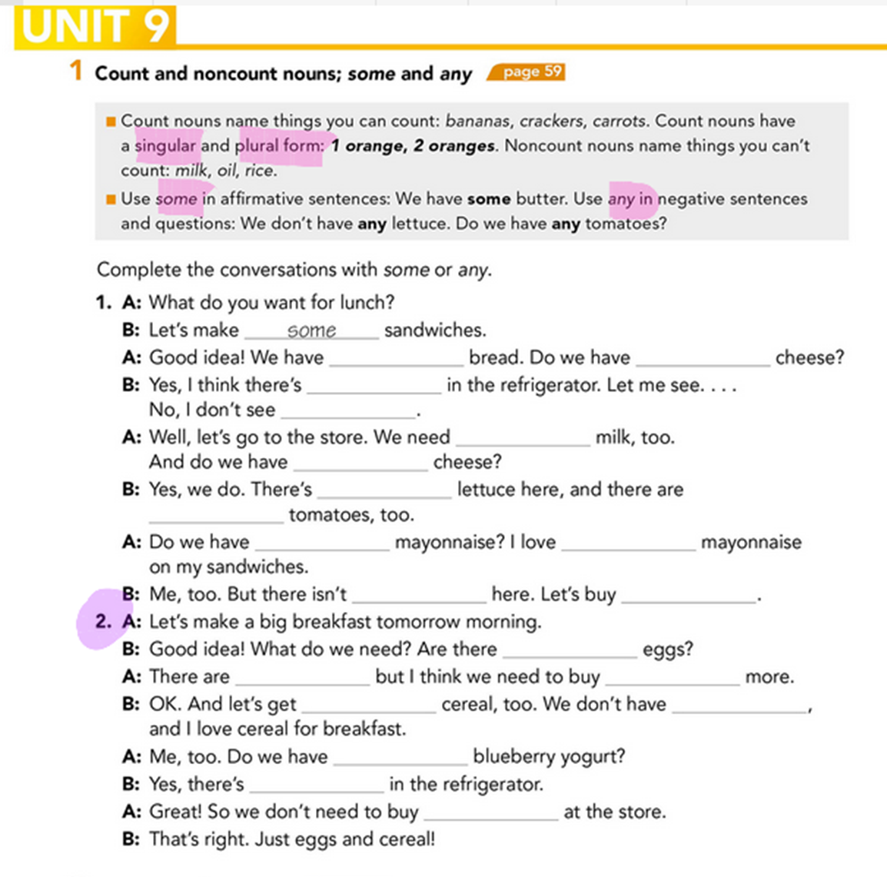A:SOME -ANY

B: SOME- ANY

A:SOME - ANY

B:SOME – SOME

A: ANY – SOME

B: ANY – SOME



B:ANY

A:SOME- SOME

B:SOME – ANY

A:ANY

B:SOME

A:ANY