THESE ARE THE PAGES YOU NEED TO COMPLETE.

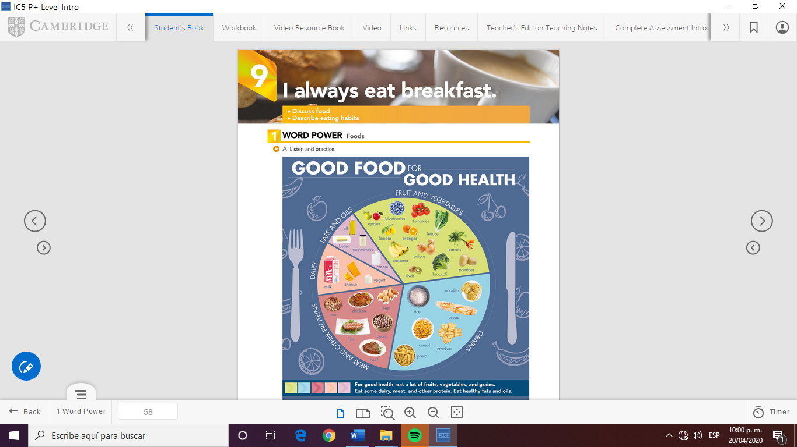

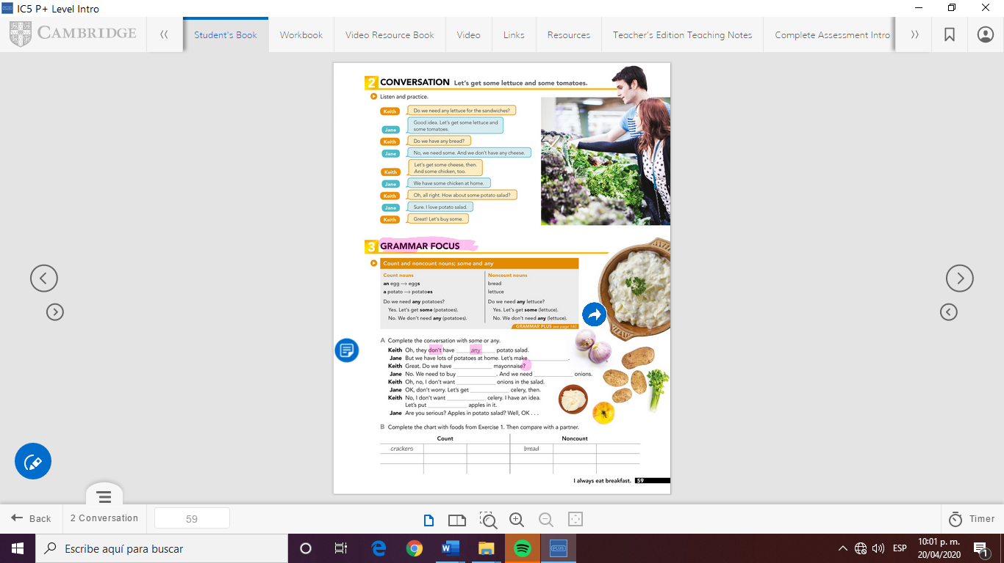

Answers:

Keith: any

Jane: some

Keith: any

Jane: some, some

Keith: any

Jane: some

Keith: any, some

GRAMMA FOCUS

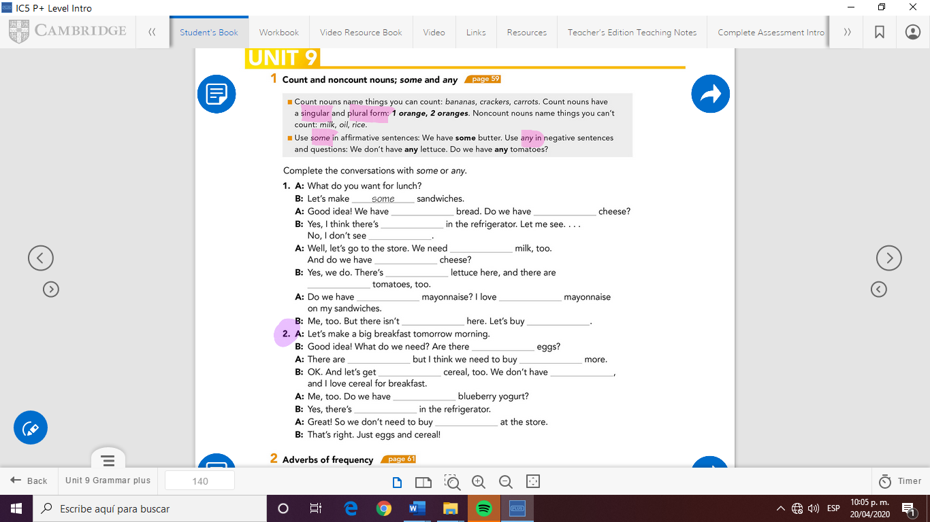

Answers

1:

A: some, any

B: some, any

A: some, any

B: some, some

A: any, some

B: any, some

2:

B: any

A: some, some

B: some, any

A: any

B: some

A: any



Check your answers here:

<https://drive.google.com/open?id=1tAdUNvs29Gw88jv3MEnq2BzbMMsPabRa>