THESE ARE THE PAGES YOU NEED TO COMPLETE.

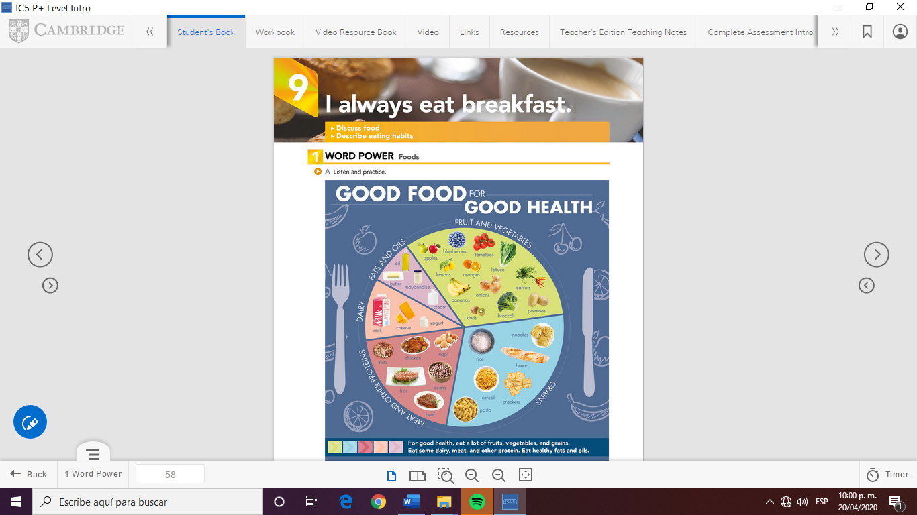

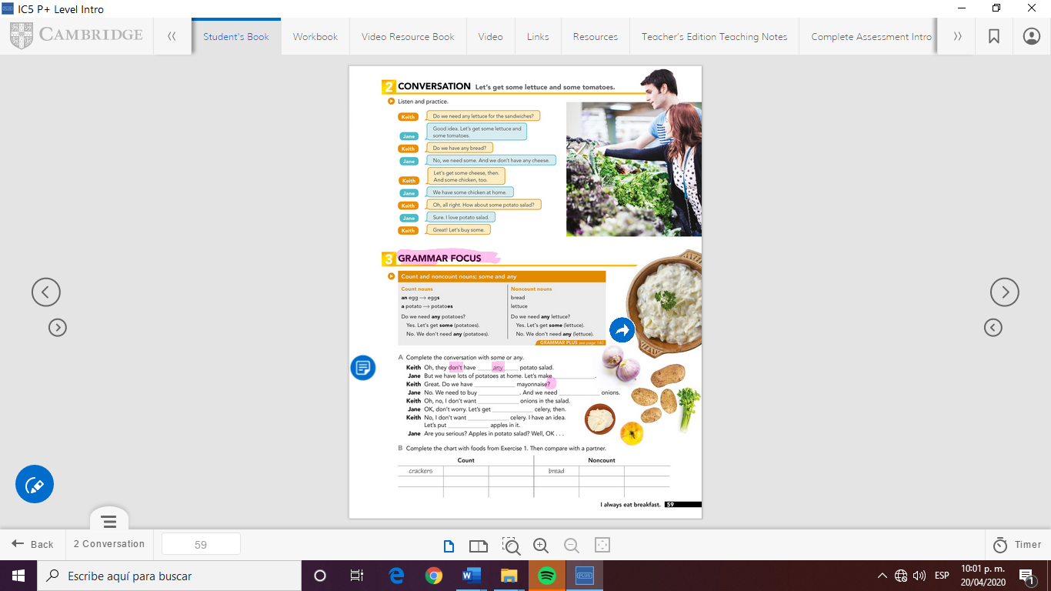

some

Some

some

Some

any

Some

ANY

ANY

GRAMMAR FOCUS

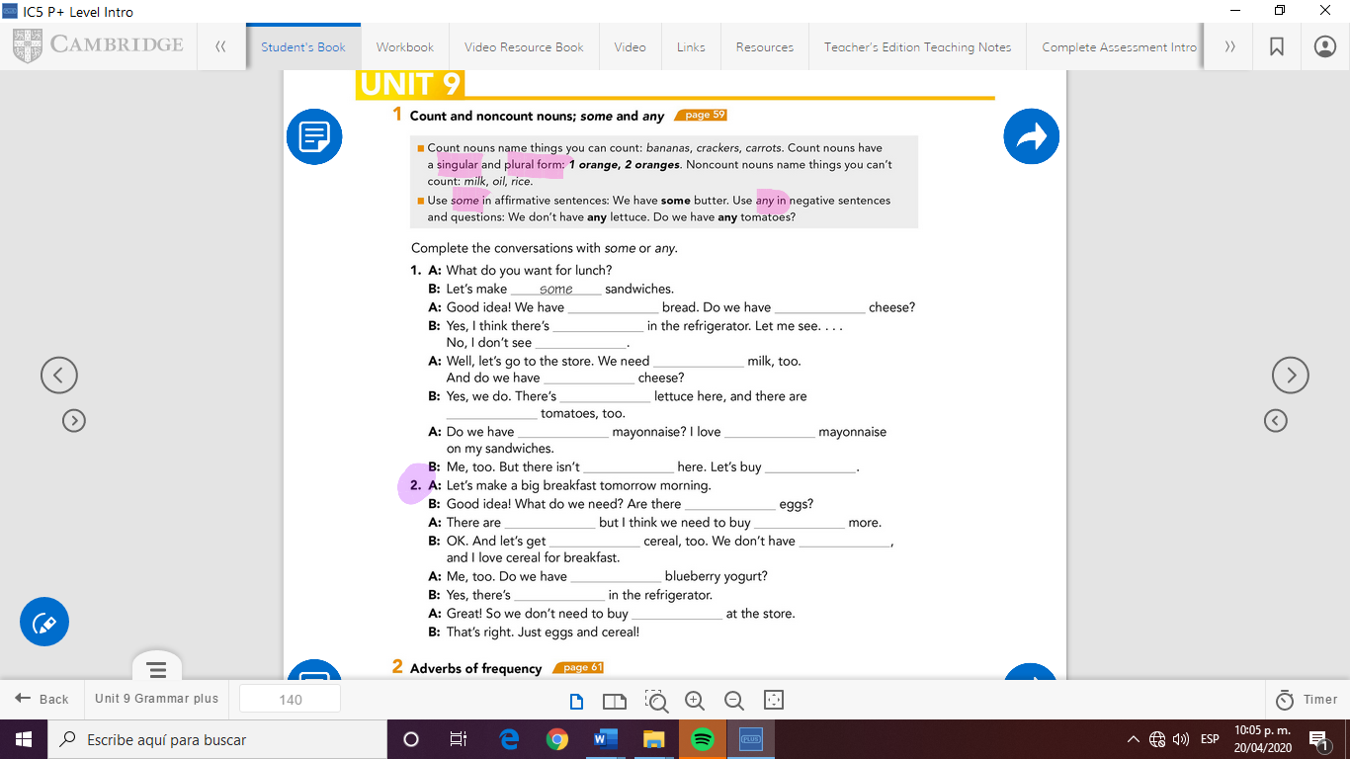

some

Any

some

Some

any

some

Any

some

any

some

some

any

some

Any

some

some

some

any

any

some



Check your answers here:

<https://drive.google.com/open?id=1tAdUNvs29Gw88jv3MEnq2BzbMMsPabRa>