THESE ARE THE PAGES YOU NEED TO COMPLETE.

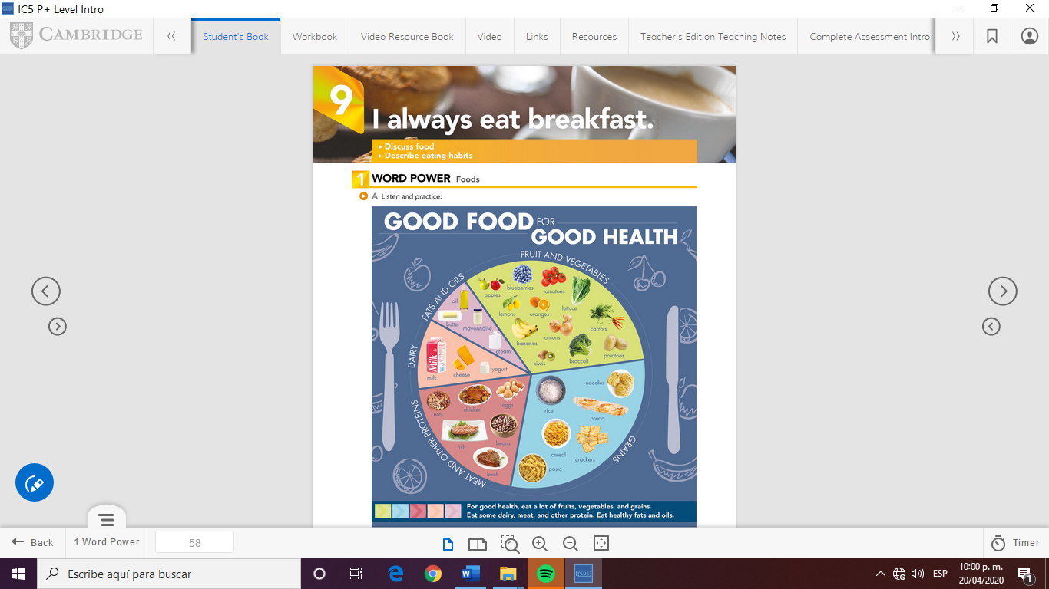

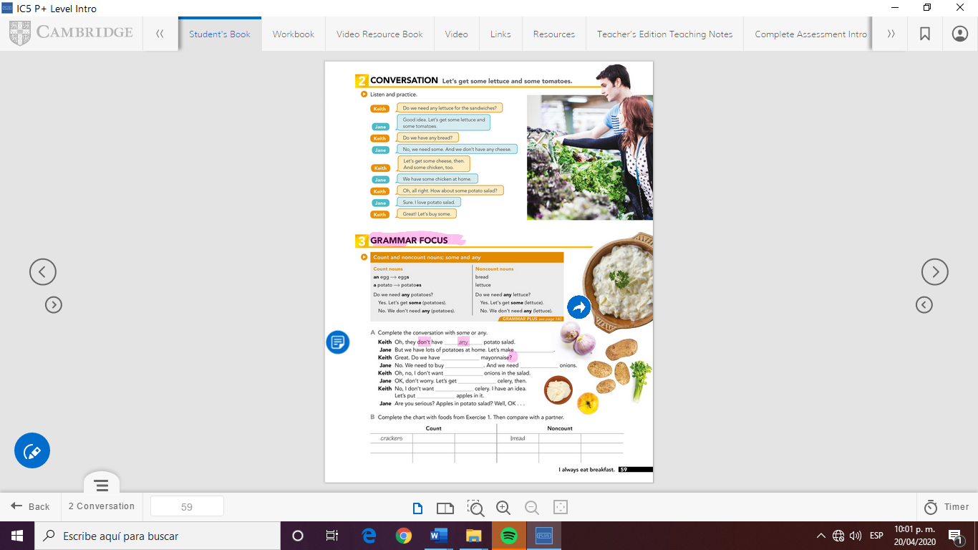

potatos

onios

apples

some

it

any

bbuy

To eat

celery

mayonaise

To add

onions

it

GRAMMAR FOCUS

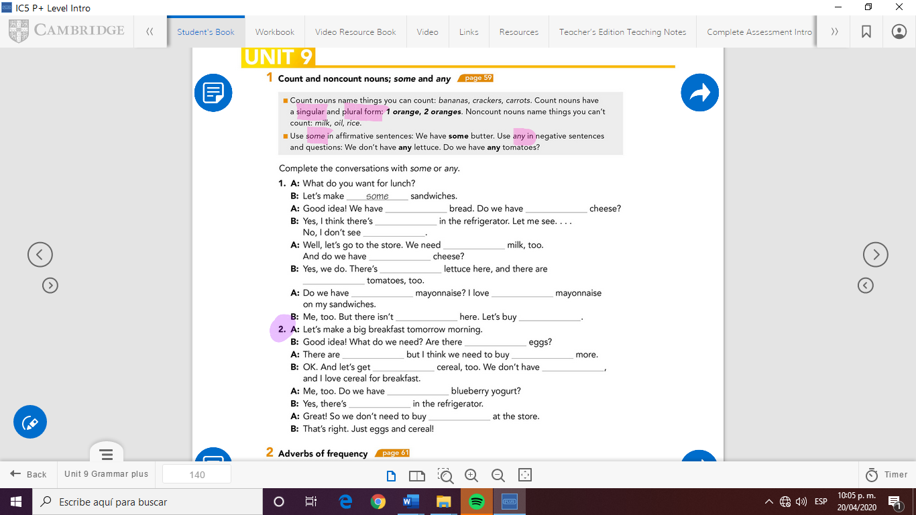

any

some

some

some

Any one

any

some

some

some

some

some

some

some

some

some

any

the

some

some

some



Check your answers here:

<https://drive.google.com/open?id=1tAdUNvs29Gw88jv3MEnq2BzbMMsPabRa>