THESE ARE THE PAGES YOU NEED TO COMPLETE.

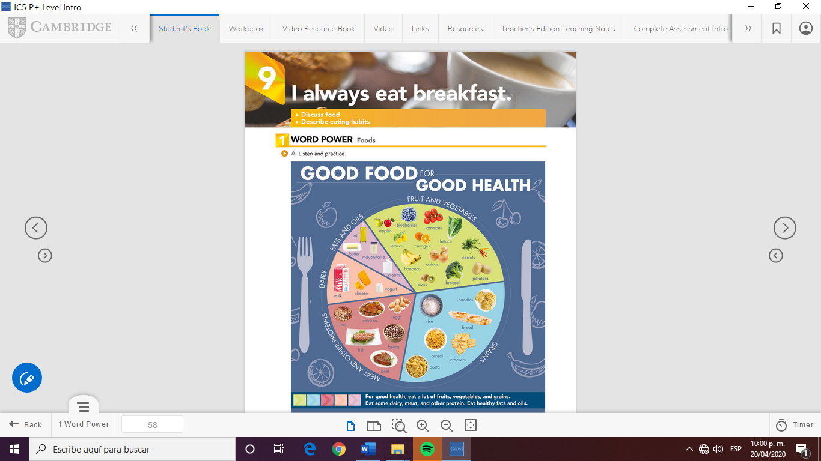

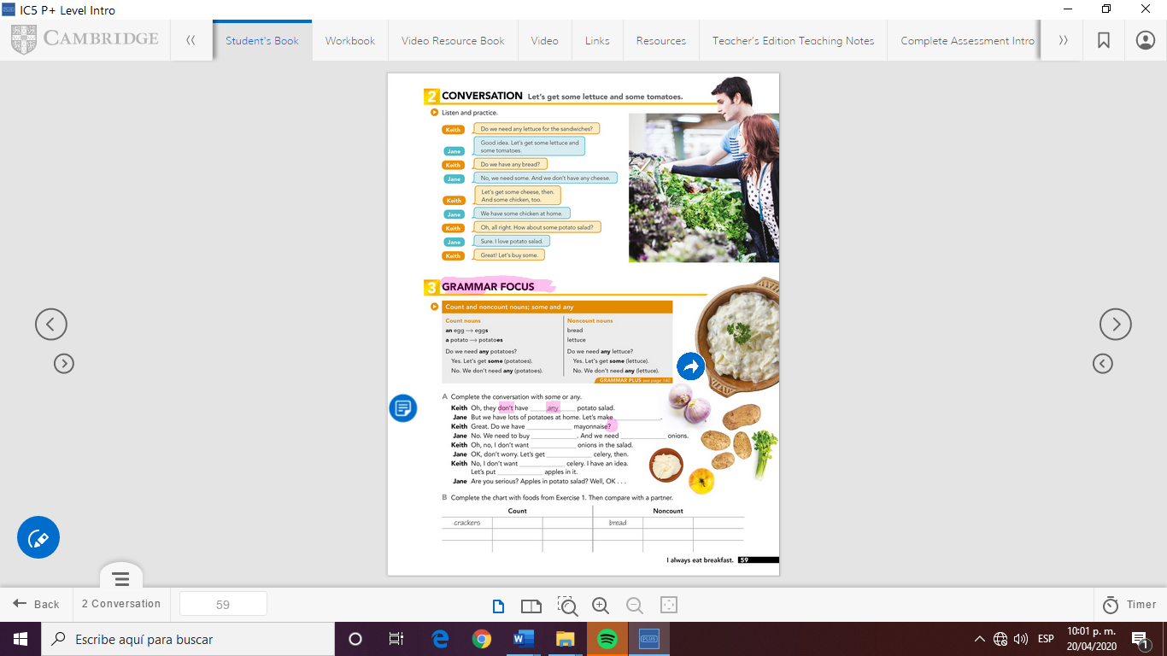

Oranges Apples Oil Rice

Bananas Carrots Grapes Milk Water Tea

Potatoes Eggs Tomatoes Cheese Butter Meat

some

some

any

some

any

some

some

some

GRAMMAR FOCUS

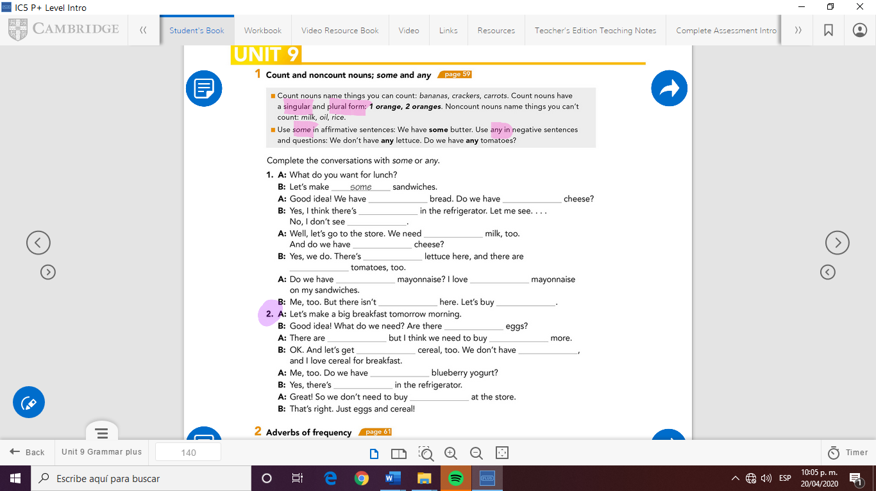

any

any

any

any

any

any

any

some

some

some

some

some

some

some

some

some

any

some

any

some



Check your answers here:

<https://drive.google.com/open?id=1tAdUNvs29Gw88jv3MEnq2BzbMMsPabRa>