FOOD AND BEVERAGES
THIS IS VOCABULARY FROM UNIT 9 Karla Elena Calzoncit Rodriguez

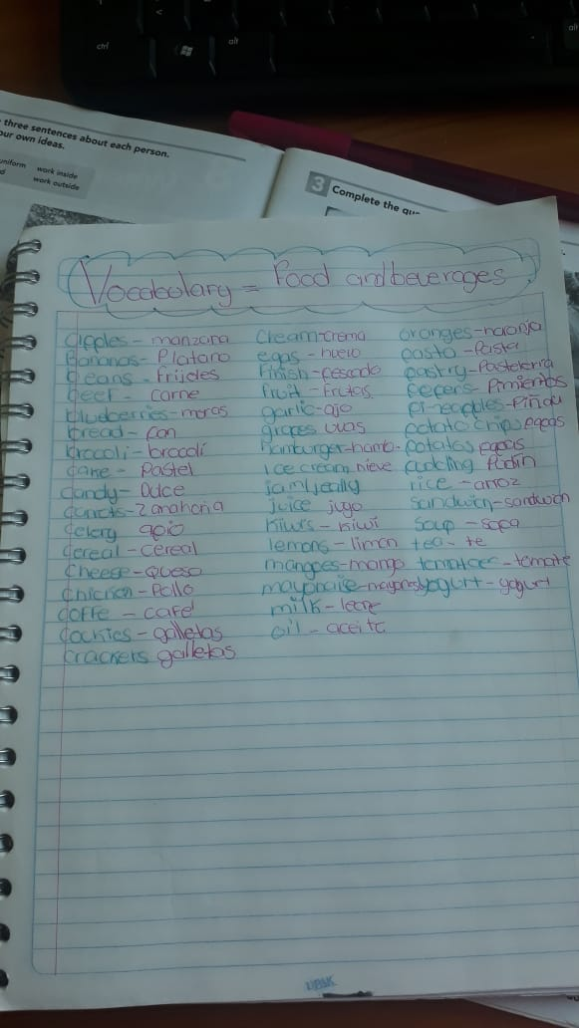

WRITE THE WORDS THAT ARE NEW FOR YOU

Celery, garlic, rice, carrots, beans

These are the new words I learned.

INSTRUCTIONS:

- Classify the food items from the vocabulary list. Create your own classification column.

FRUITS | VEGETABLES | DESSERTS | DRINKS | YOUR OWN IDEA
Apples | Broccoli | Cake | Milk | Bread
Bananas | Celery | Cockis | Tea | Beans
Blueberries | Tomatoes | Pudding | Yogurt | Garlic
Grapes | Potatoes | Ice cream | Coffe | Pasta
Pineapples | Carrots | Candy | Juice | Rice
Mangoes | Lemons |  |  | Soup
Kiwis |  |  |  | Eggs

- Answer the following questions

What do you usually have for breakfast, lunch, and dinner?
What are your favorite types of food?
A: What do you usually have for breakfast?
B: I have coffee and bread and butter. I sometimes have cereal, too.
A: What’s your favorite food?
B: I like beef, and I like pasta.
What do you usually have for breakfast, lunch and dinner?
breakfast: cereal, egg or fruit.
like: pasta, chicken, meat.
dinner: egg, fruit cereal,
What are your favorite types of food?
tacos and cakes

