**ESCUELA NORMAL DE EDUCACIÓN PREESCOLAR**

“INGLÉS”



Docente: Brenda Bollain y Goytia de la Peña

Alumna: Graciela de la Garza Barboza

2° semestre, sección “C”

27 de abril de 2020

THESE ARE THE PAGES YOU NEED TO COMPLETE.

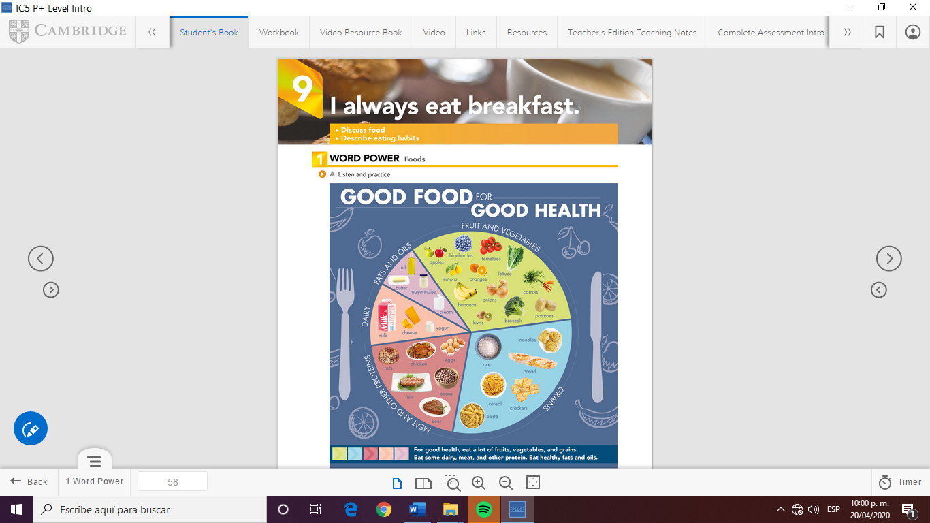

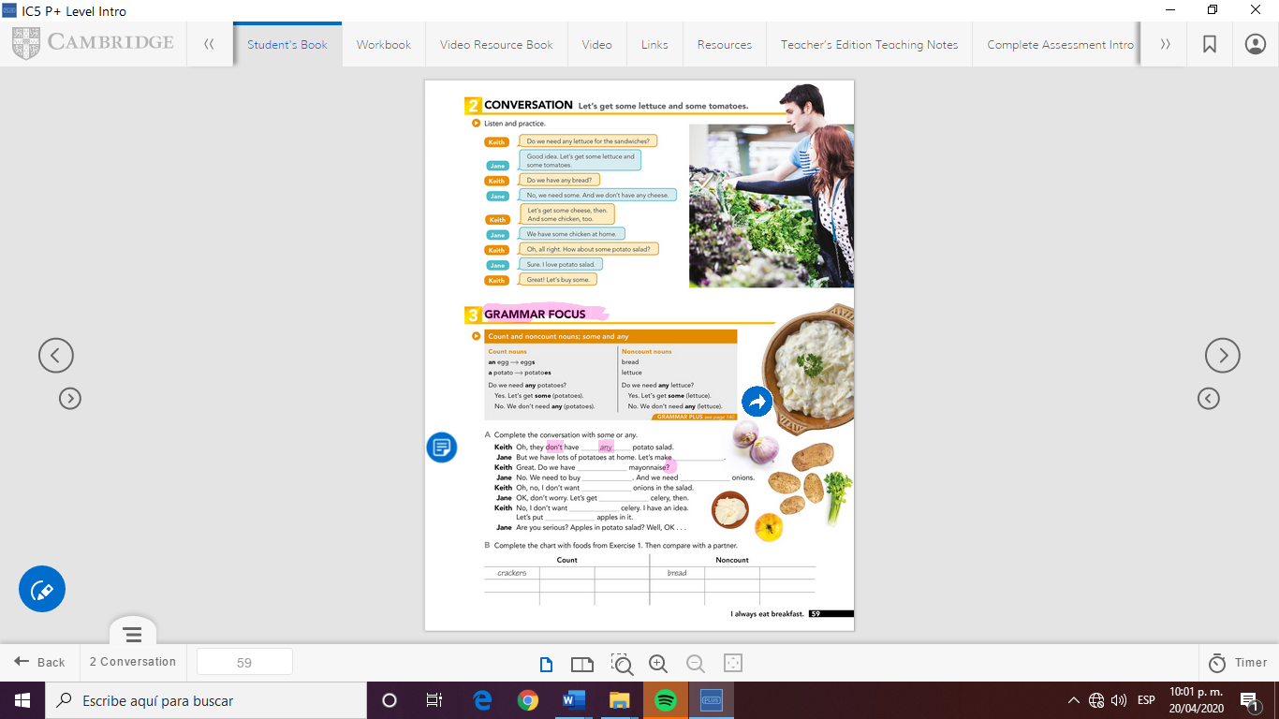

Fish

Milk

Oil

Cream

Yogurt

Bananas

Apples

Lemons

Eggs

Cereal

Jane: some

Keith: any

Jane: some, some

Keith: any

Jane: some

Keith: any, some

GRAMMAR FOCUS

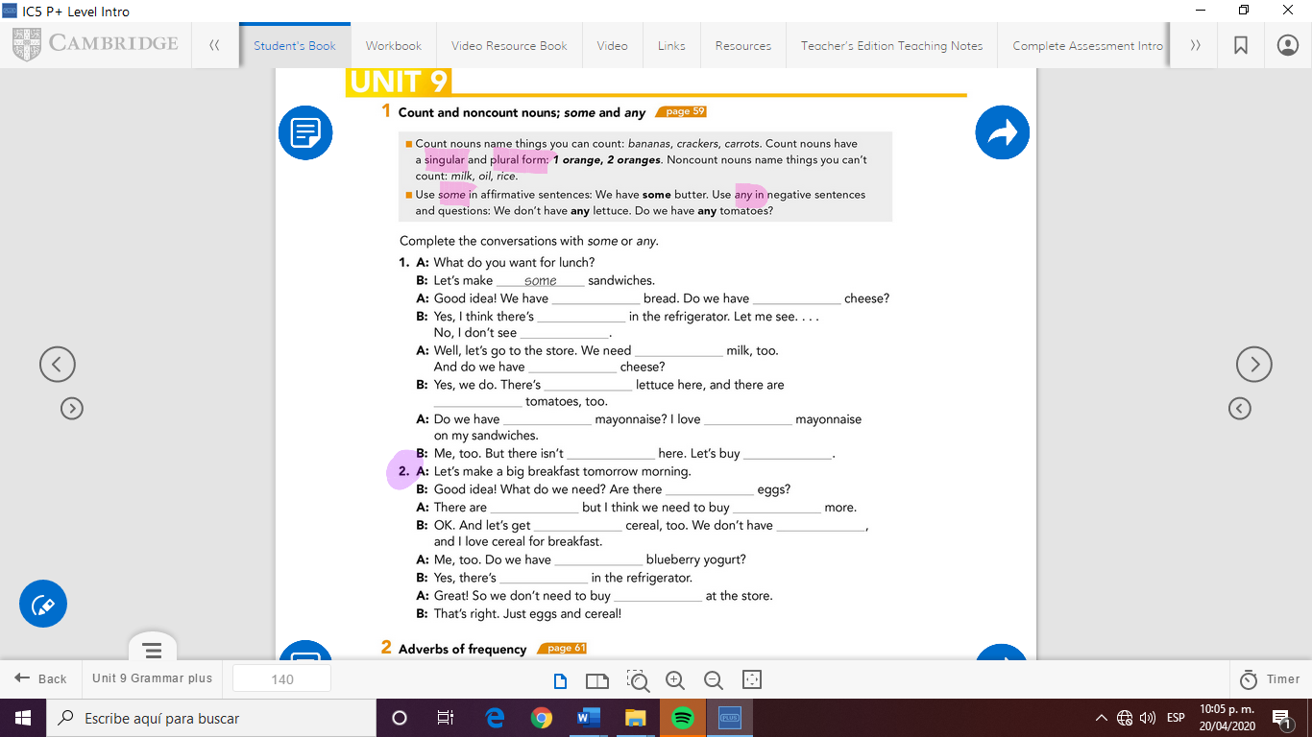

any

Some

any

any

Some

any

Some

Some

Some

any

Some

any

Some

Some

any

any

Some

any

Some

Some