THESE ARE THE PAGES YOU NEED TO COMPLETE.

**MARIA GUADALUPE MORALES MENDOZA**

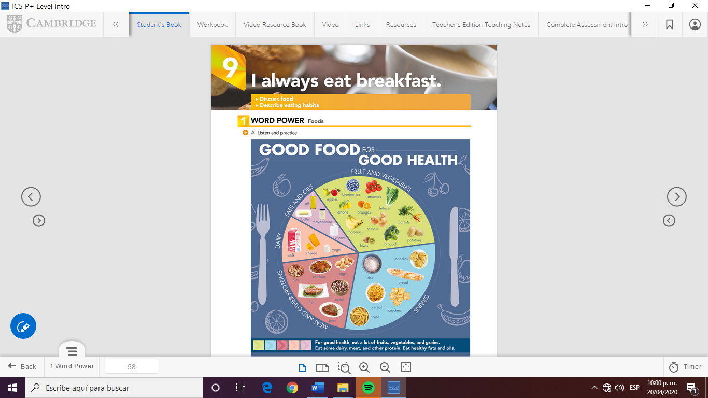

THESE ARE THE PAGES YOU NEED TO

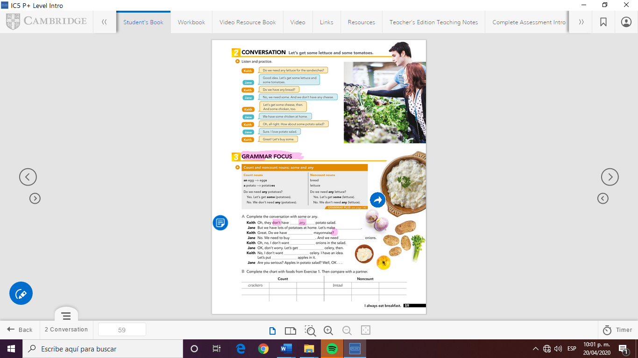

COMPLETE.

A complete the conversation with some or any.

Keith Oh, they don´t have any potato salad.

Jane But we have lots of potatoes at home. Let´s make some .

Keith Great. Do we have **any**  mayonnaise?

Jane No, we need to buy **some** and we need **some** onions.

Keith Oh, no, I don´t want **any** onions in the salad.

Jane Ok, don´t worry. Let’s get **some** celery, then.

Keith No, I don´t want **any**  celery. I have an idea.

Let´s put **some**  apples in it.

Jane Are you serious? Apples in potato salad? Well, OK…

|  |  |  |  |  |  |
| --- | --- | --- | --- | --- | --- |
| **Count** | | | **noncount** | | |
| Carrots | kiwwis | Eggs | milk | yogurt | cream |
| tomatoes | bananas | Oranges | cheese | oil | bread |
| lemons | apples | nuts | rice | cereal | cream |

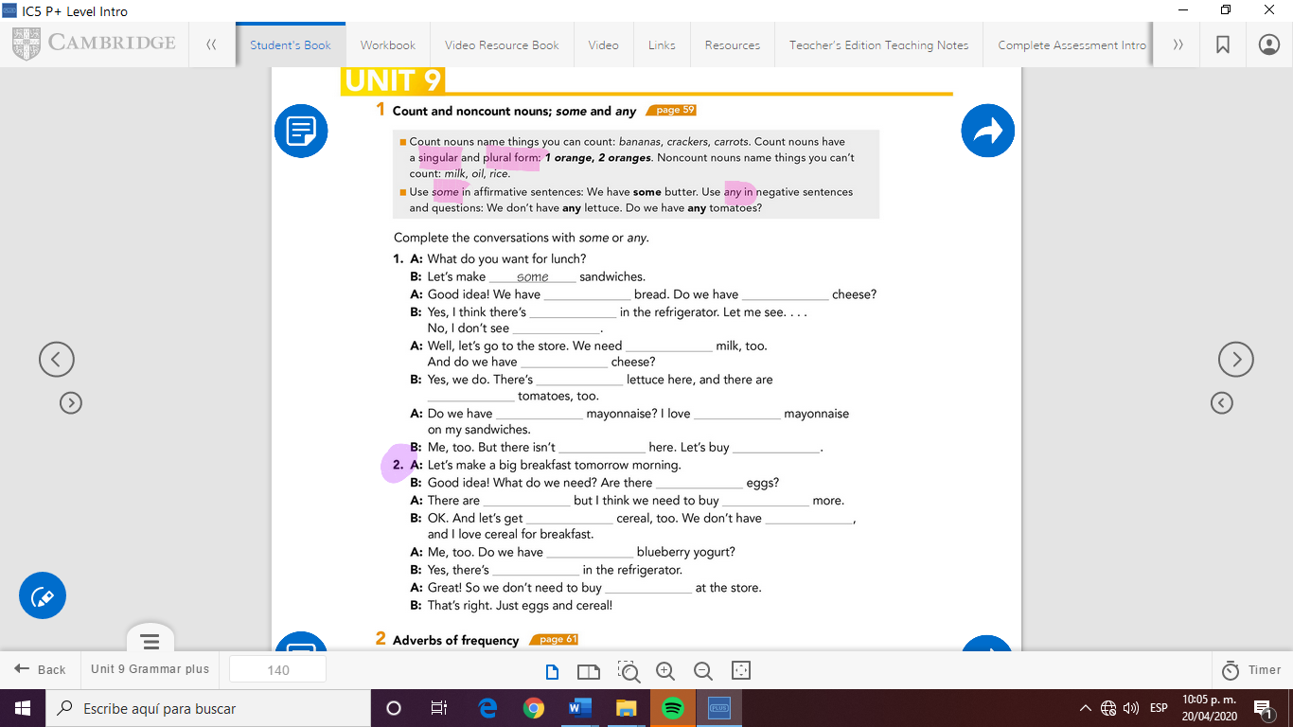

Count and noncount nouns; some and any

1. **A:** What do you want for lunch?

**B:** Let´s make **some** sandwiches.

**A:** Good idea! We have **some**  bread. Do we have any cheese?

B: Yes, I think there´s **some** in the refrigerator. Let me see….

No, I don´t see **any**  .

A: Well, let´s go to the store. We need **some** milk, too.

And do we have **any**  cheese?

B: Yes, we do. There´s **some** lettuce here, and there are **some**  Tomatoes, too.

A: Do we have **any**  mayonnaise? I love **some** mayonnaise

On my sandwiches