THESE ARE THE PAGES YOU NEED TO COMPLETE.

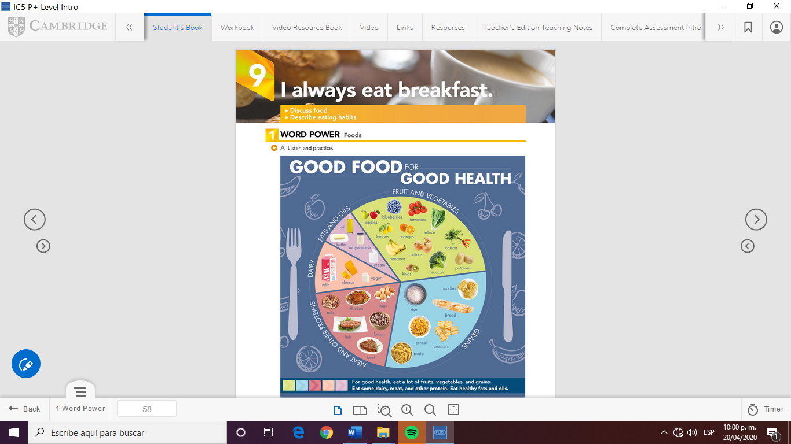

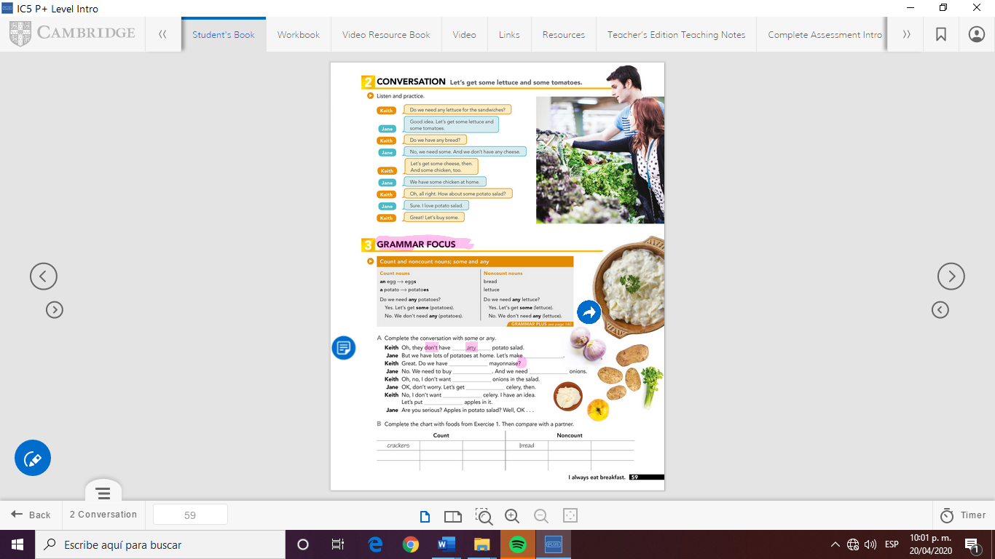

milk

cheese

tomatoes

eggs

cream

mayonnaise

celery

potatoes

apples

onions

some

any

any

some

Any(mayonnaise)

Some( potatoes)

some

any

GRAMMAR FOCUS

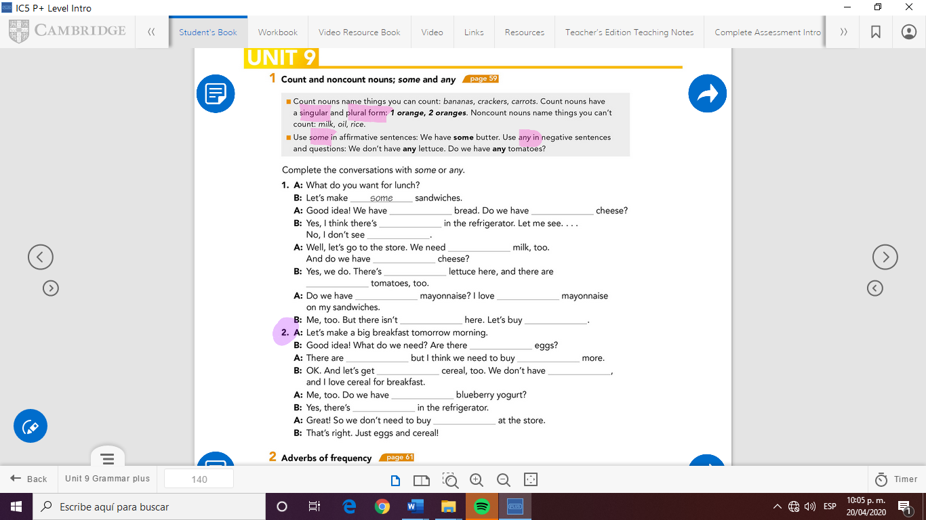

some

some

any

any

some

any

any

some

some

any

some

any

some

some

any

some

any

some

any

some



Check your answers here:

<https://drive.google.com/open?id=1tAdUNvs29Gw88jv3MEnq2BzbMMsPabRa>