THESE ARE THE PAGES YOU NEED TO COMPLETE.

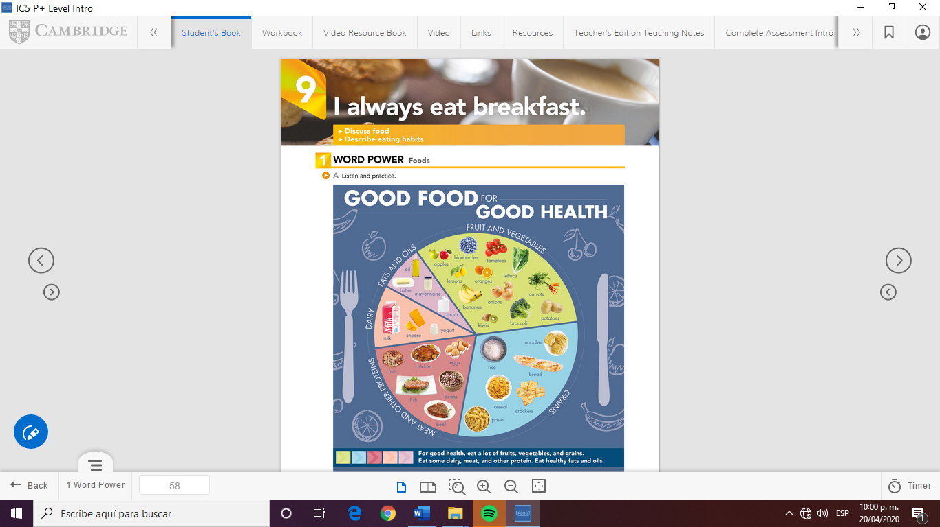

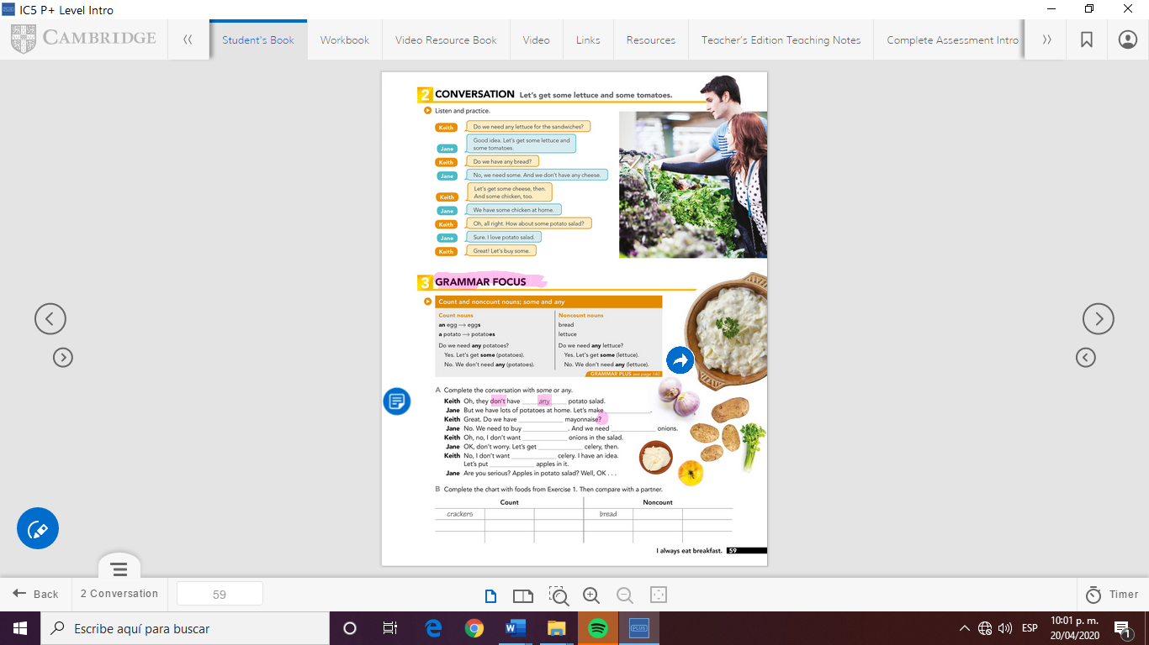

eggs

bananas

apples

cream

milk

fish

oil

butter

onions

oranges

some

some

any

some

some

any

some

any

GRAMMAR FOCUS

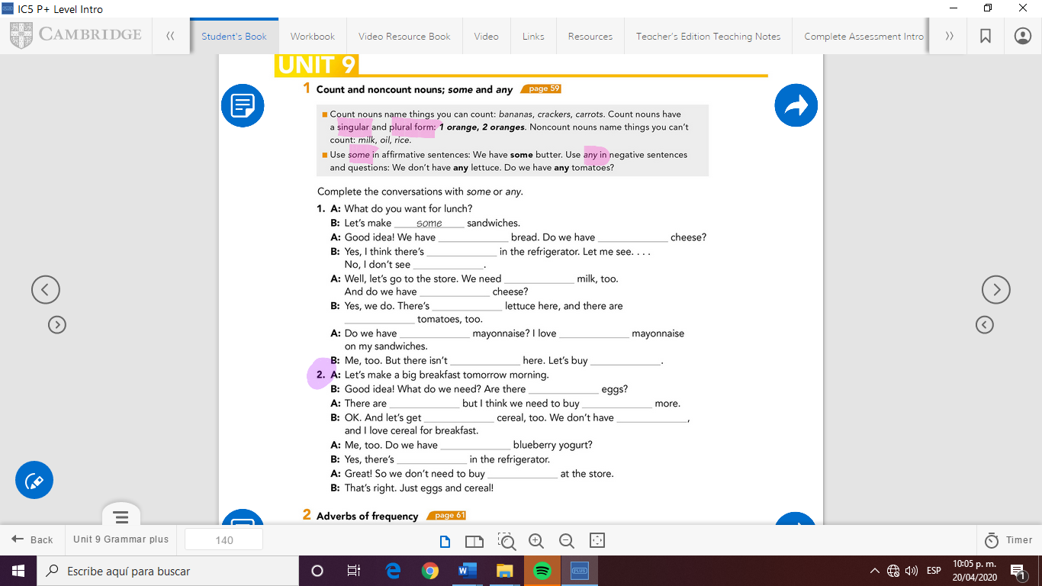

any

some

any

any

some

some

some

any

some

any

some

any

some

some

any

some

any

some

some

any



Check your answers here:

https://drive.google.com/open?id=1tAdUNvs29Gw88jv3MEnq2BzbMMsPabRa