English guide
Unit 2 quiz
Book units 7 & 8

Study the REGULAR & IRREGULAR verbs:
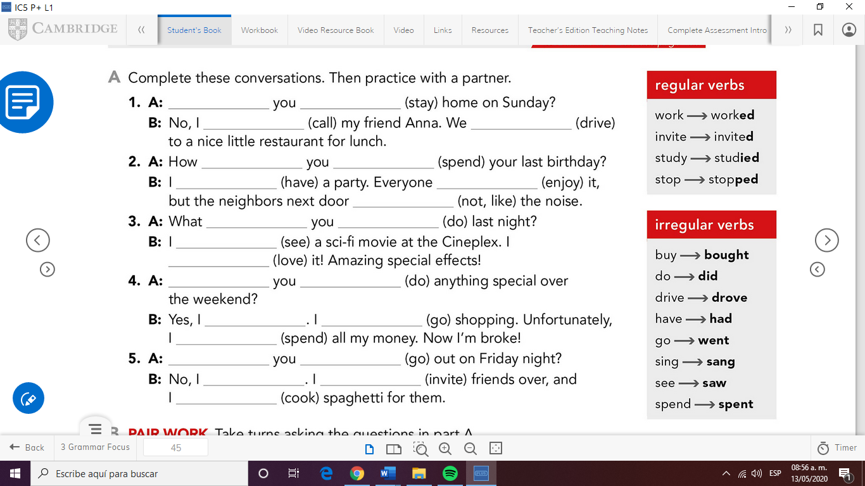

Check the CLUES to identify simple present vs past simple:

I went to the movies yesterday.
Last week, last weekend, last night…

Work on the exercises in unit 8 in your workbook.
Ex. 1,2,3,7 & 8
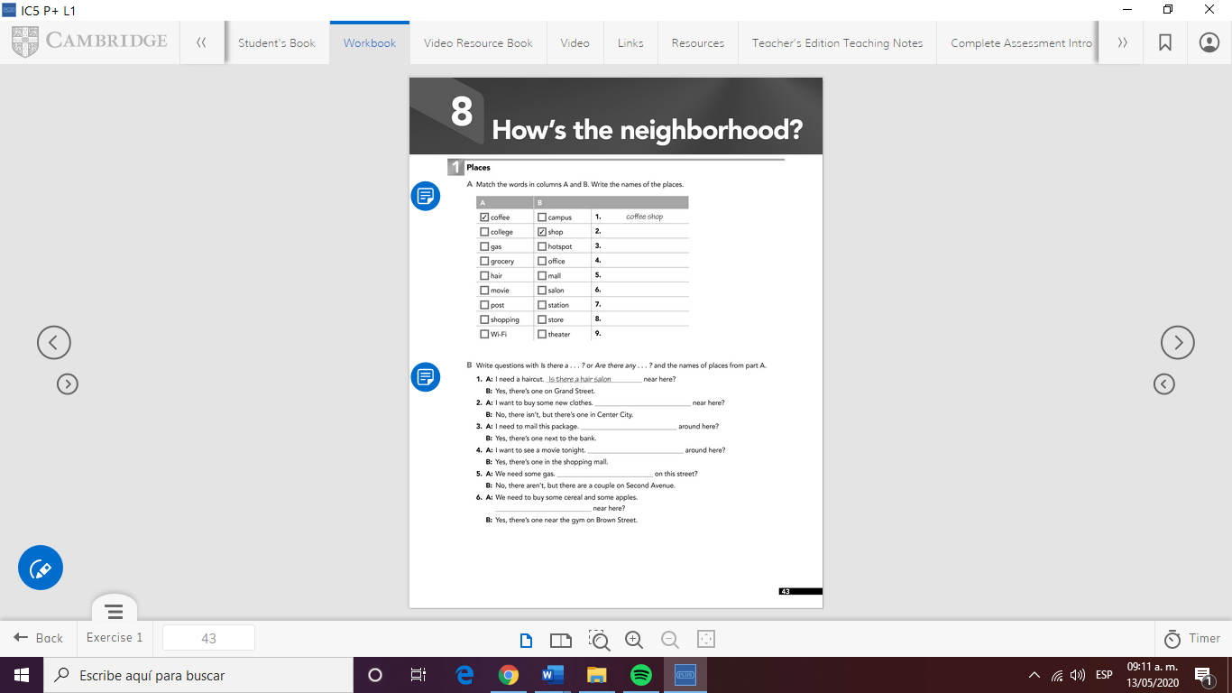
Take pictures of the pages and paste them in this document.
Good luck!!!


