English guide

Unit 2 quiz

Book units 7 & 8

**Study the REGULAR & IRREGULAR verbs:**

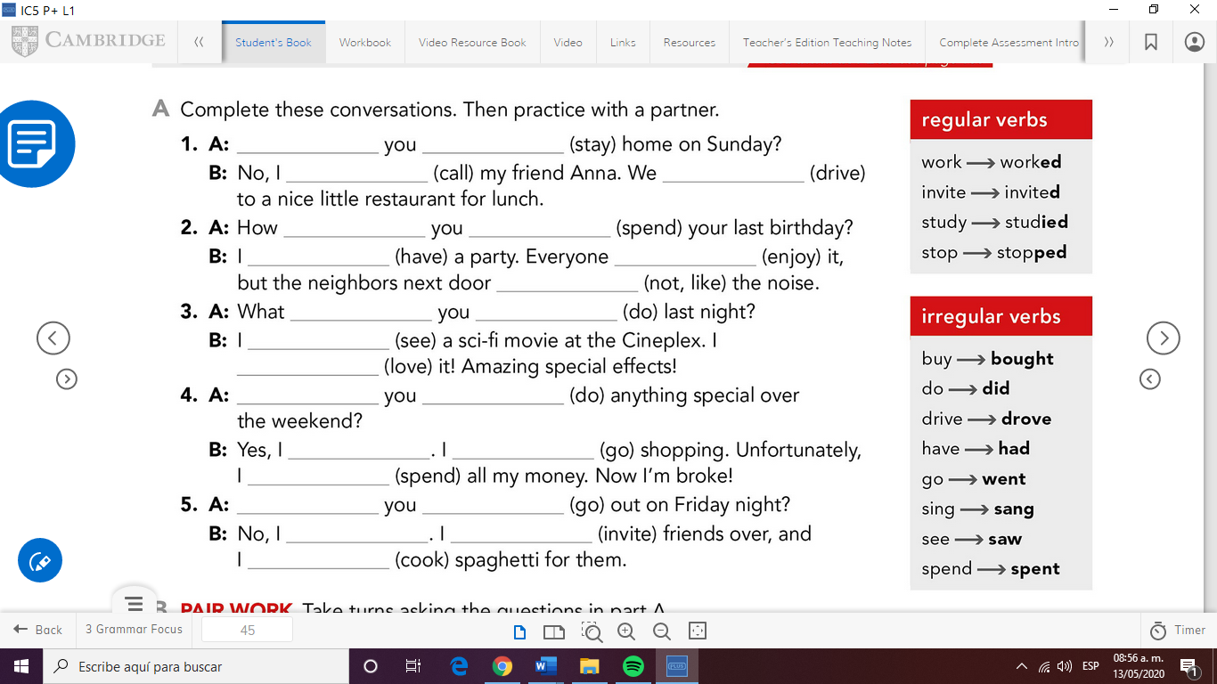

**Check the CLUES to identify simple present vs past simple:**

**I went to the movies yesterday.**

**Last week, last weekend, last night…**

**Work on the exercises in unit 8 in your workbook.**

**Ex. 1,2,3,7 & 8**

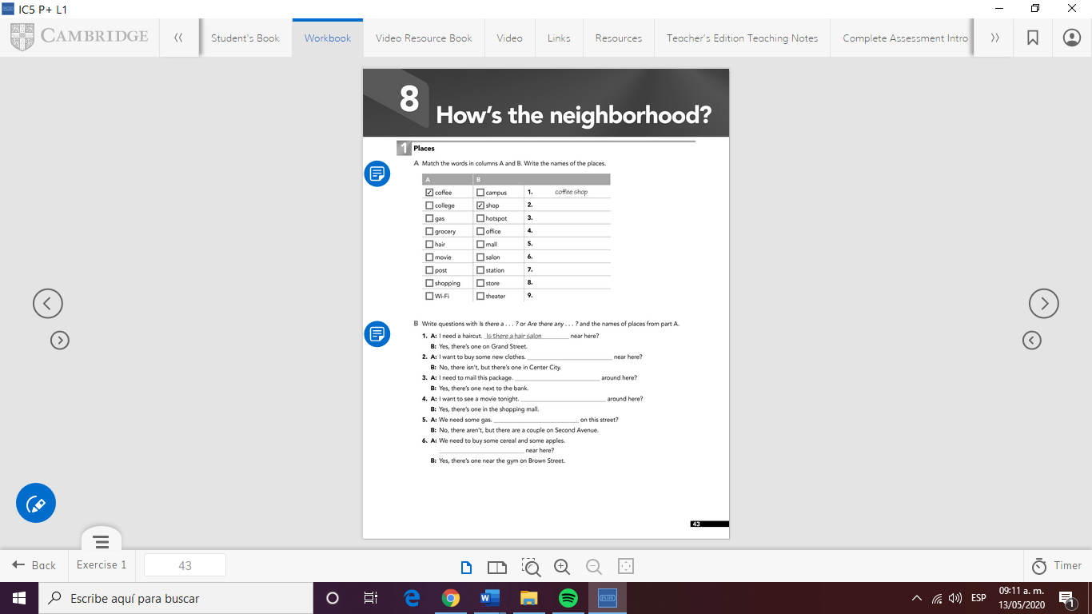

**Take pictures of the pages and paste them in this document.**

**Good luck!!!**



