English guide

Unit 2 quiz

Book units 7 & 8

**Study the REGULAR & IRREGULAR verbs:**

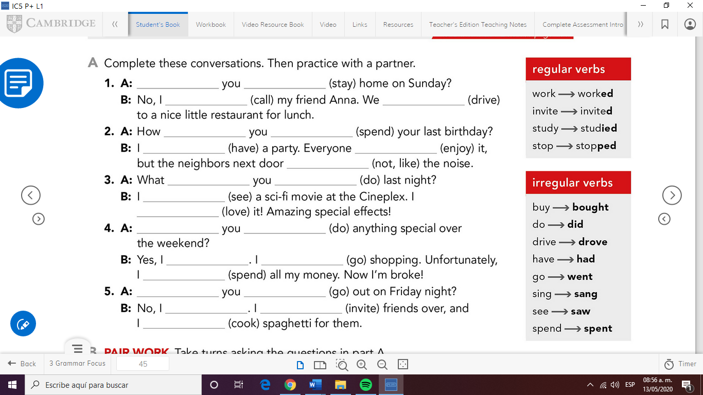

**Check the CLUES to identify simple present vs past simple:**

**I went to the movies yesterday.**

**Last week, last weekend, last night…**

**Work on the exercises in unit 8 in your workbook.**

**Ex. 1,2,3,7 & 8**

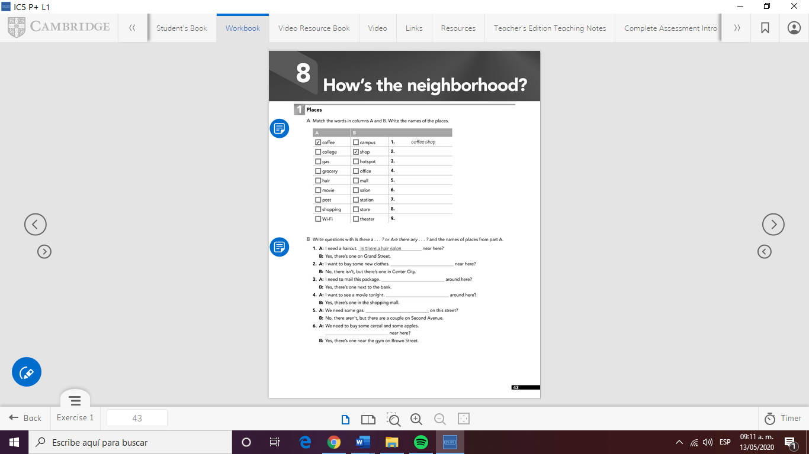

**Take pictures of the pages and paste them in this document.**

**Good luck!!!**



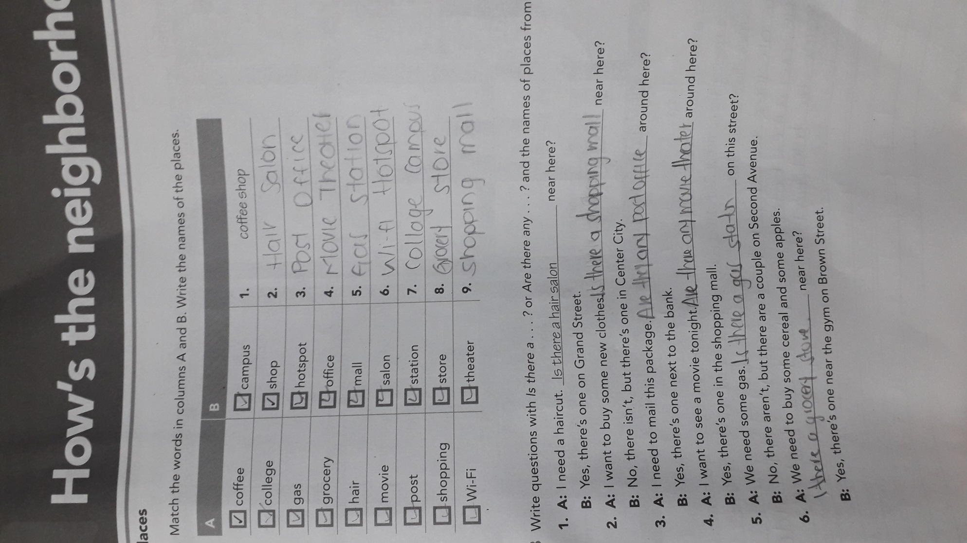

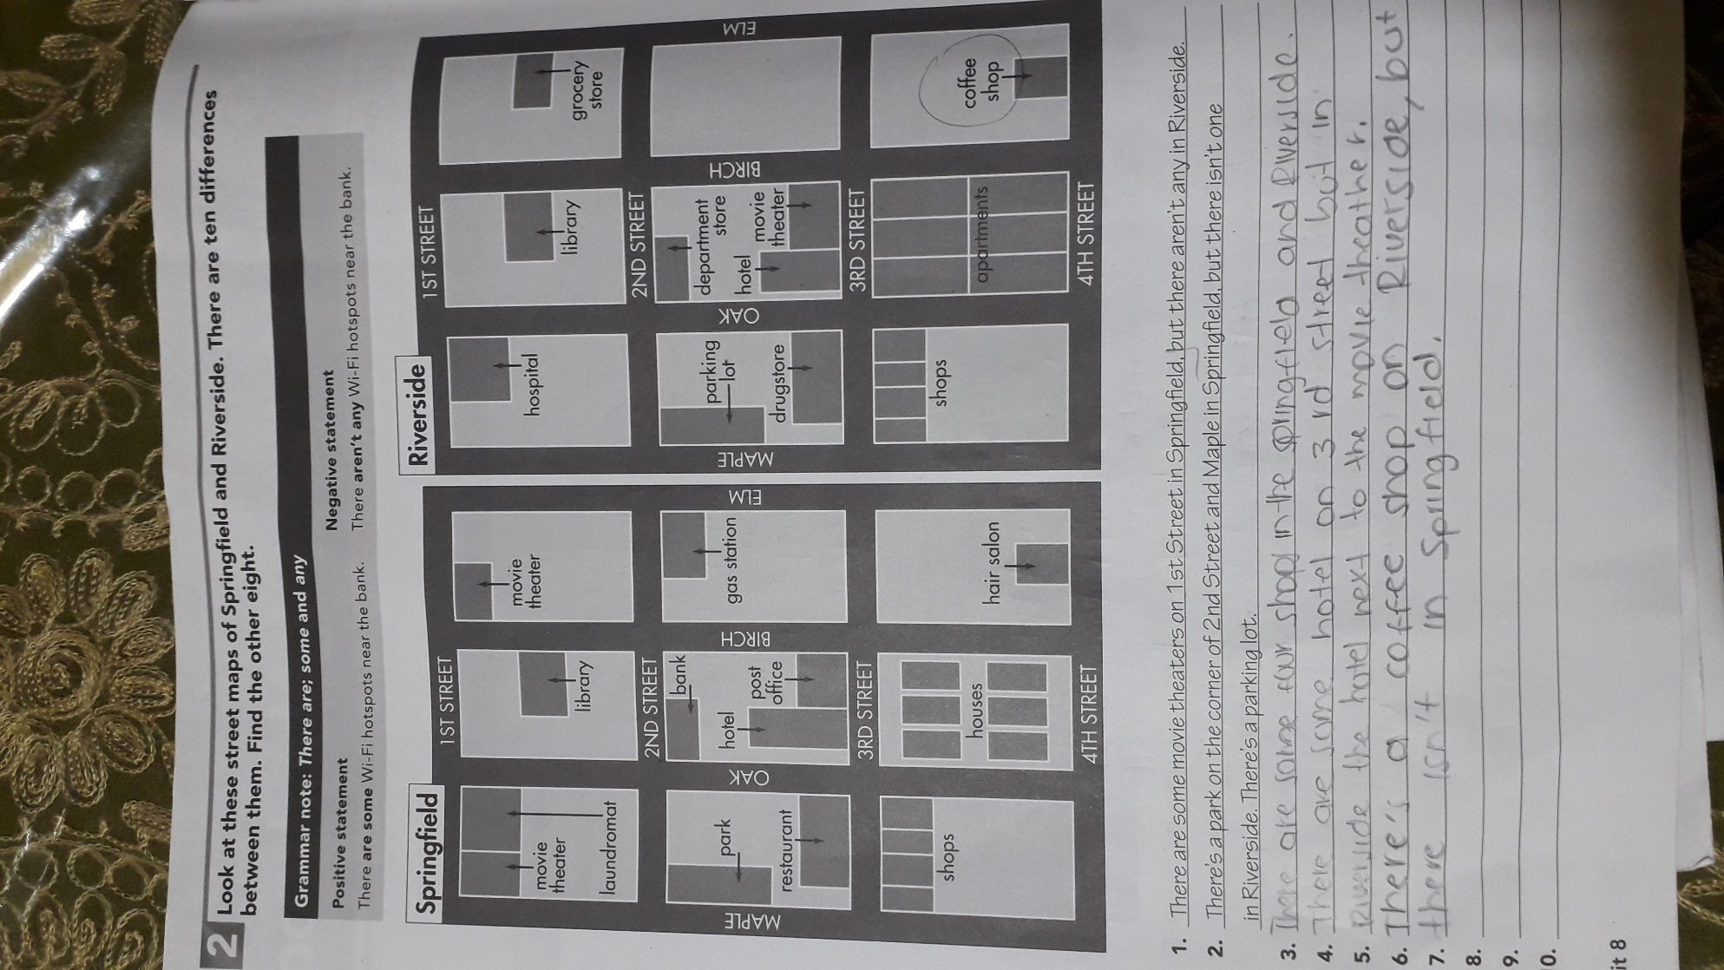

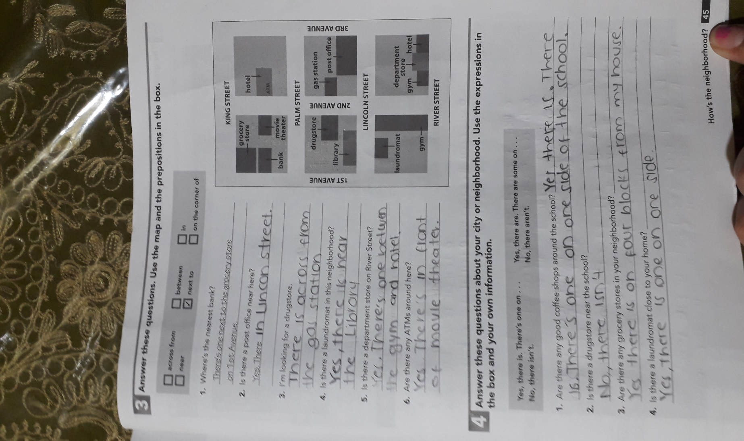

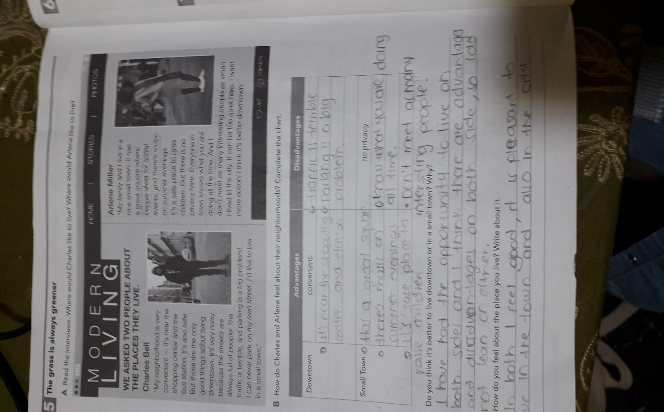

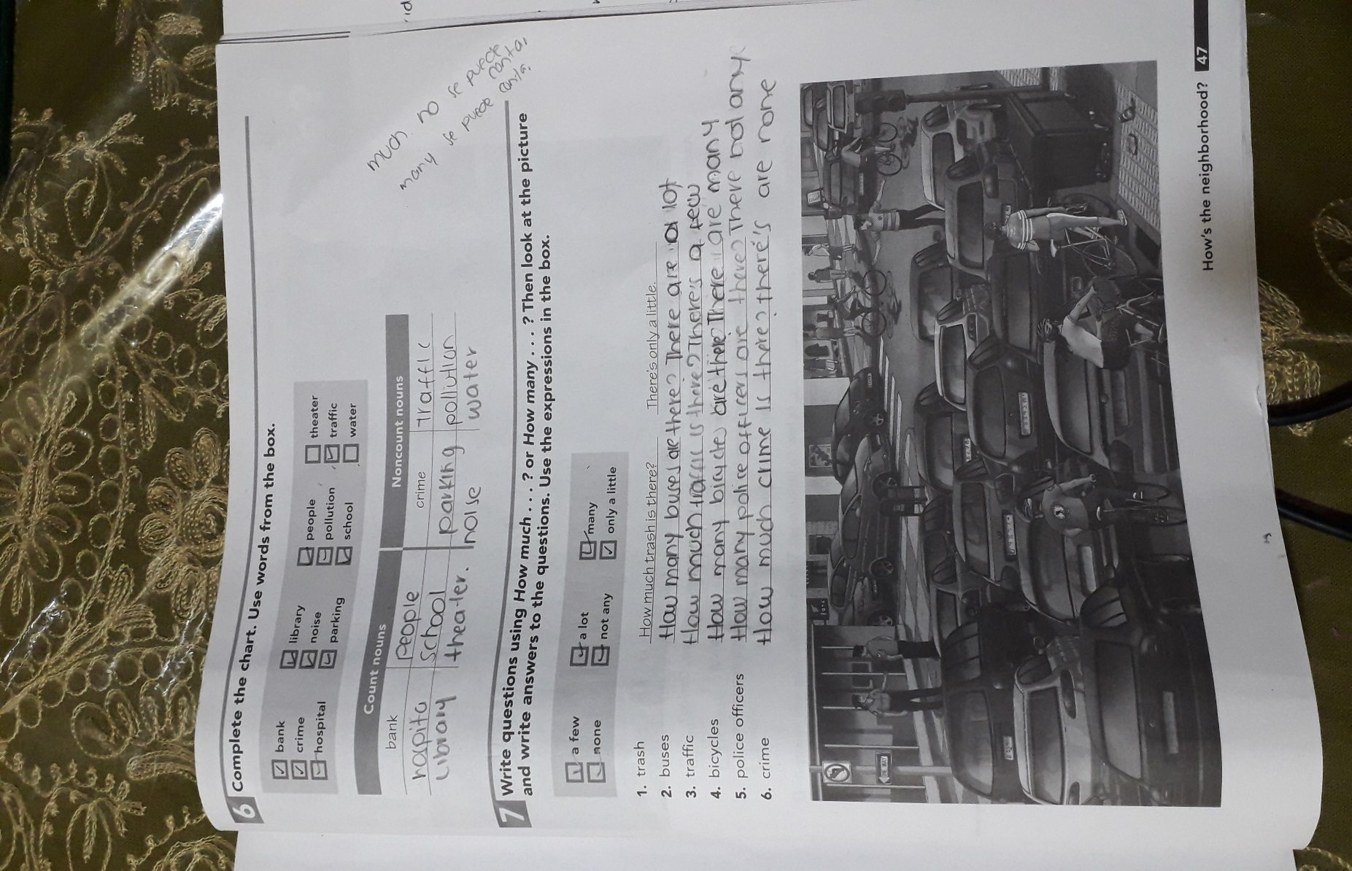

**Teacher; I had doubts about how much? and how many?**

**I investigated and it appeared to me that much is used when it cannot be counted and many when it can be counted, I do not know if it is correct or not**