Escuela Normal de Preescolar

B1.2 Becoming Independent Learners

UNIT 11 “RITES OF PASSAGE”

**WELCOME TO UNIT 11!!!!**

**Dear students,**

**In this lesson you will talk about milestones, you will describe turning points in your life and you will talk about regrets and hypothetical situations.**

*Typical **rites of passage** are baptisms, bar mitzvahs and confirmations, school graduation ceremonies, weddings, retirement parties, and funerals.

*A **milestone** is a significant event in your life. Often a **milestone** marks the start of a new chapter. For example, the day you graduated from high school was a **milestone** in your life.

*A **Turning Point** is a critical time in your **life** where big decisions could lead to big change, both in work and in **life**.

*A **regret** is a feeling of sadness, repentance, or disappointment over something that has happened or been done.

**Read the following conversation “I was so immature”**

**Luke and his uncle are talking about milestones and turning points in their lives. In the chart below you will find some useful time clauses and subordinating conjunctions to describe life experiences**

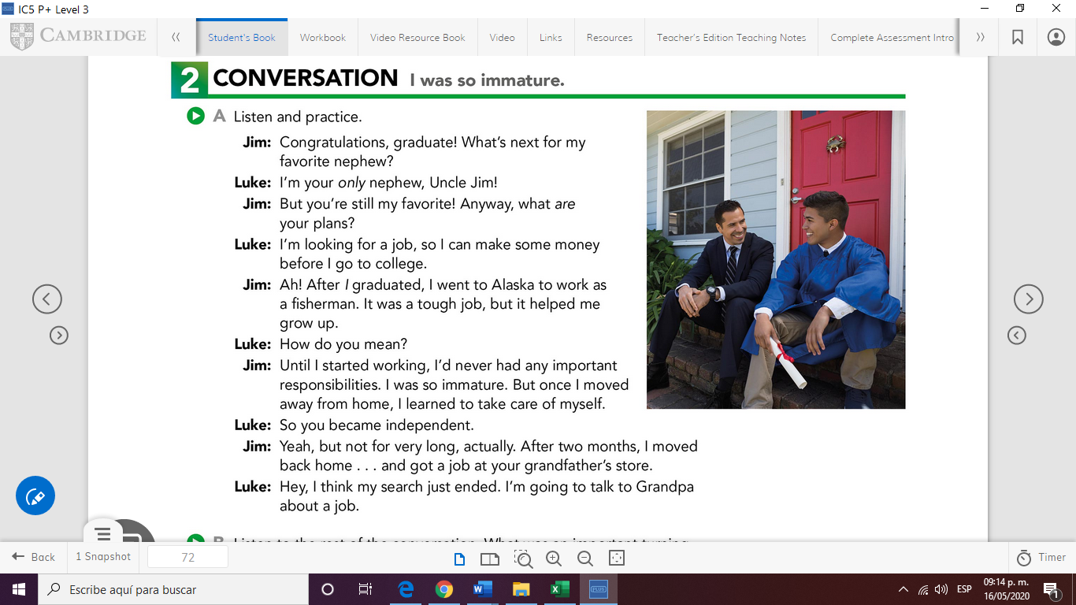

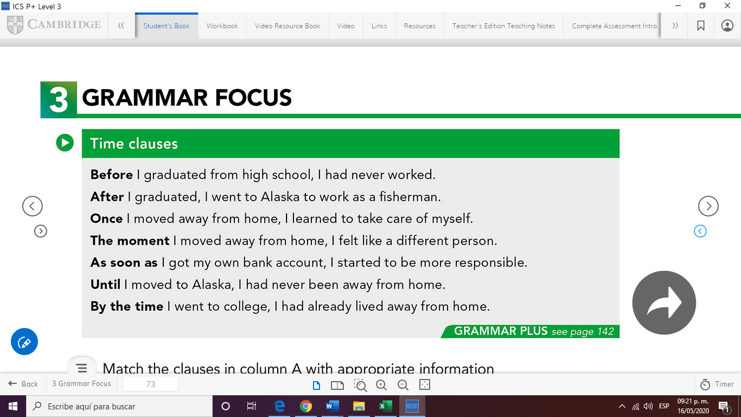

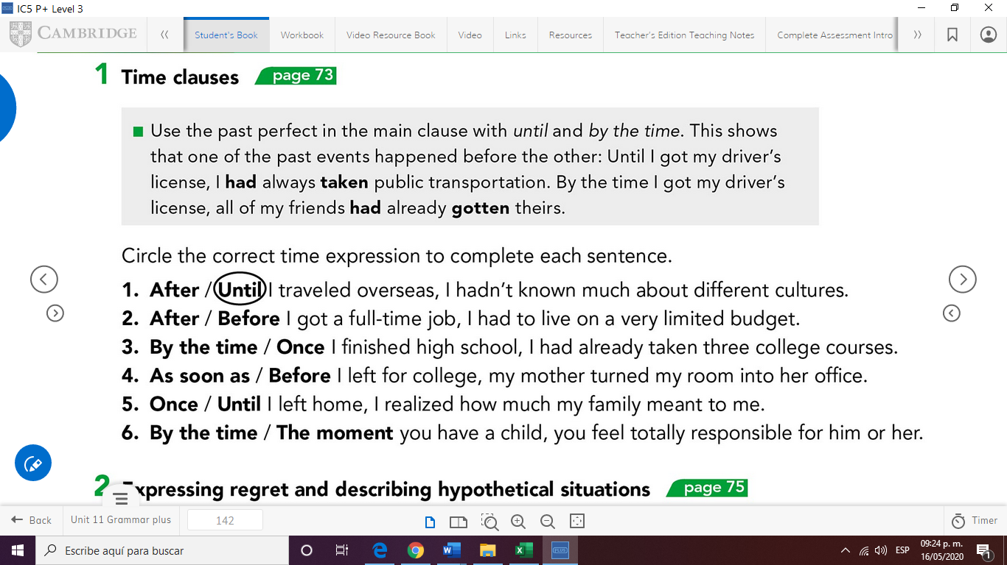

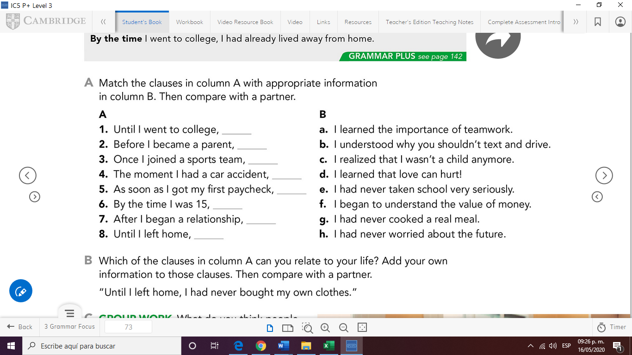

h

g

d

c

f

b

a

e

**Write your answer for exercise A here:**

A 1 – e

**Write your answers for exercise B here:**

**By the time I was 15, life was easier**

**Until I went to college , I learned what stress is**

**The moment I had car accident , I learned to appreciate the effort to buy things**

**Workbook (more practice)**

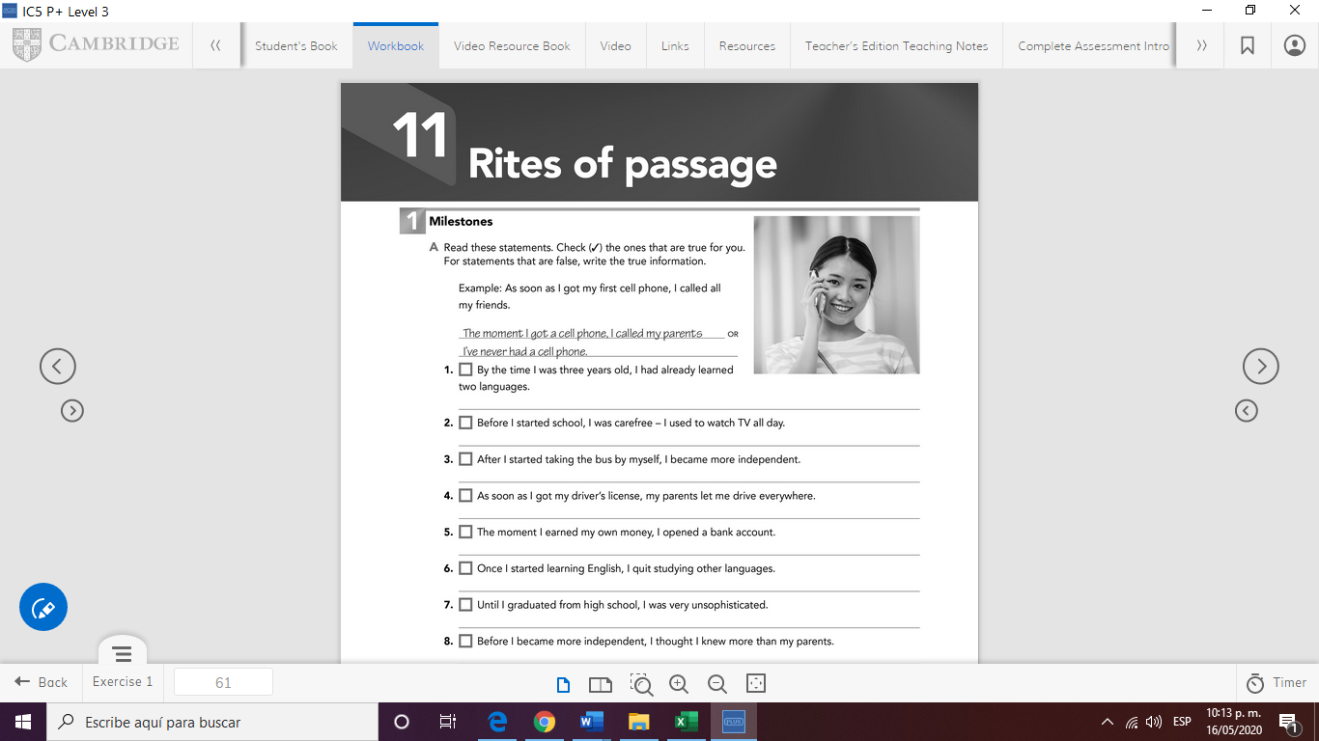

**Write your answers for the wb exercises here:**

1. **I have not learned another language until high school**
2. **Before I star school I only watched TV shows and movies**
3. **I have never took a boss**
4. **I don’t have a driver license**
5. **I have not studied to earn my money**
6. **Once I studied learned English I only focus on that**
7. **Until I graduated from high school I was always appropriated**
8. **I´m not independent yet**