**ESCUELA NORMAL DE EDUCACIÓN PREESCOLAR**

**ENGLISH A1.2 SHARING INFORMATION AND IDEAS**

**UNIT 8 – HOW’S THE NEIGHBORHOOD?**

**DURING THIS UNIT YOU WILL LEARN HOW TO ASK ABOUT AND DESCRIBE PLACES IN A NEIGHBORHOOD.**

**DANIELA GONZALEZ ESCOBEDO**

**ACTIVITY 1 - VOCABULARY**

Copy the vocabulary in your notebook and write a keyword or a clue to remember the meaning of each one, it can be the name of a place you know.

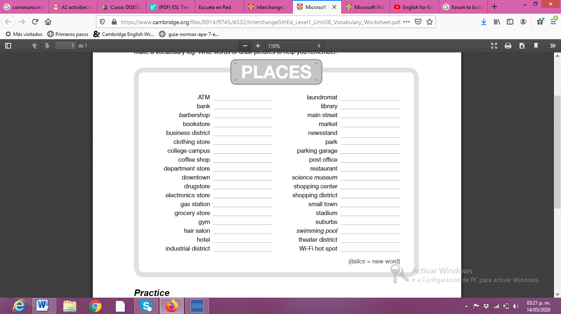

Banorte

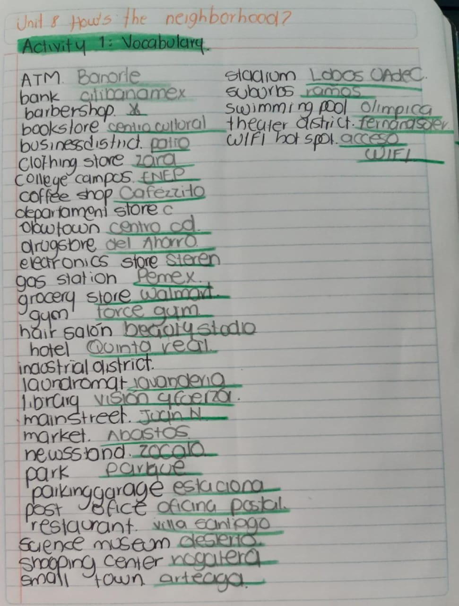

**ACTIVITY 2 – STUDENT’S BOOK PAGE 50**

Complete the activities of your Students’ book page 50:

1. Match the places and the definitions in your book.
2. Write definitions for the places in the box in your NOTEBOOK.

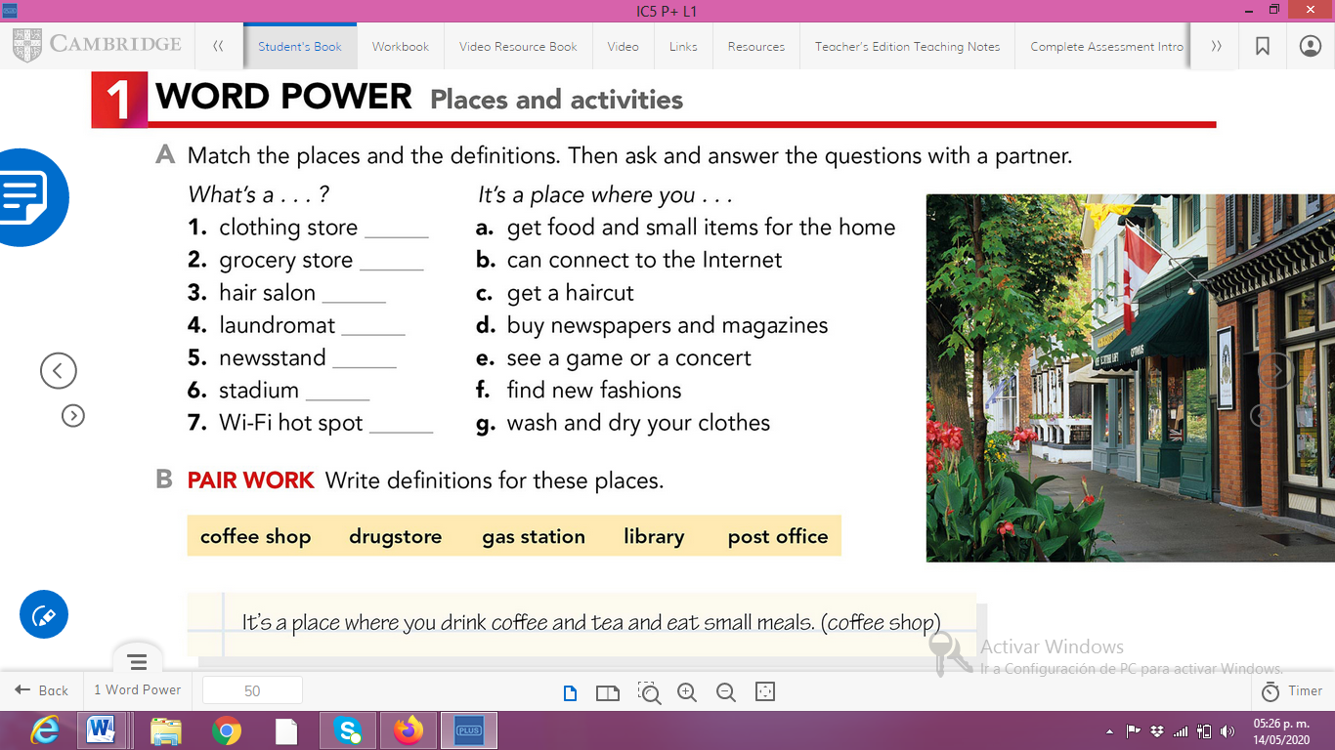

d

b

e

g

c

a

f

**Teacher mi libro lo dejé en la escuela, y ya no pude recuperarlo por lo de la pandemia.**

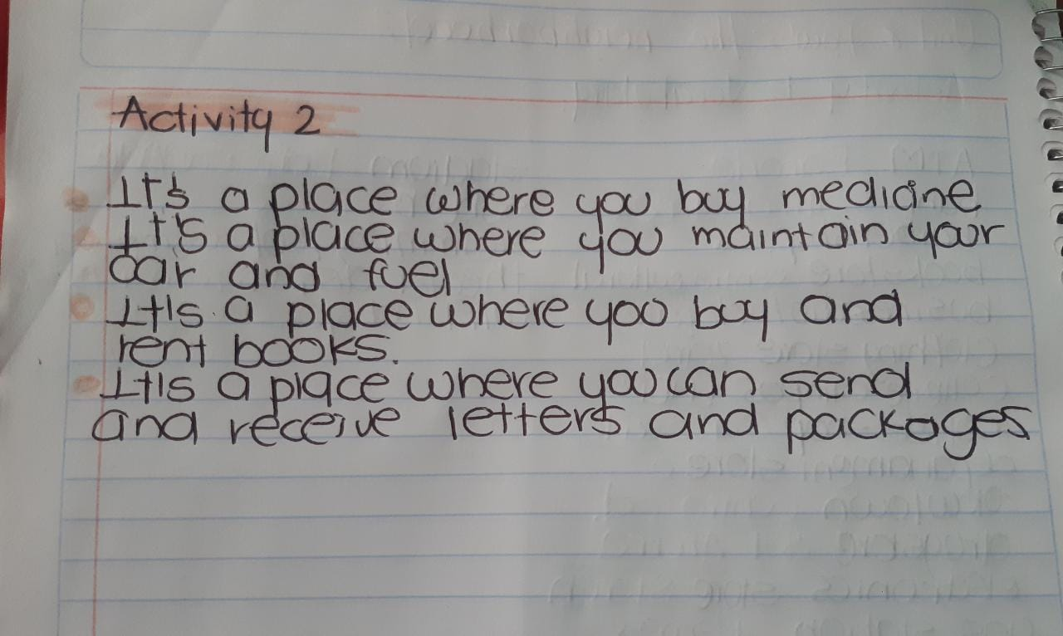

**ACTIVITY 3 – WORKBOOK**

Complete exercise 1 of the page 43 of your workbook.

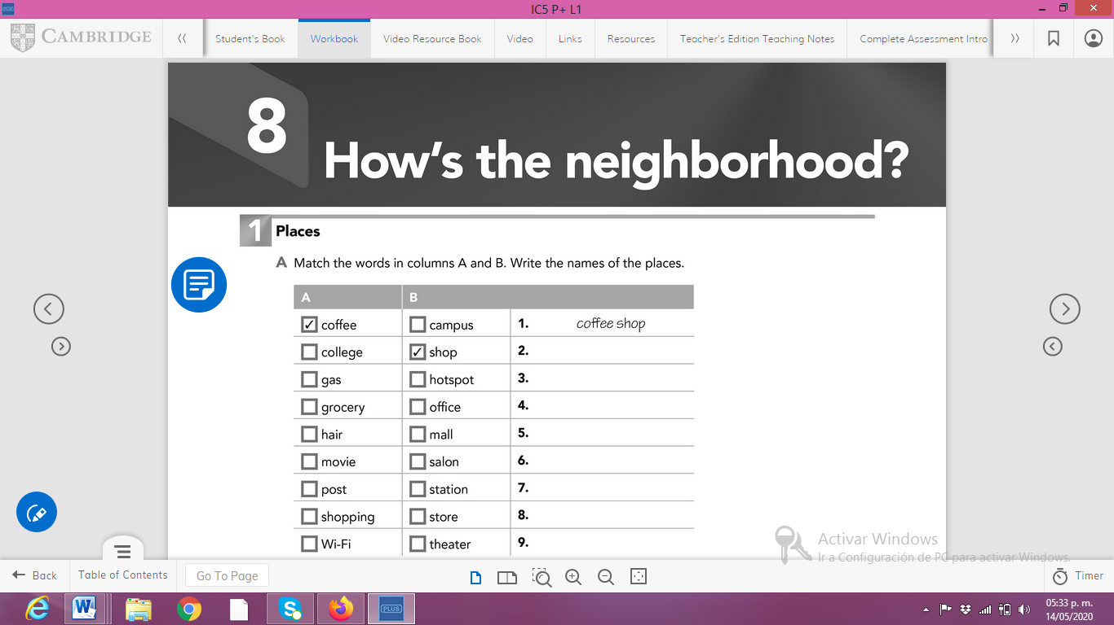

Wi- Fi hotspot

shopping mall

post office

movie theather

hair salon

grocery store

gas station

college campus

**Paste a picture of your workbook here.**