**ESCUELA NORMAL DE EDUCACIÓN PREESCOLAR**

**ENGLISH A1.2 SHARING INFORMATION AND IDEAS**

**UNIT 8 – HOW’S THE NEIGHBORHOOD?**

**DURING THIS UNIT YOU WILL LEARN HOW TO ASK ABOUT AND DESCRIBE PLACES IN A NEIGHBORHOOD.**

**ACTIVITY 1 - VOCABULARY**

Copy the vocabulary in your notebook and write a keyword or a clue to remember the meaning of each one, it can be the name of a place you know.

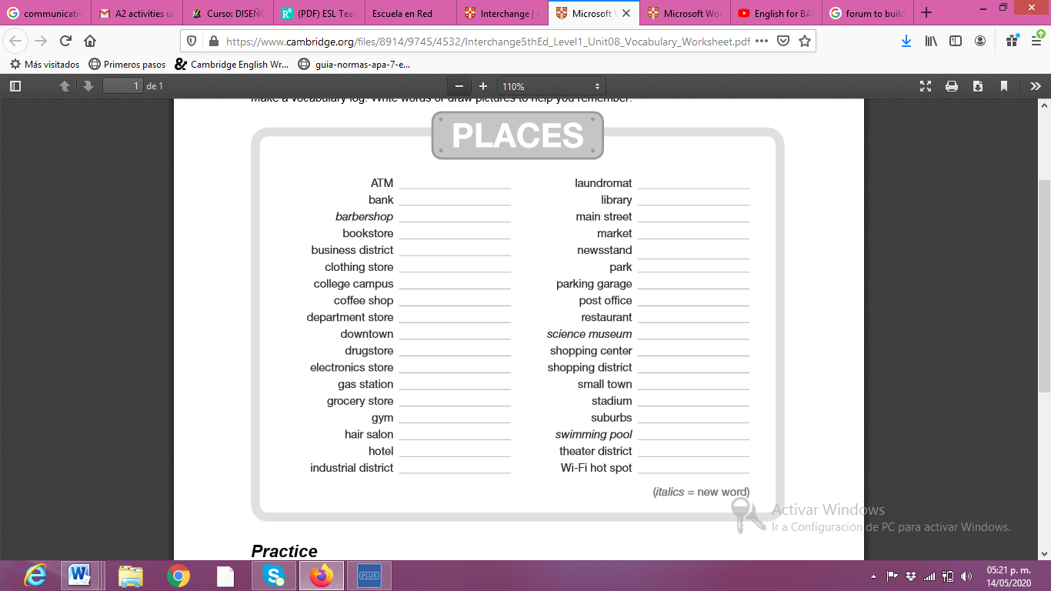

Banorte

**Paste a picture of your notebook here.**

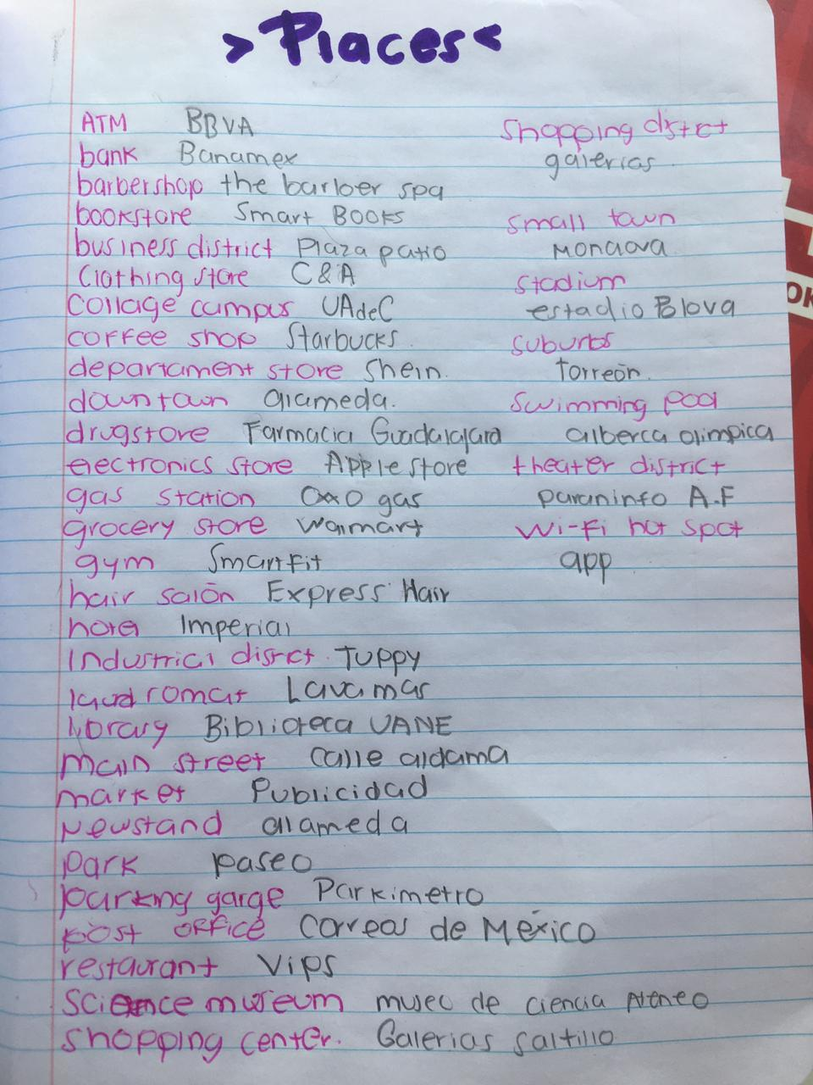

**ACTIVITY 2 – STUDENT’S BOOK PAGE 50**

Complete the activities of your Students’ book page 50:

1. Match the places and the definitions in your book.
2. traWrite definitions for the places in the box in your NOTEBOOK.

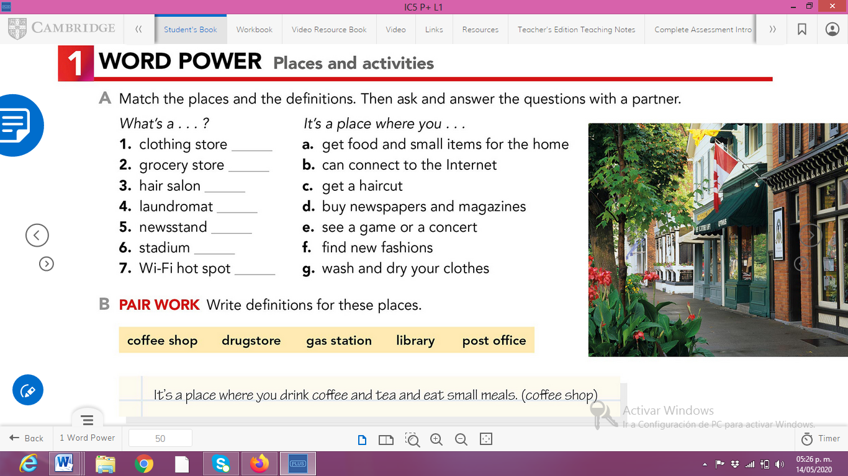

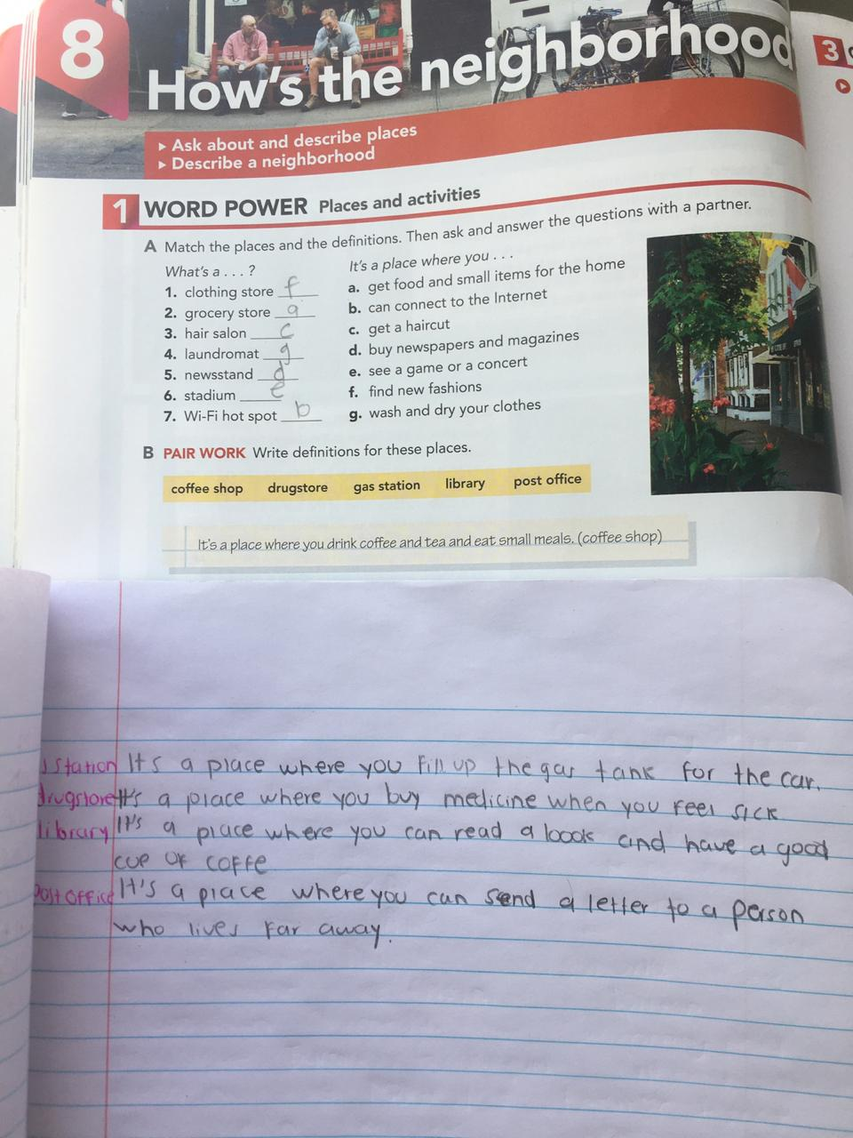**Paste a picture of your book and notebook here**

**ACTIVITY 3 – WORKBOOK**

Complete exercise 1 of the page 43 of your workbook.

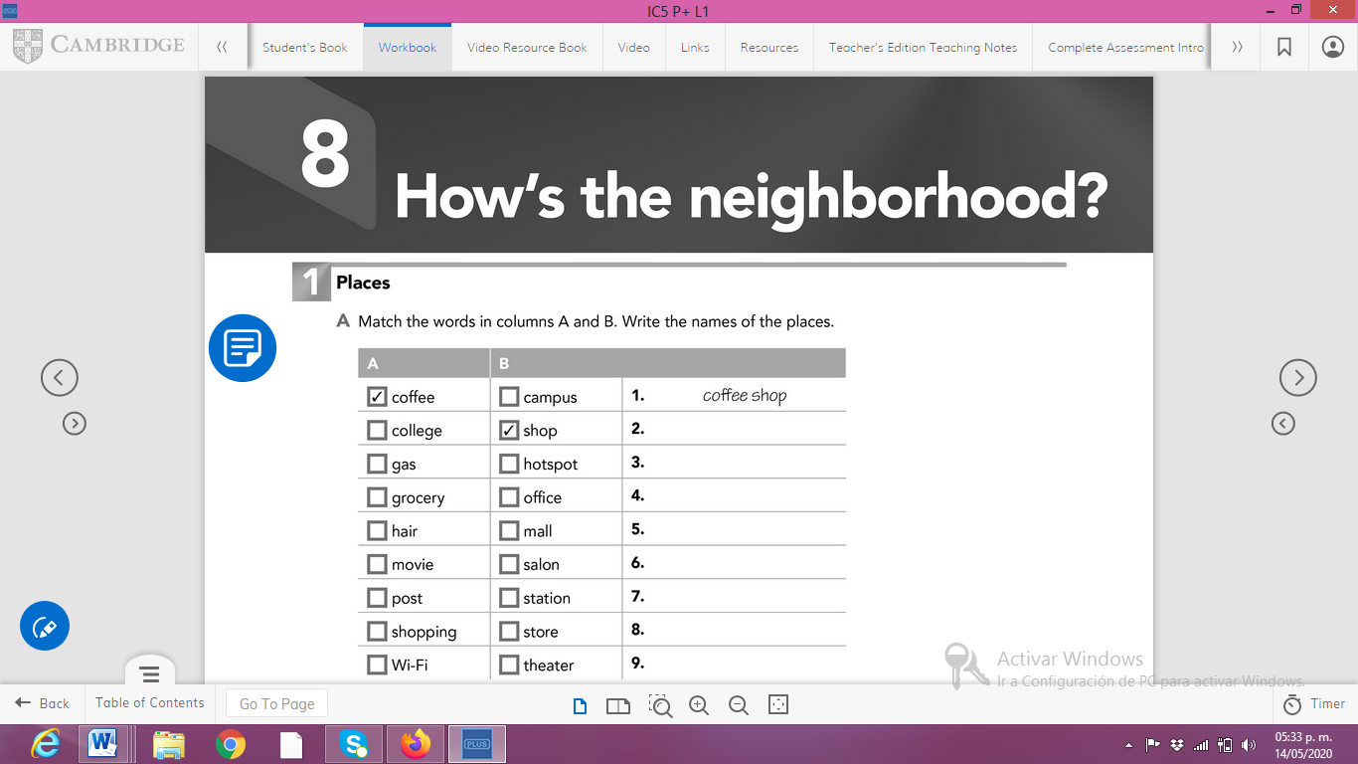

**Paste a picture of your workbook here.**

