ESCUELA NORMAL DE EDUCACIÓN PREESCOLAR
ENGLISH A1.2 SHARING INFORMATION AND IDEAS
UNIT 8 – HOW’S THE NEIGHBORHOOD?
Student : Moed Villalobos
DURING THIS UNIT YOU WILL LEARN HOW TO ASK ABOUT AND DESCRIBE PLACES IN A NEIGHBORHOOD.

ACTIVITY 1 - VOCABULARY
Copy the vocabulary in your notebook and write a keyword or a clue to remember the meaning of each one, it can be the name of a place you know.
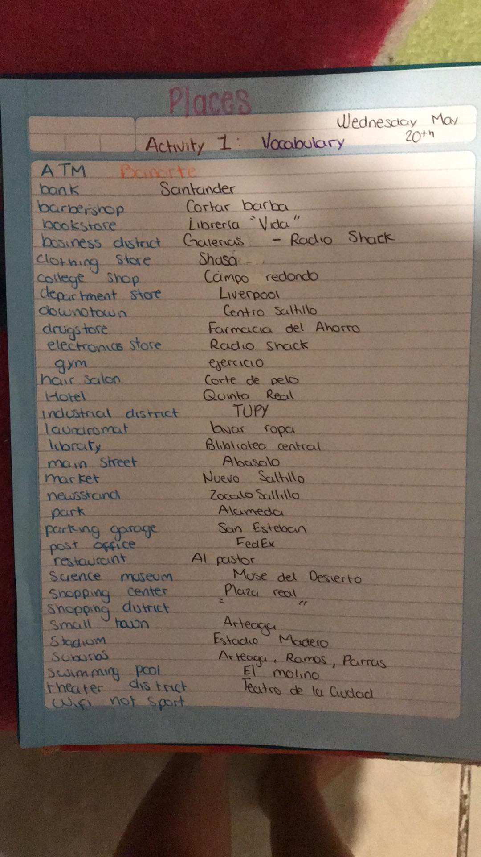Paste a picture of your notebook here.
ACTIVITY 2 – STUDENT’S BOOK PAGE 50
Complete the activities of your Students’ book page 50:
- Match the places and the definitions in your book.
- Write definitions for the places in the box in your NOTEBOOK.
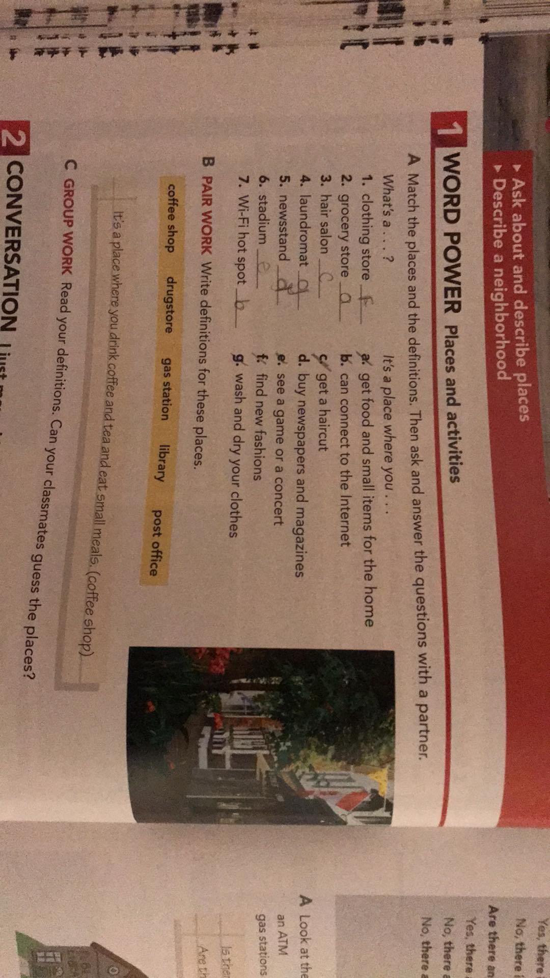
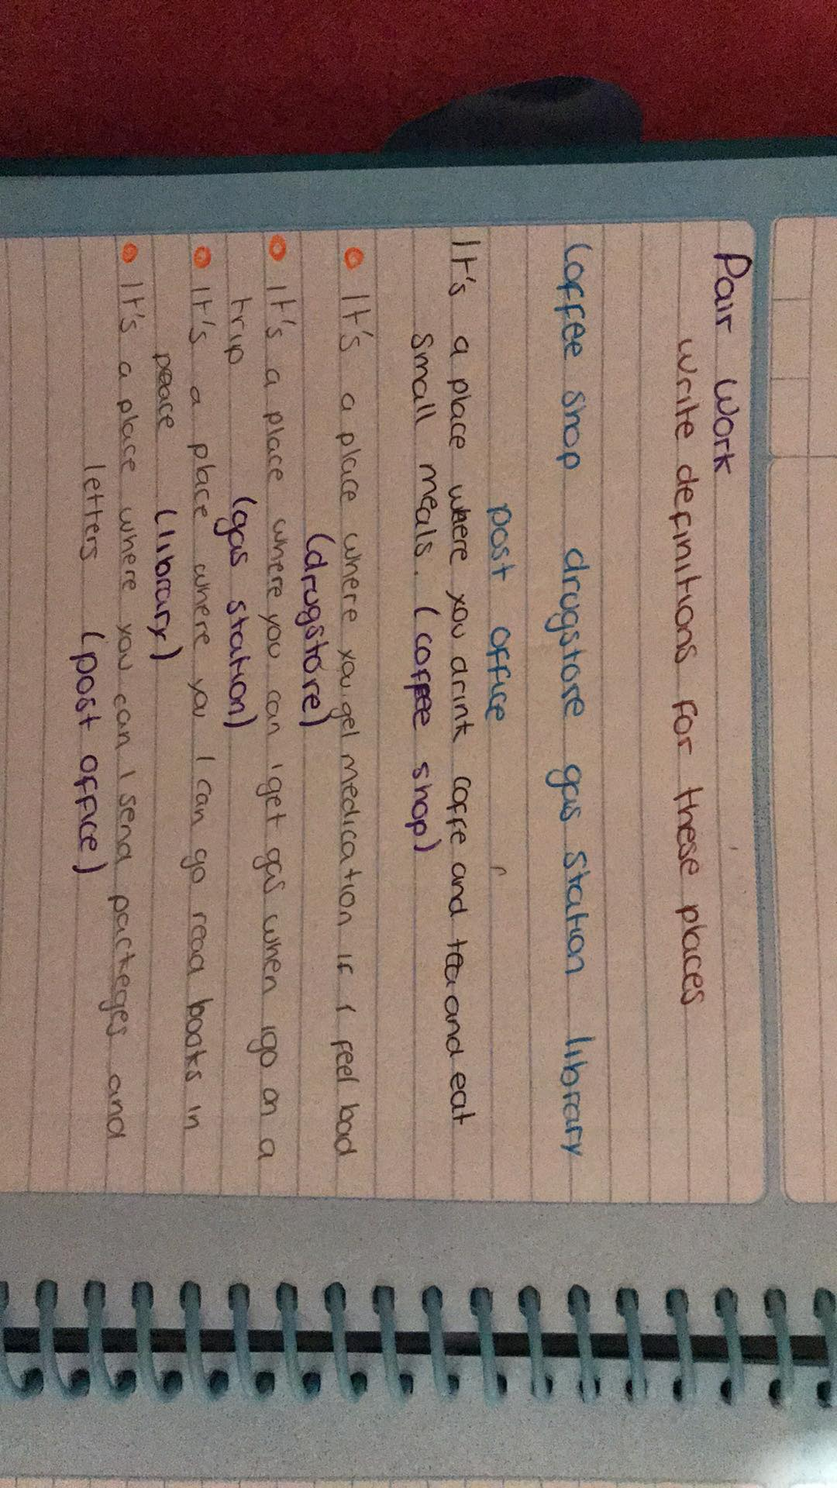
Paste a picture of your book and notebook here.
ACTIVITY 3 – WORKBOOK
Complete exercise 1 of the page 43 of your workbook.
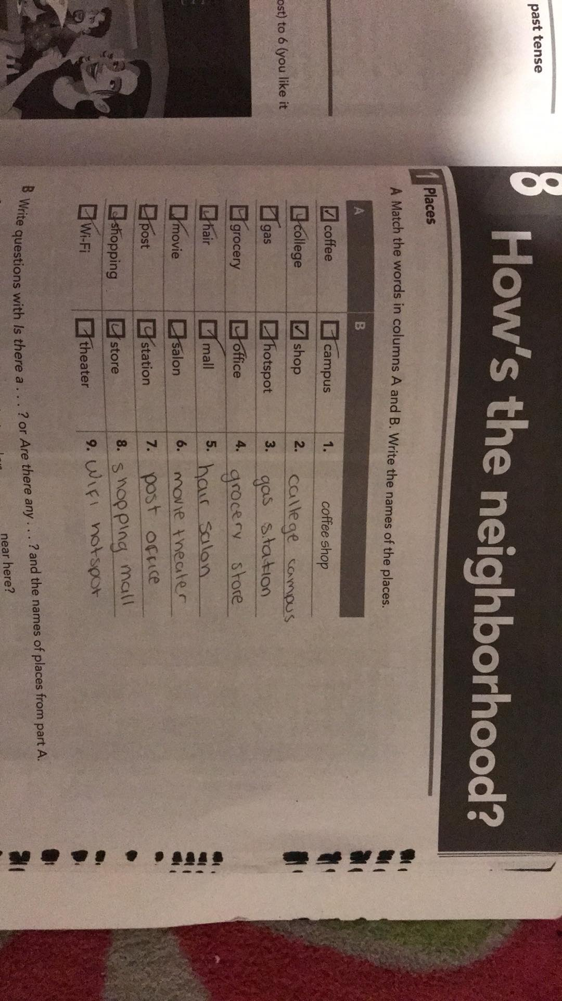
Paste a picture of your workbook here.

