**ESCUELA NORMAL DE EDUCACIÓN PREESCOLAR**

**ENGLISH A1.2 SHARING INFORMATION AND IDEAS**

**UNIT 8 – HOW’S THE NEIGHBORHOOD?**

**DURING THIS UNIT YOU WILL LEARN HOW TO ASK ABOUT AND DESCRIBE PLACES IN A NEIGHBORHOOD.**

**ACTIVITY 1 - VOCABULARY**

Copy the vocabulary in your notebook and write a keyword or a clue to remember the meaning of each one, it can be the name of a place you know.

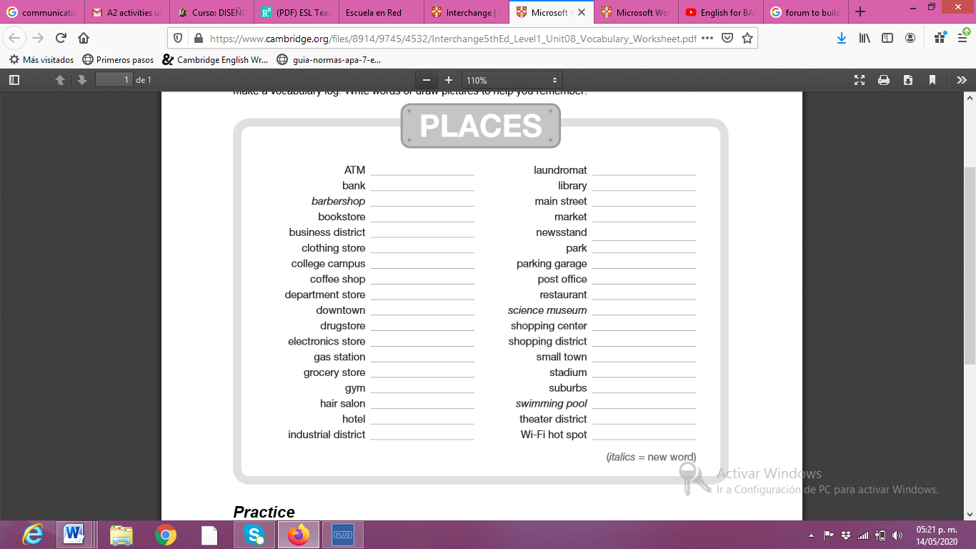

Aurrera

Centro

Soriana

Colegio del valle

vertiche

centro

periodicos

Mercado

16 de septiembre

Lavanderia

Estacionamiento alameda

Correos

Museo del normalismo

Sendero

Lomas del refugio

Saltillo

Parras

Galerias

Estadio de los saraperos

Teatro juarez

Estetica cristal

Libros

Starbucks

El meson de don evaristo

Parque pamanes

Coppel

Internet

Gera barber

Los portales

ejercicio

gasolinera

similares

libros

banamex

Banorte

**ACTIVITY 2 – STUDENT’S BOOK PAGE 50**

Complete the activities of your Students’ book page 50:

1. Match the places and the definitions in your book.
2. 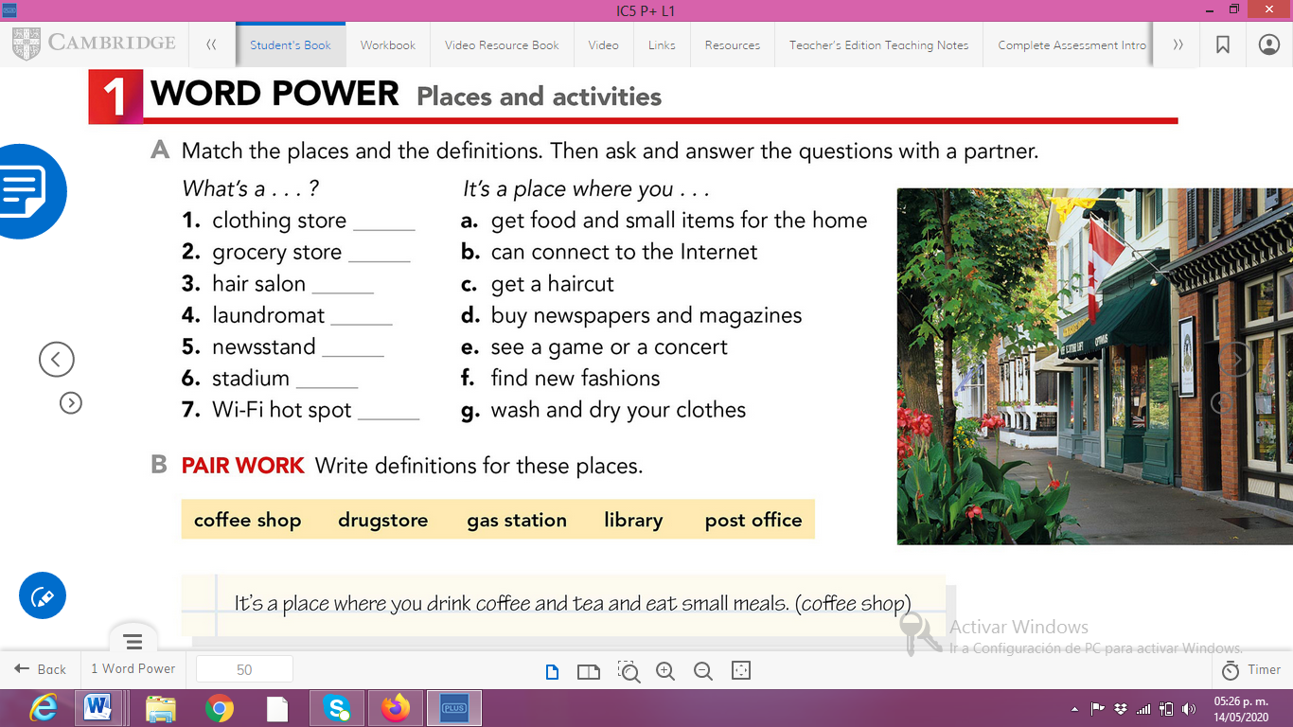Write definitions for the places in the box in your NOTEBOOK.

f

a

c

g

d

e

b

* It’s a place where you drink and tea and small meals
* it's a place where they sell medicine (drugstore)
* It is the place where you can go to buy gasoline for your car (gas station)
* it is the place where you can find all kinds of books (Library)
* place to check emails from city to city (post office)

**ACTIVITY 3 – WORKBOOK**

Complete exercise 1 of the page 43 of your workbook.

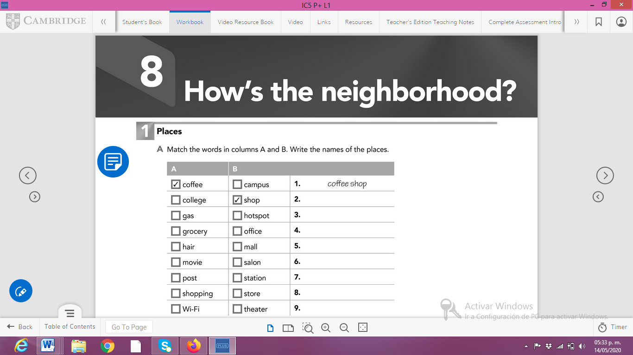

Shopping mall

Wi-Fi hostpot

Post office

Movie theater

Hair salon

Grocery store

Gas station

College campus

College campus

**Paste a picture of your workbook here.**

**(no tengo mis libros acá, los deje en Saltillo ☹ )**