Escuela Normal de Preescolar

B1.2 Becoming Independent Learners

UNIT 11 “RITES OF PASSAGE”

WRITING TASK

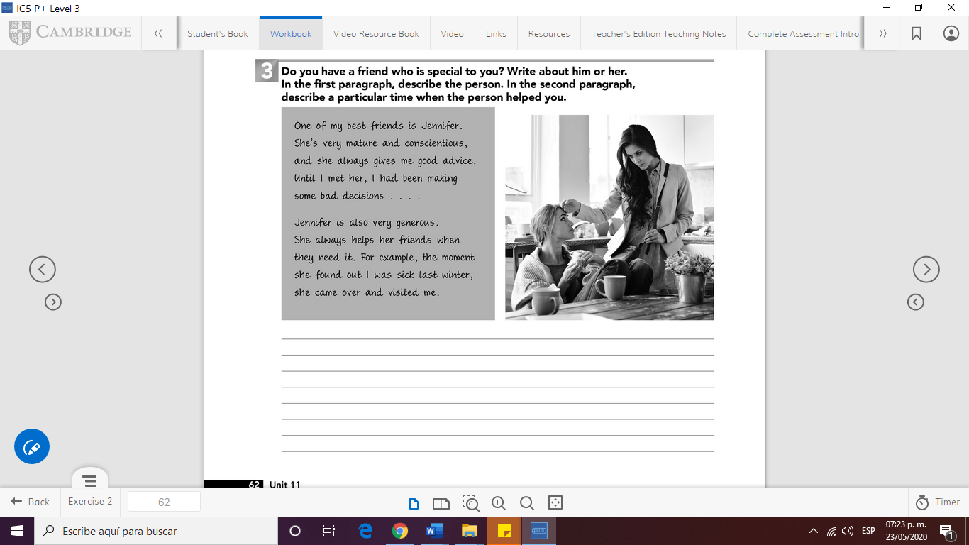

WRITE YOUR PARAGRAPH HERE (150 WORDS)

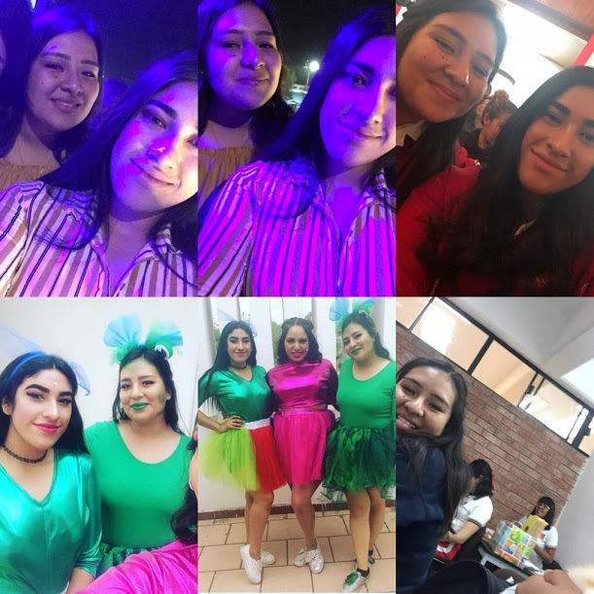One of my best friends is Denisse Sánchez, she has 21 years old. I remember I met her during the first semester of the career.

I never imagined being friends with a very argumentative person, she’s always looking for a fight. But she is also a very loving and conscientious person, she gives me good advices and she’s always there when I need her, like an older sister. In fact, we like to say that we are “Sisters of different mother”.

For example: Once, she supported me in my love disappointments, she endured my tears and my mood swings. Another day I got sick and I couldn´t go to school, so she recorded all the classes and she came over and visited me with my favorite food.

I just want to say that I thank the ENEP and anniversary party for unite us, because from there a big friendship was born.