Escuela Normal de Preescolar

B1.2 Becoming Independent Learners

UNIT 11 “RITES OF PASSAGE”

WRITING TASK

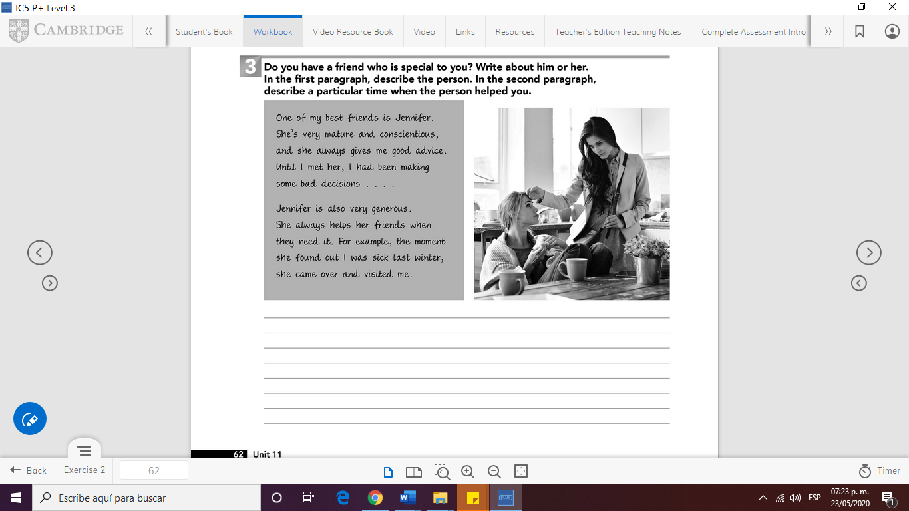

WRITE YOUR PARAGRAPH HERE (150 WORDS)

One of my best friend is Leyda, she cares a lot for people she want and who is important to her. She is an ambitious and an argumentative person, just to make justice in some circumstances. She is also an independent person who always do everything by herself and she doesn´t need anyone.

Leyda is a helpful person, especially with her friends. One experience I have with her, with this characteristic is when I didn´t understand a topic of a class, she borrowed me her notes and that helps me to understood in a better way the classes.