<https://www.youtube.com/watch?v=e0pecj7ZCcQ>

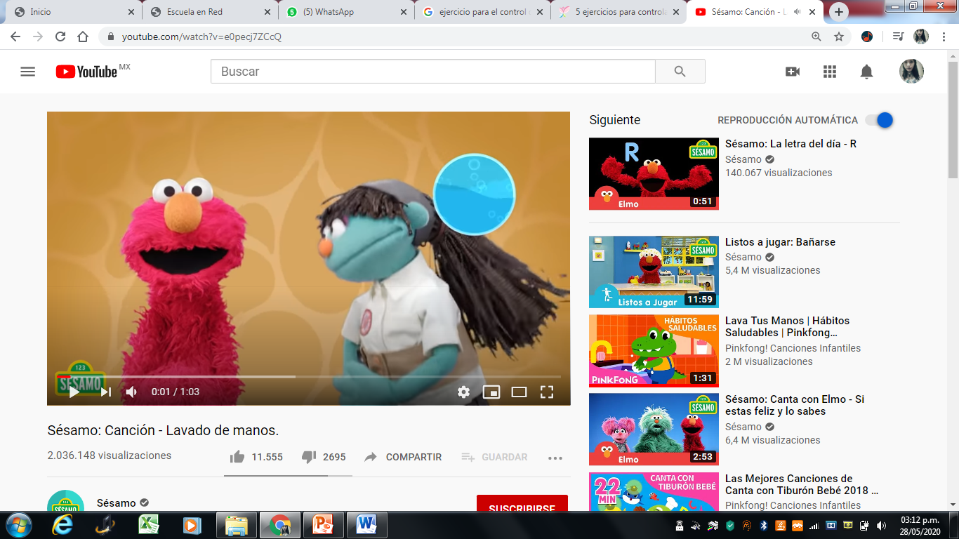

<https://www.youtube.com/watch?v=WnnUAMSt7EY>

