**ESCUELA NORMAL DE EDUCACION PREESCOLAR**

**LICENCIATURA EN EDUCACION PREESCOLAR**



**CURSO:**

**ENGLISH B1**

**TEACHER:**

**CRISTINA ALVARADO CHAVARRIA**

**ACTIVITY:**

|  |  |
| --- | --- |
| |  | | --- | | **PROJECT UNIT 8 - WHAT HAPPENED NEXT?** | |

**ALUMNA:**

**PAULINA FLORES DÁVILA**

**NUM. DE LISTA: 4**

**FECHA: 19 JUNE 2020 SALTILLO, COAHUILA**

LINK: https://drive.google.com/file/d/1endqkD2sQ6jTYQDyRNMHvpMJW5P8MAmb/view?usp=sharing

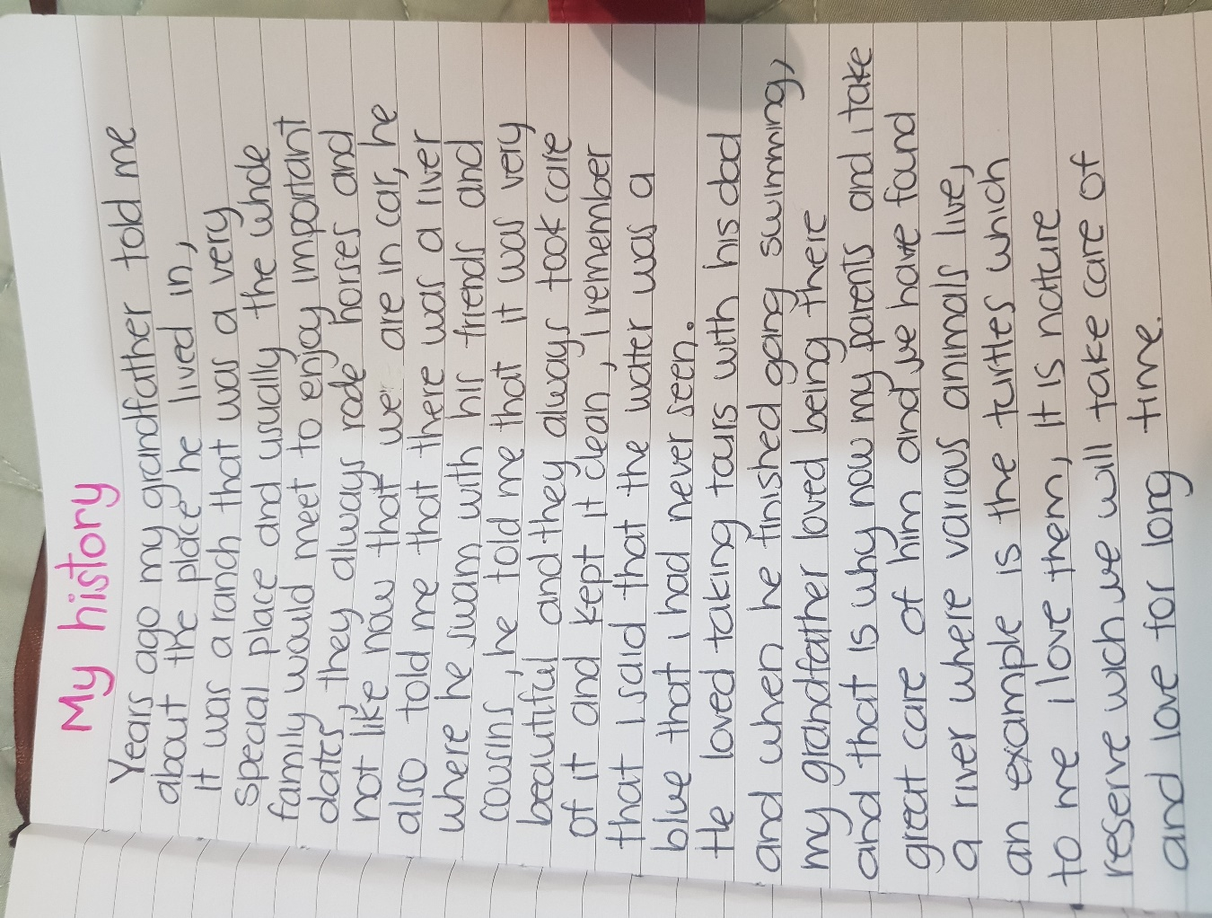



PROJECT EVALUATION

|  |  |  |
| --- | --- | --- |
| CHECKLIST TO GRADE UNIT PROJECT 8 | | |
|  | YES | NO |
| WRITTEN PRODUCT |  |  |
| Grammar structures from the unit are used in the story (past continuous and simple past) |  |  |
| The words when and while are used correctly |  |  |
| Adverbs for story telling are used appropriately |  |  |
| The story has 100 or more words |  |  |
| The pictures provided are connected with coherence and cohesion |  |  |
| VIDEO |  |  |
| Includes a cover with the student’s general information |  |  |
| Includes the pictures provided by a classmate |  |  |
| The student record the story and the audio is intelligible |  |  |
| *Is able to express his/her ideas fluently with correct intonation using complete sentences and with no major production errors.* |  |  |