**Escuela Normal de Educación Preescolar**

Licenciatura en educación preescolar



**Course**

English

**Teacher**

Cristina Aracely Alvarado Chavarria

**Student**

Yamile Margarita Mercado Esquivel #11

**B1 3 MIXTO**

**Unit 8 Project**

**What happened next?**

**June 18, 2020**

**Written Product**

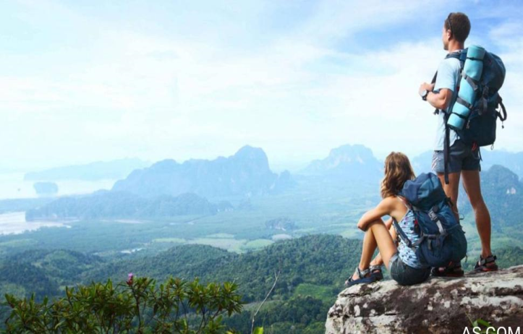

**Matthew and his rare vacation**

One summer day, Matthew and his friends went out in search of new adventures in the wild and went to climb the highest mountain in the city, when suddenly a very loud noise was heard in the car, Matthew and his friends were frightened and decided to stand on the road to see what was happening, while Alice and Susy waited in the car. Scared Matthew and his friends realized that the tire had struck out and they needed to change it, fortunately Matthew had a spare tire in the trunk. They all helped and calmly came up the mountain to start their new adventure, Alice and Susy began to check the place while Matthew and the others prepared to begin.

**Video**

<https://drive.google.com/file/d/1WXBsUodL06w2LE15UfgrGbmD54s-zwss/view?usp=sharing>

PROJECT EVALUATION

|  |  |  |
| --- | --- | --- |
| CHECKLIST TO GRADE UNIT PROJECT 8 | | |
|  | YES | NO |
| WRITTEN PRODUCT |  |  |
| Grammar structures from the unit are used in the story (past continuous and simple past) |  |  |
| The words when and while are used correctly |  |  |
| Adverbs for story telling are used appropriately |  |  |
| The story has 100 or more words |  |  |
| The pictures provided are connected with coherence and cohesion |  |  |
| VIDEO |  |  |
| Includes a cover with the student’s general information |  |  |
| Includes the pictures provided by a classmate |  |  |
| The student record the story and the audio is intelligible |  |  |
| *Is able to express his/her ideas fluently with correct intonation using complete sentences and with no major production errors.* |  |  |