**Escuela Normal de Educación Preescolar**



**Licenciatura en Educación Preescolar**

**Cuarto Semestre Sección B**

**INGLÉS B1 3 MIXTO**

**Teacher: Cristina Aracely Alvarado Chavarria**

**Name:** Daiva Ramírez Treviño N.13

**Date:** 18/06/2020 Saltillo, Coahuila

ESCUELA NORMAL DE EDUCACIÓN PREESCOLAR

UNIT 8 PROJECT

WHAT HAPPENED NEXT?

|  |
| --- |
| **Aim:**  Give Ss practice telling stories.  **Preparation:**  Look for two different pictures that you find interesting on the Internet. These must be pictures of people, places, or things and they should not have anything to do with each other.  Exchange your pictures with your partner, you can send the pictures by e-mail or WhatsApp.  Is able to express his/her ideas fluently with correct intonation using complete sentences and with no major production errors. |

PROJECT EVALUATION

|  |  |  |
| --- | --- | --- |
| CHECKLIST TO GRADE UNIT PROJECT 8 | | |
|  | YES | NO |
| WRITTEN PRODUCT |  |  |
| Grammar structures from the unit are used in the story (past continuous and simple past) |  |  |
| The words when and while are used correctly |  |  |
| Adverbs for story telling are used appropriately |  |  |
| The story has 100 or more words |  |  |
| The pictures provided are connected with coherence and cohesion |  |  |
| VIDEO |  |  |
| Includes a cover with the student’s general information |  |  |
| Includes the pictures provided by a classmate |  |  |
| The student record the story and the audio is intelligible |  |  |
| *Is able to express his/her ideas fluently with correct intonation using complete sentences and with no major production errors.* |  |  |

**PICTURES:**

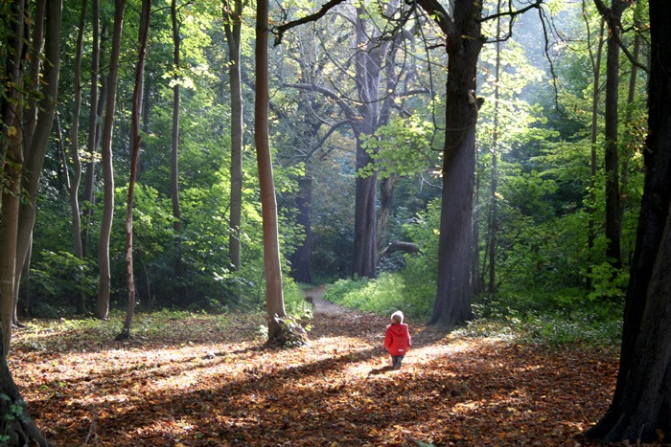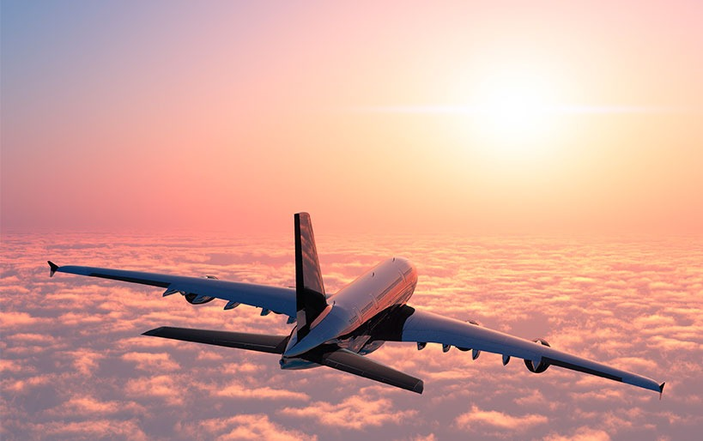

**WRITTEN PRODUCT**

I´ll tell you a story about a family trip we had a few years ago.

Luckily my mother won a trip to Canada for all my family, so we went to the beautiful destination of Canada.

A day before the trip I was making my luggage when I remembered that Canada is a cold country so I packed some winter clothes. Unfortunately, I didn't tell that to my family so they hadn't pack winter clothes.

We went to the airport and we take the plane but when we were arriving to the airport of canada it was very cold.

While I was putting my jacket, they bought expensive jackets in the airport, because they had not pack jackets.

We had a great time, we went to the national park of Banff and we had beautiful moments in family.

Video:

<https://www.youtube.com/watch?v=myeDUzO0c7s>