**ESCUELA NORMAL DE EDUCACION PREESCOLAR**

**ENGLISH B1.1.2**

**UNIT 8 PROJECT**

**WHAT HAPPENED NEXT?**

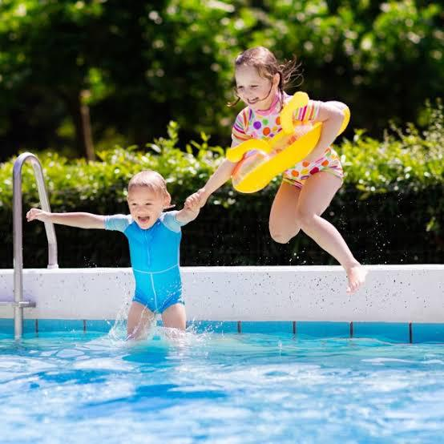

<https://drive.google.com/file/d/1z8bIMU041NAhPI2tQvmIbQ64cFceoO4h/view?usp=sharing>