Escuela Normal de Educación Preescolar

B2+ Online course

Writing project

Unit 1

**Aim:** To give ss practice on exposition and narration

To invite ss to share human experience through creative writing.

**Preparation:**

Listen to the song “Yellow” by Coldplay. <https://www.youtube.com/watch?v=jy5Lel93Jt0>

Use the graphic organizer below to jot down the feelings, emotions, thoughts, or memories the lyrics evoke.

**Presentation:**

Write a one-page article for a women’s rights magazine.

Start your works using the following lines:

By listening to the song “Yellow” by Coldplay, I…

The lyrics of “Yellow” by Coldplay made me… (feel, evoke, remember…)

Print your article and deliver it to your teacher for feedback and revision.

This task worth 10 pts= 10% of the unit evaluation

The task will be evaluated in terms of originality, use of language, appropriate connectors, grammar and punctuation. (And due date delivery)

|  |  |  |  |
| --- | --- | --- | --- |
| Originality | 2 | 1 | 0 |
| Use of language | 2 | 1 | 0 |
| Appropriate connectors | 2 | 1 | 0 |
| Grammar | 2 | 1 | 0 |
| punctuation | 2 | 1 | 0 |

**Step 2:**

What do you think were the author’s intentions when he wrote the song?

Do you think the song was written for someone in particular?

Access the following link to read some fun facts about the song written by the band Coldplay- https://www.songfacts.com/facts/coldplay/yellow

Which songfacts surprised you the most?

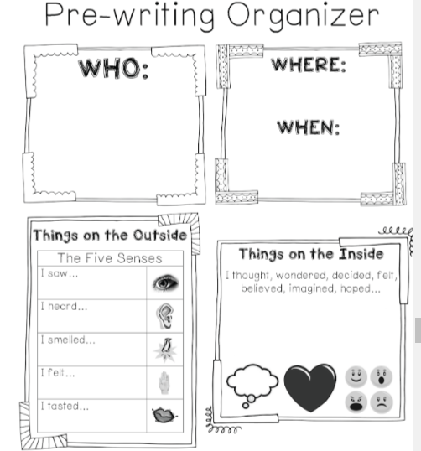

|  |
| --- |
| Dear fellow sister,  Please insert your article here. If the content is relevant for our public, we will send you a notification to publish it in the next issue.  Be brave and keep supporting our good cause.  Thanks a lot.  https://www.womensrights_magazine/womankind |



A magazine for women

**Womankind**

Escuela Normal de Educación Preescolar

B2+ Online course

Writing project

Unit 2

Discussion forum “The meaning of life”

