**UNIT 7 PROJECT**

**UNIT 7**

**DOES IT HAVE A VIEW?**

**Objective:** To discuss homes and furniture and to describe a home using there is/there are and the simple present.

**Preparation:**

Choose a partner to work with.

Choose a house and make a description of your dream home answering the following questions.

* **What is your dream home?**
* **Where is it?**
* **What rooms does it have?**
* **What things are in the rooms?**
* **Does it have a view?**

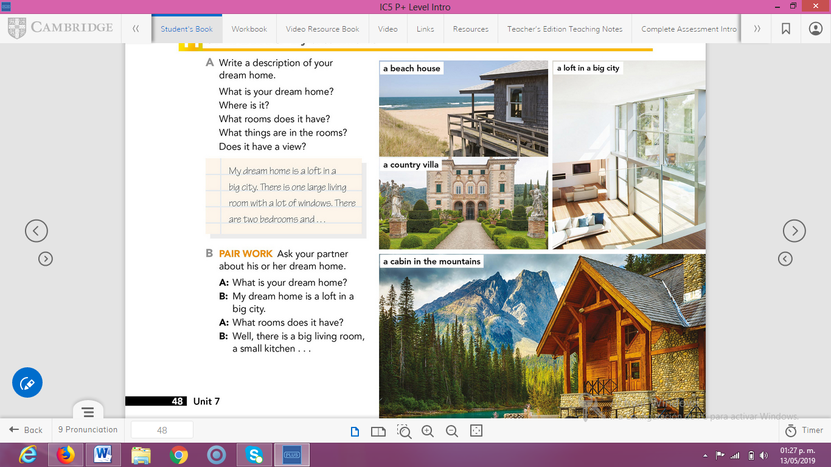

***Example.***

*My dream home is a beach house in Cancún . There is a big living room with a big window and a beautiful view. There are three bedrooms, two bathrooms, a dining room and a big yard. There is a swimming pool in the yard. There is a big bed in my bedroom and the bathroom has a bath tub. There is a table and six chairs in the living room. There are no curtains in the living room…*

**Product:**

Make a presentation with pictures (no text) of it and its rooms (kitchen, dining room, living room, bedroom, bathroom and yard)

The Power Point presentation must include:

* Cover
* Pictures of the rooms
* Rubric

THE POWER POINT PRESENTATION MUST BE UPLOADED THIS **THURSDAY, MARCH 12TH** AND THE PRESENTATION WILL TAKE PLACE ON **FRIDAY, MARCH 13TH.**

**RUBRIC**

|  |  |  |  |
| --- | --- | --- | --- |
| EVALUATION CRITERIA | NEEDS IMPROVEMENT | GOOD | EXCELLENT |
| PRODUCT | The product was not uploaded to the platform.  **0** | A Power Point presentation with pictures of the dream home and its rooms.    **2 pts.** | A Power Point presentation with cover, pictures of the dream home and its rooms, and the rubric.  The student makes the presentation look professional.    **3 pts.** |
| SPEAKING TASK | Expresses him/her ideas with many hesitations and poor intonation.  Uses incomplete sentences.  Mispronounces several words.  Rarely uses appropriate vocabulary and grammar structures.  **2 pts.** | Is able to express his/her ideas with some hesitation but managed to maintain flow and adequate intonation.  Uses correct vocabulary and grammar structures appropriately most of the time  **5 pts.** | Is able to express his/her ideas fluently with correct intonation using complete sentences and with no major production errors.  Uses vocabulary and grammar structures appropriately.  **7 pts.** |