**ESCUELA NORMAL DE EDUCACIÓN PREESCOLAR**

**ENGLISH B1.2** Becoming Independent Learners

Final project

“I need advice”

**Aim:** Give Ss practice asking for and giving advice

**Prepare:** .

* **The video will be done in PAIRS through ZOOM platform.**

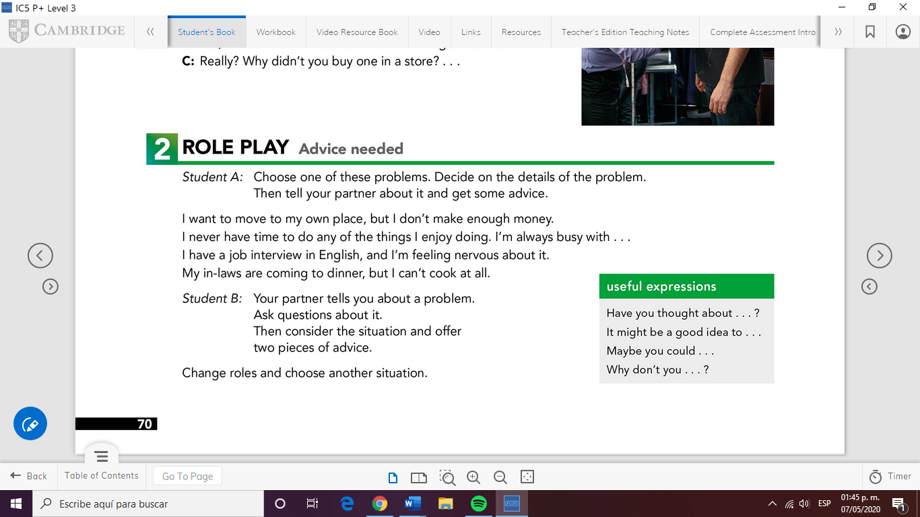

* **Use the structures below to make suggestions**

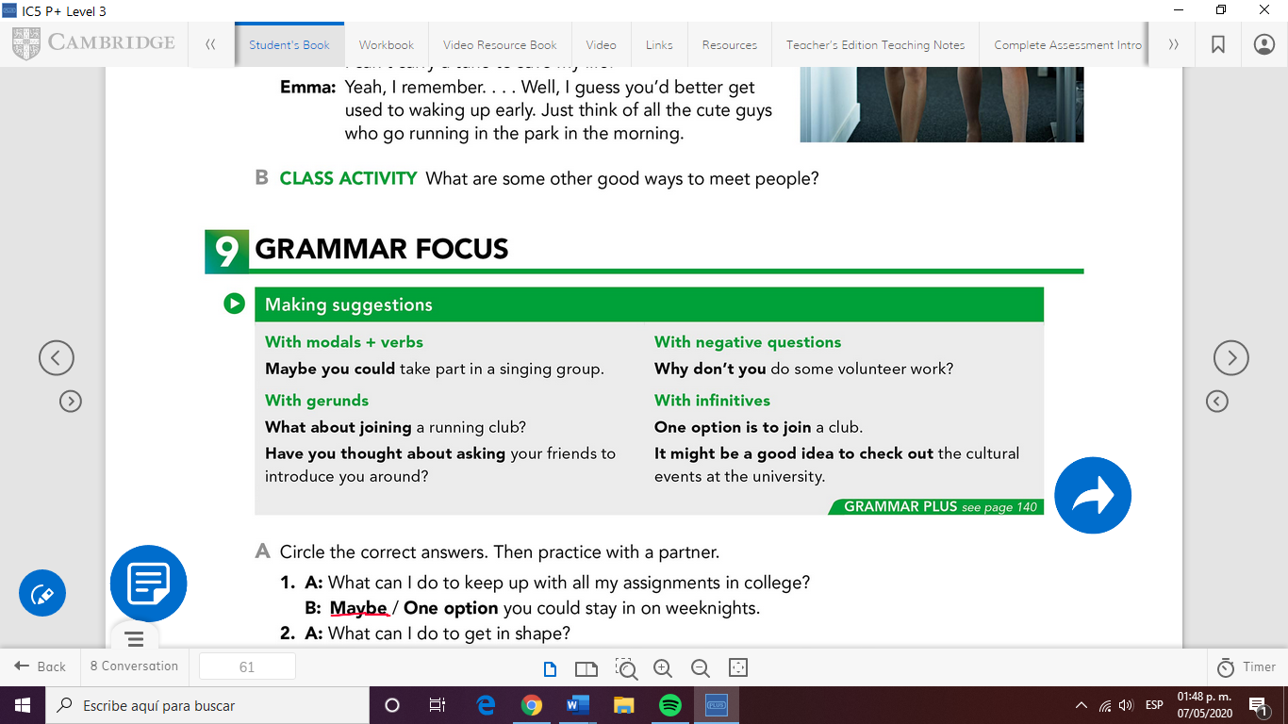

**Present:**

* Make a **video** in which you ask for and give advice to a friend ***Try not to read.***
* You must give at least two pieces of advice*
* You must use the structures and useful expressions in the box*
* The video must include a cover with an introduction, and it must look professional and creative
* 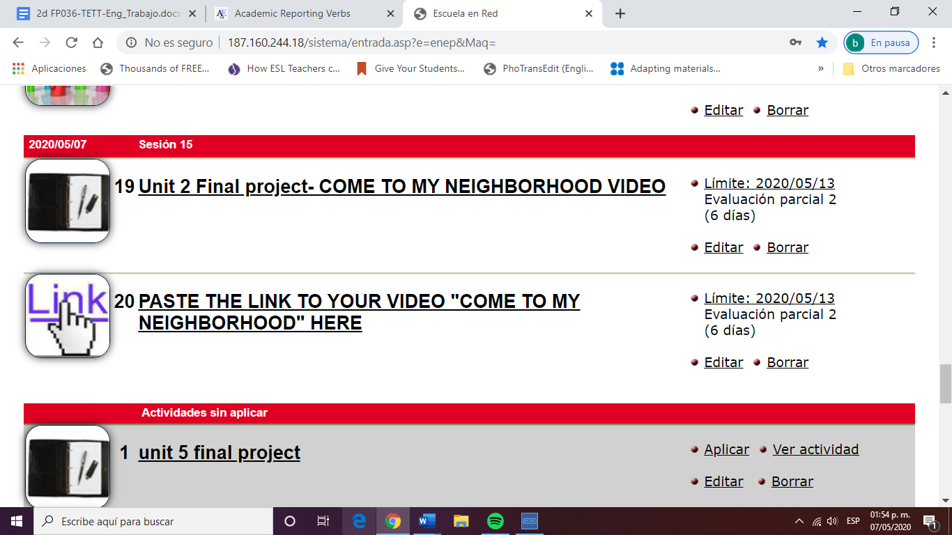Upload your video to **Youtube or Google Drive** and upload a ***Word document with the link*** to Escuela en Red you must also paste the link in the activity with this icon:

|  |  |  |  |
| --- | --- | --- | --- |
| **EVALUATION CRITERIA** | **NEEDS IMPROVEMENT** | **GOOD** | **EXCELLENT** |
| **PRODUCTS** | A Word document with a link to a video on YouTube.  The video shows the student(s) asking for and giving advice but some of the following are missing: describing a problem/giving two pieces of advice / not using the criteria above*  or  The video doesn’t include a cover or introduction and it doesn’t look professional and creative  **1 point** | A Word document with a link to a video on YouTube.  The video shows the student (s) asking for and giving advice but one of the following is missing: describing a problem/giving two pieces of advice  or  The video doesn’t include a cover or introduction and it doesn’t look professional and creative    **2 pts.** | A Word document with a link to a video on YouTube.  The video shows the student (s) describing a problem/asking and giving two pieces of advice using the criteria above *  The video includes a cover or introduction and it looks professional and creative    **3 pts.** |
| **CONTENT** | The presentation does not meet the requirements in the guideline.  some of the following are missing: describing a problem/giving two pieces of advice / not using the criteria above  **1 pts.** | The presentation does not meet the requirements in the guideline one of the following is missing: describing a problem/giving two pieces of advice  **2 pts.** | The task meets all the requirements in the guideline  describing a problem/asking and giving two pieces of advice using the criteria above *  **3 pts.** |
| **SPEAKING TASK** | Expresses him/her ideas with many hesitations and poor intonation.  Uses incomplete sentences.  Mispronounces several words.  Rarely uses appropriate vocabulary and grammar structures.  **1 point.** | Is able to express his/her ideas with some hesitation but managed to maintain flow and adequate intonation.  Uses correct vocabulary and grammar structures appropriately most of the time  **3 pts.** | Is able to express his/her ideas fluently with correct intonation using complete sentences and with no major production errors.  Uses vocabulary and grammar structures appropriately.  **4 pts.** |

**RUBRIC**

**Paste your link here:**